April Newsletter 2014 gregandsophiesangwine@gmail.com www.gregsophiesangwine.org.uk
Dear Friends,
Another month nears its end on our Zimbabwean adventure and after a full on 13 week first term we’ve had the majority of this month without any work commitments at all. We have lots of news and stories to share with you though, so thanks for sticking with us and supporting us so faithfully.
Our little Pistachio
I could not start this month’s newsletter anywhere else other than to express our delight that we are expecting a baby in November. We are so happy that the scan showed us that he or she is happy, healthy and growing normally. Sophie hasn’t been feeling that well though and is vomiting most of what she eats. We hope and pray this subsides soon. The day we realised Sophie was pregnant we read that the baby would be the size of a small nut so it has been known as ‘Pistachio’ ever since. Don’t worry this won’t be its name for ever! (I don’t think…)

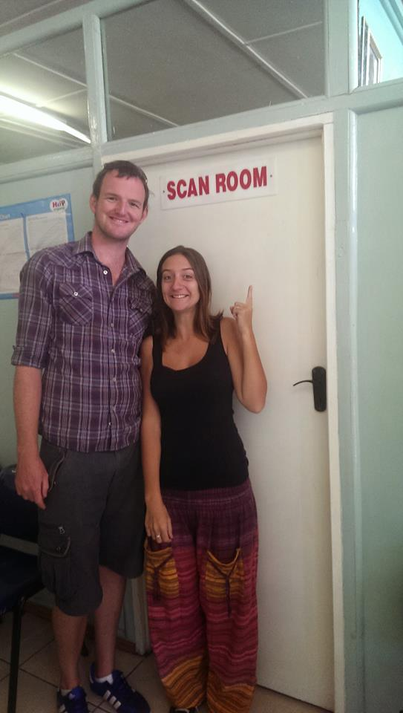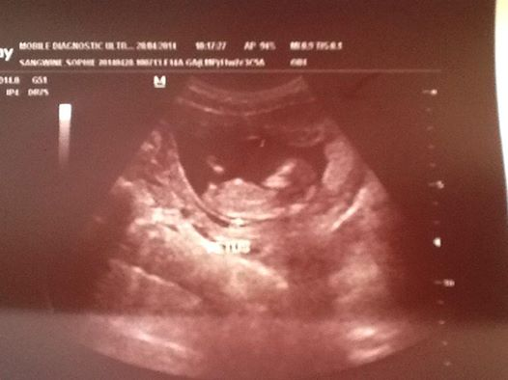
One Way School
Our first term ended with a fun day for all the children which included a water slide for the children (and bigger, teacher like children) to play on, games and face painting. It was a great way to celebrate their growth and progress and it increased the pot of money the pre-school has raised for next year’s primary school renovations. Total fundraising from school now stands at $1182 of our $2000 school target. I’m sure we’ll smash that target over our winter term.
Next term starts soon and we’ll be spending the whole term working alongside the ladies who are taking over the classes full time so they feel comfortable to work on their own next year.
In numbers One Way School offers 60 children (91 in total over the last 4 terms) full time education and 8 local people full time employment.
Grade 00 (Nursery-turning 4 that year) Teachers are: Auntie Lorraine and Auntie Leeshy who each have diplomas in early childhood development from Star Training College, Harare, Zimbabwe.
Grade 0 (Reception-turning 5 that year) Teachers are: Auntie Patience who is training for a diploma in early childhood development and Auntie Rumbi who is training for a certificate in early childhood development.
We also employ Prudence, Masline, Betty and Wilson who have roles such as a cook, administrator, cleaner, gardener, school nurse, security guard and parent/school liaison officer.
God’s provided the school with a great group of people who we believe are set to educate children in the school for many years to come. Thank-you to those who give on a monthly basis as 100% of your donations has gone to the training of these adults and they are incredibly grateful for their gift of education.
Holiday’s
My Mum and Dad (Ali and Dave) came to visit us and we travelled to Rhino Safari Camp in the Matusodona national park and then spent a wonderful time in Victoria Falls which fell over my birthday. We caught our own fish, had encounters with elephants, tracked wild lions, saw 77 new (to us) species of birds, canoed the Zambezi and I got to jump on a gorge swing so the holiday was absolutely amazing (see photos below!). There really aren’t sufficient adjectives to describe the beauty of Zimbabwe. Right now Mike and Sue are staying with us and that is just so lovely and relaxing as we sort our plans for our new family arrival as well as opening a primary school. It’s all a lot but we know that these things are God’s will and that He’ll make a way.
Please consider this an open invitation to visit us and Zimbabwe. We love having visitors and we’d be delighted to show you all that we are doing and the country that we now live in (and will always accept babysitters!)
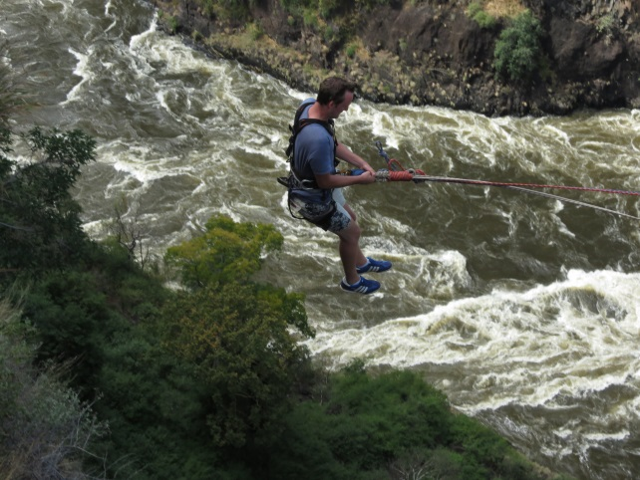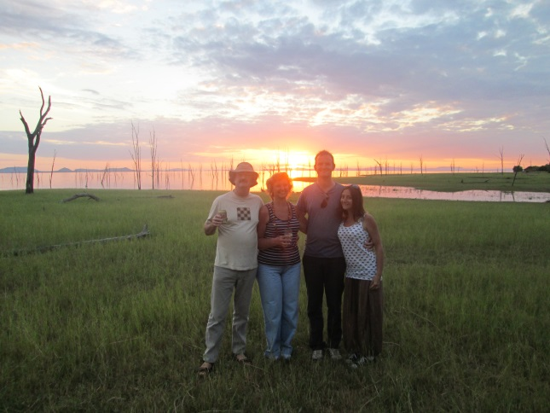
One way to celebrate turning 28…jump off a cliff into the Zambezi River next to Victoria falls!
Fundraising
As well as exciting holiday’s this month we’ve had some really encouraging e-mails from people with fundraising ideas. Coffee mornings, cake sales and sponsored swims are all due to happen to raise money for One Way School over the next few months. But for this newsletter I’d be delighted if you support Beckie Bowler (Sophie’s elder sister) in running 10k to raise us money. I don’t know how she has the time to train for this seeing as she’s just gone back to work full time in a new job, her two little boys have been poorly and are starting a new nursery and Matt (her husband) has been on crutches. We really appreciate her wanting to do something so why not pop over to www.hopeforharare.org to sponsor her. 100% of the money will go directly towards the $5000 international fundraising total for One Way School.
Prayer Points
- Thank-you God for One Way School
- Sophie’s health and the growth of our pistachio
- Beckie’s 10k run and fundraising
Thank you again and God Bless!
Sophie and Greg xx

