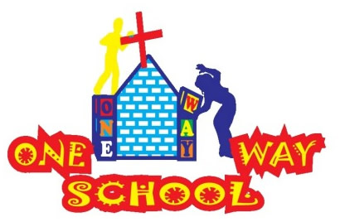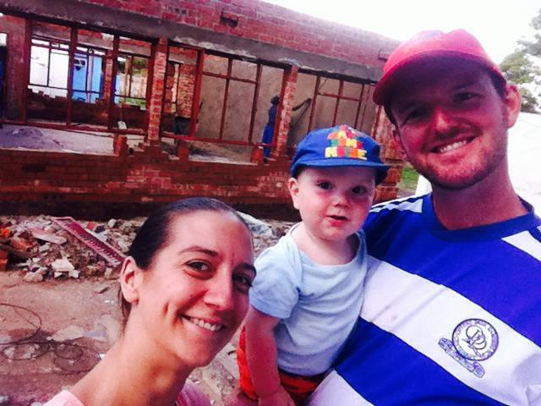

Holidays are over…and what a MEGA time it has been! We feel very blessed this month.

April 2016

SANGWINE NEWS  
Harare, Zimbabwe

**Dear Friends and Family,**

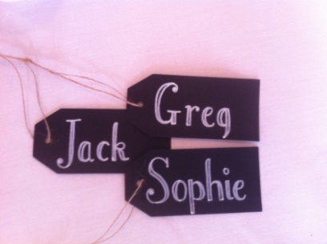

**News from last month’s prayer requests**

**Prayer Points**

* For a restful, fun and blessed holiday period for all of us Success!!
* For continued improvements in sleeping for JT Success!!!
* For a fantastic wedding for Andy and Sophie! HUGE Success!!
* For continued interest in registrations for the school Success!! (at least 5 new registrations so far!)
* For continued development works over the coming months Success!!! – Read below…



Wedding Vibe



Ginger ninja…

School

The new term is once again upon us and we have had a fantastic first few days. We have had a few new registrations most noticeably in the ECD which is where we needed them.

The school continues to do well particularly with teachers feeling more confident in their roles and taking on more responsibilities over time.

We are delighted that a local school, Hellenic Academy, have chosen us once again as their charity school for the year and after a brief meeting they have offered the following – to collect and provide sports equipment, to run a Fun Day and to bus our whole school to theirs for Sports Day (fun!) and also to allocate us a potentially large sum of financial aid in order to construct the Grade 4 classroom in August. WOW! What a blessing they have been and will be to us!

CHEESEEE!

Birthdays, Weddings, Family, Friends and a whole lot of Braais!

We have had such a wonderful holiday period, highlighted by visits from Sophie’s mum and also Andrew and Sophie Field (JT’s Godparents!) and Joe and Beth Travis, our long time friends – the three men all celebrated their 30th birthdays in the last month and so we celebrated this whilst here! Spectacularly, Andrew and Sophie also got married whilst here! We had a wonderful time at Pamuzinda lodge where they married on the island, canoed away from the ceremony and fed the giraffe at their reception! It was beautiful and we feel so, so blessed that they chose to celebrate here. JT was their ring bearer, which he did very well….until he asked for the rings back! Sophie’s mum passed through on her way to London to celebrate her 50th birthday, we had a wonderful week with her including her crossover with the guys above. We celebrated all events with some yummy braai’s and the creation of a mega burger!

Makorokoto to everyone! (Congratulations!)

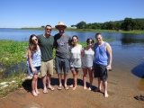

**GAP YEAR**

Are you a teacher? Do you know a teacher? Are you in need of a new challenge? Something a bit different for a while?

Come and spend a gap year here!

We’d arrange your accommodation, a vehicle to use, your visa and an allowance to live on. Inspired? Send us an email.

We are delighted to have Emily visiting us for the next 6 weeks to volunteer alongside the project!



***An invite – Please feel free to come to Harare to see us – all are welcome!***

Contact Info

[www.gregsophiesangwine.org.uk](http://www.gregsophiesangwine.org.uk)

[gregandsophiesangwine@gmail.com](mailto:gregandsophiesangwine@gmail.com)

[www.onewayschool.co.zw](http://www.onewayschool.co.zw)

**Prayer Points**

* That One Way School would continue to develop and grow especially in teacher development
* That we would seek God first and foremost in all decision both short and longer term
* For the country as it struggles in desperate economic times