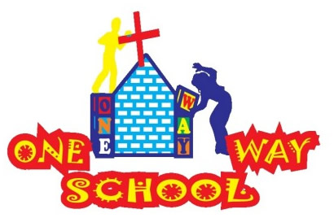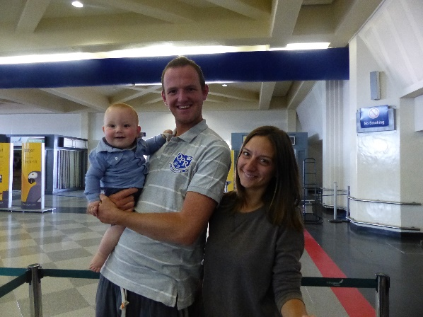

**Dear Friends and Family,**

SANGWINE NEWS

August 2015

**EXCITING UPDATE!**

Thank you to everyone who has been praying for our visa situation. Our current visas were due to end in October 2015 and we had applied for 2 year extensions before we left; however after 6 weeks we had still heard nothing. We are delighted to announce that as of last week, we have not only been approved to have our visas extended, but for the first time we have been approved for 2 years rather than 1! This now allows us to remain with the project for the immediate future to ensure its sustainability long term and gives us time to make long term decisions as a family.

Today marks the first day of September, already! We have been back in the UK for nearly 5 weeks and in 2 days we return to Zimbabwe for the final term of the school year! We have had such a wonderful time on holiday with friends, family and church and are so grateful to everyone for making it so special!

**Developments**

Whilst we have been on holiday the intention was that Charles, our ‘go to guy’ for our building and development works, would take charge of continuing with ensuring we get the plans for the building of the two new classrooms Additionally, that the Library project being undertaken by Hellenic School could continue to go ahead and begin renovations. The last we have heard is that the permissions from the council for the building works to start had not been approved. Therefore, it is unlikely that there will have been much, if any building works for the new classrooms as yet. On the other hand we have heard from the Hellenic School that they were due to start work on the Library last week as they have raised over $1000 towards the project! So we look forward to seeing how far they have come with their developments.

**Library**

We have made two previous requests for kind donations towards the library project and we are delighted to have been completely overwhelmed by the sheer number of books and resources we have been gifted with! We in fact have so many that we are now planning on organising a part container shipping over the next few months to get all the books to Zim! So a HUGE thank you to everyone who has already donated books and resources. If you are interested in supporting us further with this project, we are in need of financial contributions towards the cost of the shipping in order to get the books to Zim, so please do get in touch if you are able to help us in this in any way! Thank you

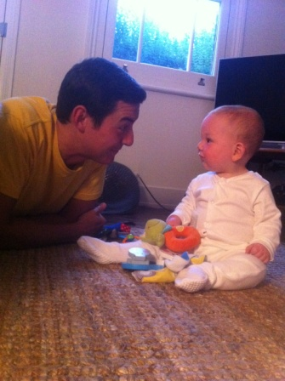

New Term

We arrive in Zim on Friday and on Tuesday the new school term starts. We will be busily preparing for end of term lessons, reports, graduations and developments so please do keep us in your prayers as we navigate our most hectic time of year!

We look forward to seeing what God has in store for us as we seek to stabilise the school with its staff changes and new roles and responsibilities as the school grows.

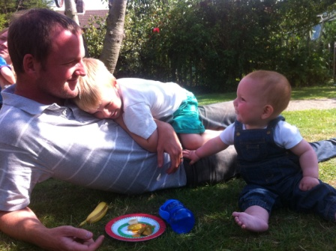

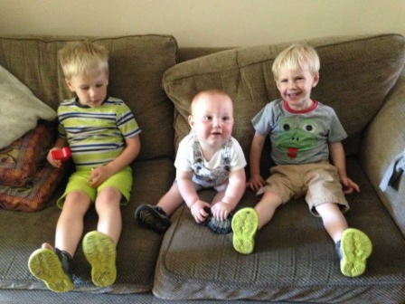

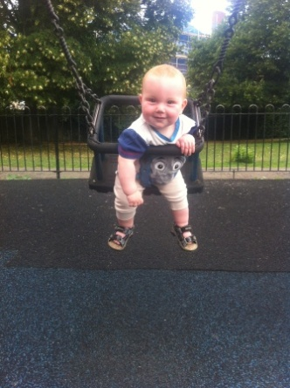

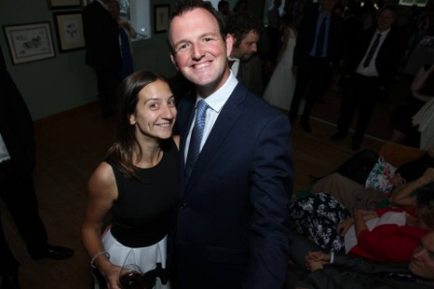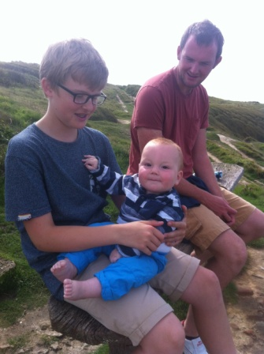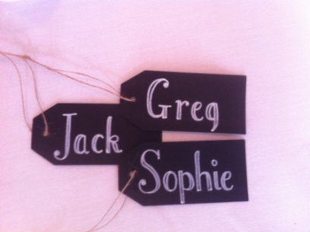

**Prayer Points**

* That all 3 of us would settle back into our daily routines
* That the developments would take place swiftly and with no setbacks
* That JT continues to grow and develop into the wonderful, happy, cheeky being he is becoming!

Contact Info

[www.gregsophiesangwine.org.uk](http://www.gregsophiesangwine.org.uk)

[gregandsophiesangwine@gmail.com](mailto:gregandsophiesangwine@gmail.com)

[www.onewayschool.co.zw](http://www.onewayschool.co.zw)