December Newsletter 2013 gregandsophiesangwine@gmail.com www.gregsophiesangwine.org.uk
Dear Friends,
One Way Pre- School
Back in July 2012 we stood in front of around 40 people at a Catford Community Church prayer meeting and boldly Said “we’re going to Zimbabwe to open a pre-school for a church” We always believed it was God’s will so therefore it’d be a success but I don’t think there’s anyone who thought it would have been as big of a success as it’s been. We estimate we had nearly 200 guests at our pre school graduation and our 20 graduating children performed so brilliantly making their teachers extremely proud. We’ve given full time employment to 6 local people, educated a total of 61 children and managed to do all of this in a financially stable way. The local early childhood development officer recently commented during an inspection that we’re the strongest up and coming pre-school in Harare and we couldn’t have done that without everyone’s support.
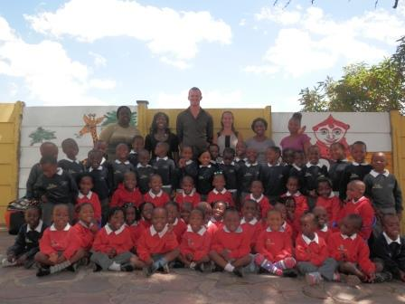DISCLAIMER: Picture by Miss E. Glass.
One Way Primary School
Pre School education is very varying in standard and expense in Zimbabwe but most children do go to primary school. However, the government primary schools are no longer funded so charge school fees for un-resourced schools with often 55 children in a class with 1 teacher. A primary school is really needed in our local area and our building has the capacity for this to happen. We have recently proposed that we could open a grade1 and grade2 (Year 1&2) in January of 2015 with two classes of 30 children. It is certainly ambitious but we believe that when you are successful you must keep going not just step back and stare at what has been done. The children in the pre-school will then graduate to the primary school and each year we will open another year group until we have a whole one form entry primary school.
Fundraising
We are certain we can do it and have estimated we need $10,000 US to make this a reality. Our pre-school will commit to raise $2000 over the next few months through cake sales, family fun days and sponsored events. The church we support will commit to raising $3000US and we’re aiming to raise $5000 (3226 pounds) internationally for the remaining funds. If you would like to do something like running a race like Santi at the London marathon or want something else exciting to help us raise the money then please do contact us.
Maybe you’d like to be involved in collecting resources for our school that we can then have shipped to Harare. Or perhaps you’d like us to send some Zimbabwean clothes, bags or ornaments to you so you can sell them at your local church to raise us some money. Sophie and I have already committed to raising some of the money by offering our spare time to tutor local children.
Teacher Training Course
A few weeks ago we educated 25 local teachers over a 2 day course. We built good relationships with 12 current schools and 2 new schools which we have committed to helping in the coming terms. We’ll be heading into their schools to offer all sorts of help and advice but the current plan is just to support with knowledge, help and advice as we continue to build relationships with this people. In the future maybe we will be able to help these schools out with money and resources.
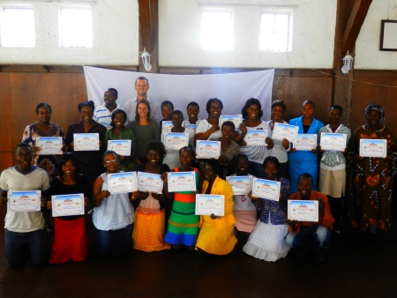
Holidays
Since term finished we’ve been taking the role of tourist to a new level. We’ve travelled to Kariba in the west of the country and to Nyanga in the east and Merv the Mitsubishi has served Sophie, Ella and I very faithfully in his long journeys. Zimbabwe is an amazingly beautiful country and the people we’ve met and the places we have stayed have helped to increase our love with this beautiful country. Many pictures and stories can be found on our website.
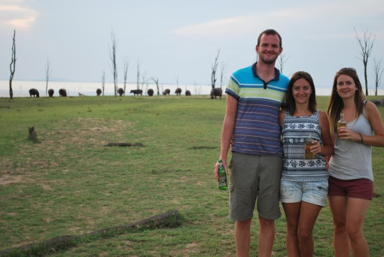
Websites
Both our websites have more pictures and content so please do have a look over the holidays and send them to your friends and family. Zimbabwe gets some bad press but we can tell you from our experience that it is a beautiful country with some amazing people. Let’s make 2014 a year where we can spread the good news from this great country. We realise we’ve been poor on the blog writing front so one of our new-year resolutions will be write a few more to keep you updated on the little things that occur in our random lives!
Happy Christmas
Thank-you; once again for reading our newsletter and praying for our work here in Zimbabwe, we hope you all have an amazing Christmas and a Happy New Year. We’ll be celebrating in our amazing little Christmas palace once again.
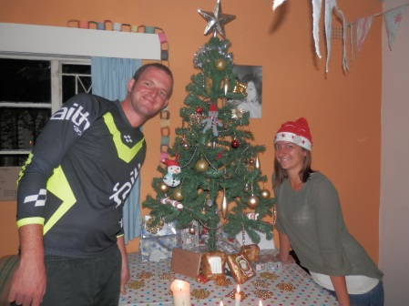
Feedback on November Prayer Requests
Teacher Training Course – We had an amazing time over the two days, built great relationships and we had enough funding to do everything we wanted at no cost to our pre-school finances.
2014 projects – On-going prayer needed for our guidance.
Prayer Requests
- One Way Primary School plans
- One Way Pre-School new children and continuing students
Love Greg and Sophie xx

