December Newsletter 2014 gregandsophiesangwine@gmail.com www.gregsophiesangwine.org.uk
Dear Friends,
Sorry for this being a couple of days late, it has most certainly been a hectic end to 2014 and start to 2015! We are writing this seated back in our pre-school office surrounded by the staff of One Way School readying the building for the new year – Exciting!
Greg, JT and I arrived back in Zim on the 29th December after an overnight flight. Naturally a little hesitant travelling with a 2.5 month old baby, we were pleasantly surprised at what a superb traveller JT is! He slept, ate and made friends – and we touched down in Zim with 30 degree heat and so he was even happier when we got to the cottage and let him laze around in just his nappy all day! We have settled in well, spending a little time readying our cottage back to its homely self and introducing JT to Alex! He is sleeping really well (probably the humidity helps!) but it is very rainy this week – supposedly the sunshine will be back in a few days! We have spent a little time catching up with friends and getting back into the swing of our daily routine!
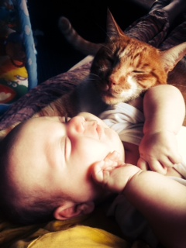
Pre school
The Pre-School has continued to go from strength to strength and the staff successfully completed 3rd term including school trips, graduation and Christmas! We are immensely proud of their self-sufficiency and the parents have been very complimentary. We are pretty much full for the intake for this year for ECD A and B already so this is great signs!
Primary school
For now, I will let the pictures below do the talking in terms of the Primary School developments, but again we are immensely proud of the progress that has been made with renovations and with registrations. Paper work is in place, curriculum is nearly ready, classrooms and office are nearly ready and the staff are excited! Due to a roof leak, there is still some decorating work to be done, however by the end of next week we should be ready to go. Once we have sourced and bought some resources also…! Could be a busy week!
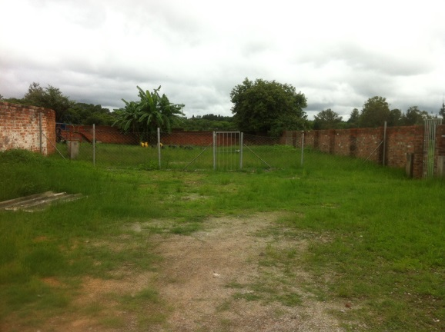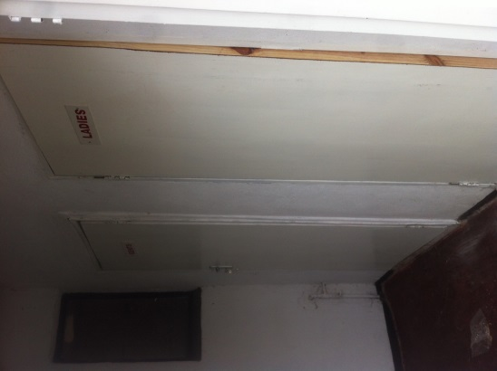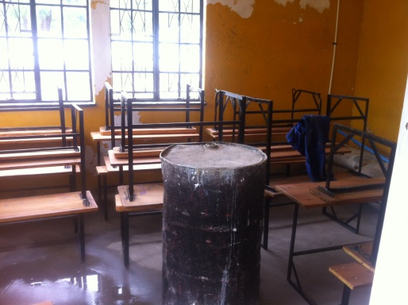
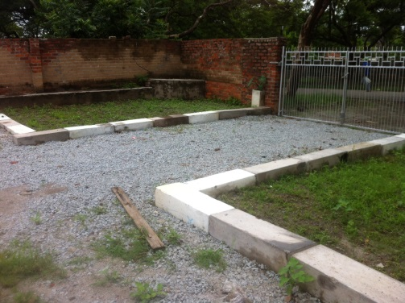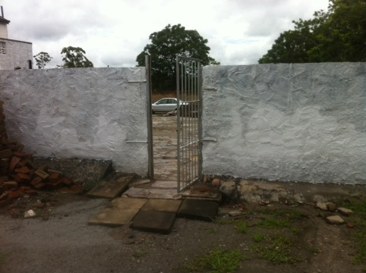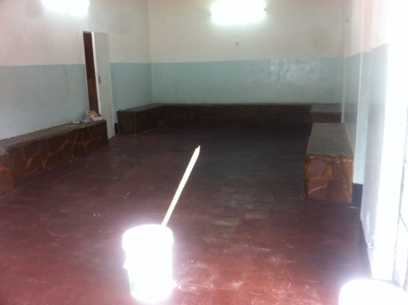
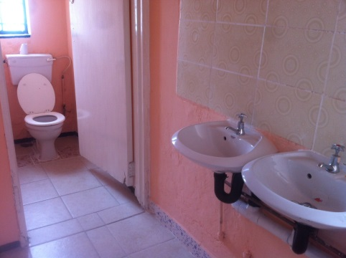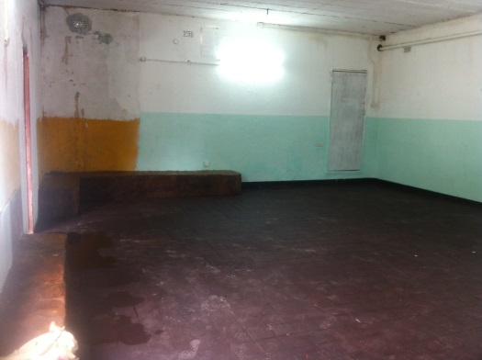
The immediate future
Currently, we have a visa until October (JT currently has one until June – to be rectified in the next few weeks). We are awaiting the opening of the Primary School, and then this first term will be a huge influencing factor in our longer term plans. We will be spending time exploring the possibilities for the school, meeting with the leadership of the church to discuss their vision, and spending time as a family discussing our future. We are taking each week as it happens and thoroughly enjoying the adventure!
Prayer points
Thank you God for the staff of One Way School and their incredible attitude to work and their relationships with each other and the children
Pray for continued registrations for the Primary School – particularly Grade 2
Pray for settling in for all 3 of us, country adjustment for JT and a work, home balance for all of us
Pray for a successful first few weeks back for One Way School
Thanks
We would like to say a huge thank you to all those who have supported us, blessed us, prayed for us, sent us encouragement and made our time in the UK so wonderful. It was a blessing to spend so much time with our friends and family and bring JT into the world. We feel utterly blessed and look forward to hearing from you all soon.
Thank you again and God Bless!
Sophie, Greg and JT xx

