February Newsletter 2014 gregandsophiesangwine@gmail.com www.gregsophiesangwine.org.uk
Dear Friends,
We cannot believe we have come to the end of the second month of 2014 already! So much has happened and is happening and we are excited for what God has planned for us over the coming months.
May we begin by saying a huge thank you to all who continue to pray for us and support us through encouragement and messages of support; we are lifted every day knowing that we are not here on our own!
One Way Pre-School
The Pre-School continues to go from strength to strength. Auntie Patience has just completed her final exams for her Certificate in Early Years and has passed so is now a qualified teacher- Congratulations! Auntie Lorraine has re-taken some of her exams for her diploma and we will be celebrating both their graduations in the April holiday – Congratulations again! The children continue to make excellent progress and we look forward to introducing new members to the staff team in the second term as both Greg and I will be reducing our hours at the school to begin handing over complete control to the Zimbabwean team – Praise God!
One Way School
As mentioned in previous letters, our intention is to open a Primary School in January 2015. This is a ridiculously exciting venture and we are keen to get started! A meeting was had this week between our administrator; Prudence and the local Government inspector for ECD centres – who has previously inspected us and said he is impressed! They discussed logistics of building planning, space allowance, registration, paperwork and permits for the Primary School – this was a hugely productive meeting which produced the following outcomes –
- Permit for a Primary School is exactly the same process as when we applied for the Pre-School, so we know what is needed and how long this should take – big relief. This is the only document we desperately need to open the Primary School – so we pray for a speedy acceptance!
- There are no issues with the amount of space required for the school as we more than cover for it with the rooms we intend to use and the outdoor area available to us.
- As a private, non-governmental school, we are able to produce our own curriculum and assessment scheme including term dates, timetables and registrations – a big surprise, but exciting for freedom to incorporate the Zim, UK and Church curriculum!
- City Health Certificate – this is necessary for the school to register with the Ministry of Education, however other schools we have spoken to, have taken 3-5 years to receive their certificate! We can open without this and register with the ministry at a later date. However it would be beneficial to receive it speedily!
Fundraising
Again, we say thank you to those of you who are able to support us in any way financially – both personally and for the project. It is a huge support to the work we are doing and allows us the freedom to work on more than one project at a time! As previously mentioned, we intend to raise around $10,000 to fully open the Primary School including the outdoor area.
One Way Pre School has currently raised $160 over two dressing up days including a ‘fancy dress day’ (they thought that meant wear your fancy clothes!) and a pyjama day – where even the staff joined in wearing dressing gowns and slippers! We intend to have such days once each month raising around $5-600 through the year.
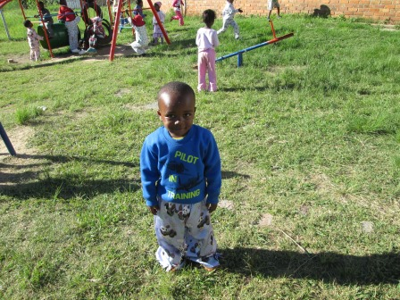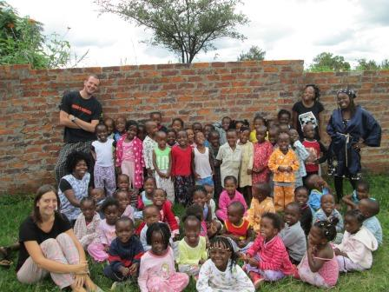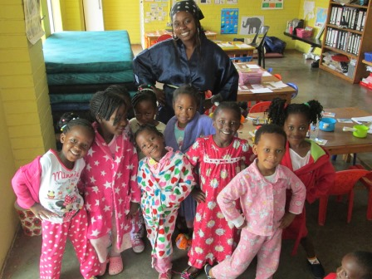
The Staff at One Way Pre School is also using their skills and knowledge to hold a FunPo (Fun Day/Expo!) on the 8th March at the church centre including Jumping castles, water slides, clown, dance troupe, penalty shootout, car wash, car park expo and a multitude of food goods! They have organised this completely independently and Greg and I are excited to attend and hopefully help to raise as much as we possibly can for the Primary School – Praise God that they are feeling confident and working efficiently as a team to run this without our support! This will be an excellent opportunity for the local community to meet with the Church Pastors and find out more about the Primary School.
The Staff are also hoping to raise funds through creating a small tuck shop/ bits and bobs stall which they will run from the Pre-School at the end of each day. Again, they have created this initiative without support and we are excited to see how much they can raise!
If you are able to support our Primary School financially in any way – perhaps a sponsored something or a one off donation – we would be eternally grateful and would love to feature your support on our website! Please contact us if you are able and willing!
Epworth
One Way Pre School in Epworth has registered 10 children since its opening a few weeks ago and are expecting more at the beginning of March. We are hoping to visit and support them with their planning and teaching techniques in the following month. They have both spent 2 days at the Pre School in Mabelreign learning how the day is run and how to teach basic lesson structures – we hope to develop on this on our visit.
Hatcliffe
The teachers in Hatcliffe who attended the teacher training course in December, have communicated to our contact in the community, that they would be grateful for some further phonics training as they are attempting to implement all the aspects of our curriculum, planning and assessment into their schools – however they are struggling to grasp the concept and teaching styles for phonic teaching. I will be spending the 28th of March in the community visiting each of the 7 pre-schools to see how they have implemented various aspects of the course into their classrooms, and spending the afternoon doing some intense phonic teaching training with the teachers. It is encouraging to hear requests for further training!
Church
One Way Ministries is a large Pentecostal Church with many members and is a lovely family to be a part of who have supported us well over the past 18 months. When we began, it was beneficial to create connections with the local and church community and support the Church who we were opening a school for! Over the past few months, our Landlord (who is a HUGE support!) has recently relocated his own Church to an old cinema complex in the local area. Greg and I have attended their Church on a number of occasions and begun to build friendships and relationships there. It is an NF Church- called One Church (we seems to like the number One!) and we have felt comfortable as the Church environment is much more similar to what we are used to from home. We are keen to develop our relationships with the One Church Community; however we do not want to lose our relationship with One Way Ministries. We are prayerfully considering our future with regards to our permanent church base, and would appreciate your prayers, words of encouragement and advice as we consider our next steps.
Prayer Points
- That the paperwork process for the Primary School would be quick and efficient
- That fundraising for the Primary School would be fruitful
- That we would hear from God regarding our Church family
Thank you again and God Bless!
Sophie and Greg xx

