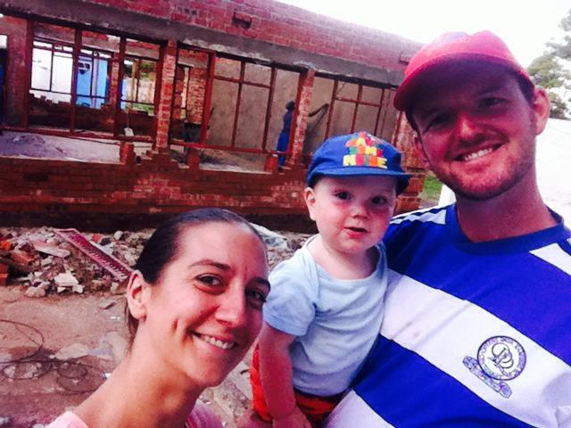

February has come and gone in a blur. It’s been a month of huge successes and great blessings so we hope you enjoy reading all of our GOOD news.

February 2016

SANGWINE NEWS  
Harare, Zimbabwe

**Dear Friends and Family,**



**News from last month’s prayer requests**

**Prayer Points**

* Thank God for the answered prayers aboveWe’ve had so many blessings recently and we are hugely thankful to God for seeing us through a difficult time.
* Pray for completed building work soon – Done ☺ Yay!!
* If someone could pray for QPR I’d appreciate it – 1 win in 12 ☹ Fortunes have changed but not really results. More prayer needed ;)

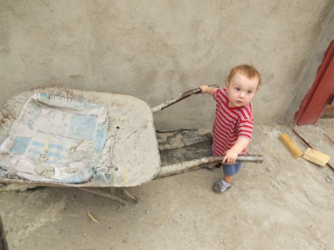

“helping…”

**New Classroom**

This weekend the new classroom has been completed. We were donated a very generous 800 pounds from everyone at Catford Community Church to cover the majority of what was taken from us by the contractor. There was a very noticeable change in the mood of the staff and parents when the work all began. The roof was built, the walls plastered and the floor was laid. We’re hoping to move the children into their new classroom on Tuesday or Wednesday once painting has been completed.

As you can see from the pictures it’s half of a whole building as there is still another classroom to build next to this one. The aim is to complete the building of this classroom in the August holiday when Sophie and I will be in England. We have already sought quotations and are estimating around $6000 for the completion of the school.

We will update our website with a new folder of recent pictures of the whole school ASAP for your viewing pleasure!

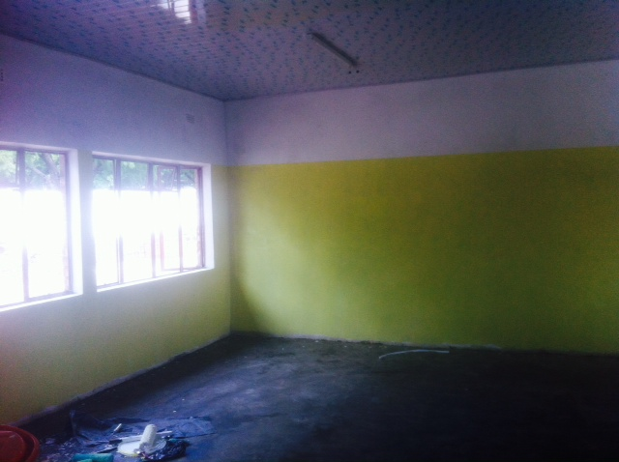 Yellow Walls!

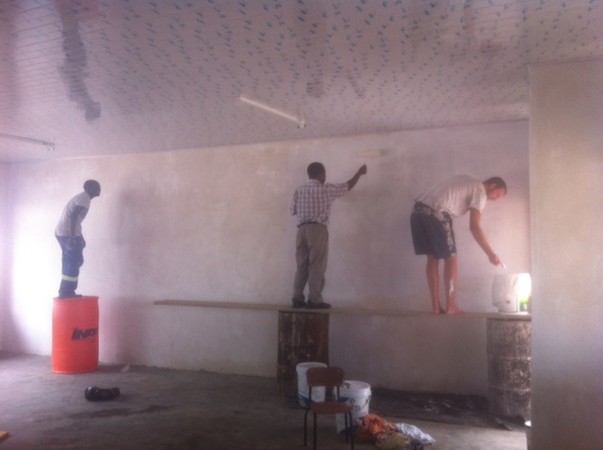

Painting – Wilson, Mike and Greg

**One Way School teaching and learning**

We’ve been very proud of the progress of the children already. Leeshy and Rumbi have teamed up this year in grade one and teach the class with confidence and excellence. They’ve got the classroom wonderfully organised; integrating child initiated learning into their teaching creating a lovely transition between the early years and primary school. I genuinely believe that early year’s teachers are the most skilled of us all – they have such a high knowledge of learning styles as they are aware of where the children have come from and teaching in practical ways is always the best way. (That’s probably why the new curriculums talk so much about application of skills) If you’re a teacher reading this then request reception in the future - I’m certain that teaching that age has made me a much better teacher.

This Friday we had primary school consultation and a parents meeting and shared how parents can help their children at home. One of the greatest complaints I get from parents is that their children need a lot more homework. It would appear to me that at a lot of schools, not only do parents pay school fees to send their children to school; they also spend an hour or two in an evening also teaching their own kids homework that they don’t know how to complete.

The meeting was excellently received and one parent commented that I have challenged 50 year old views and that they were so grateful for our school’s high standard of education. It really is so special to use the knowledge and skills we have from our own education and relatively short teaching experience to pass on to a group of parents who value education so highly.

**GAP YEAR**

Are you a teacher? Do you know a teacher? Is that teacher in need of a new challenge? Something a bit different for a while?

We’d love to have fully qualified teachers over here for a year or more to share with us your knowledge and expertise. Teach a class, work with the teachers here and assist Sophie and I with the training of more local teachers.

We’d arrange your accommodation, a vehicle to use, your visa and an allowance to live on. Inspired? Send us an e.mail.

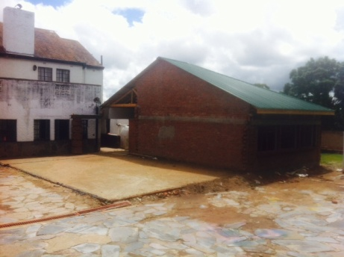 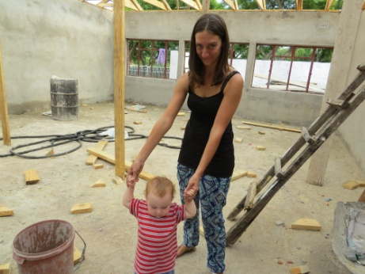 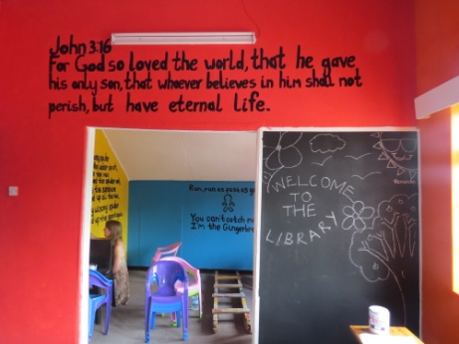

New Classroom! Health and Safety Check… Library with lovely quotes!

***An invite – Please feel free to come to Harare to see us – all are welcome!***

Contact Info

[www.gregsophiesangwine.org.uk](http://www.gregsophiesangwine.org.uk)

[gregandsophiesangwine@gmail.com](mailto:gregandsophiesangwine@gmail.com)

[www.onewayschool.co.zw](http://www.onewayschool.co.zw)

**Prayer Points**

* Please pray thanks to God for his faithful hand over the work here, trials have become triumph!
* Please pray for energy for the next 4 weeks until the end of term, they are mega busy!
* Our Primary School is full, amen! Please pray for further ECD registrations.