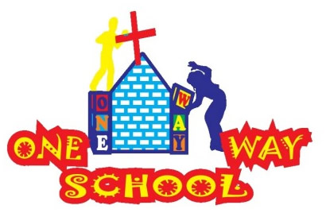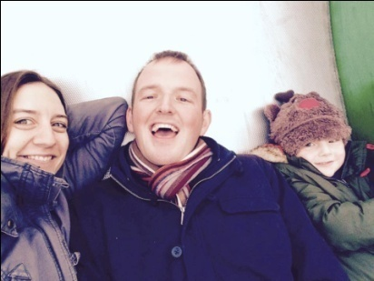

***Anyone else feel like 2017 is moving at a serious pace? So fast in fact that we wrote a Feb newsletter, then forgot to send it, and suddenly March disappeared too!!***

***So…here’s a double month whammy for you! Sorry for the delay…again!!***

February/ March 2017

SANGWINE NEWS  
Harare, Zimbabwe

**Dear Friends and Family,**

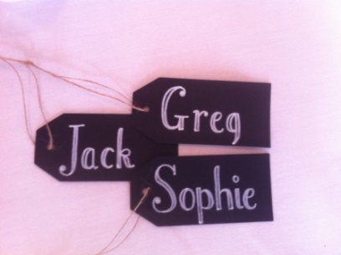

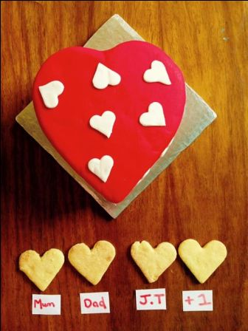

**News from last newsletter’s prayer requests**

* Thank-you God for our 6 completed classrooms, 15 new laptops and laptop trolley and 3 new staff members. We have received 5 and the remainder are coming, the trolley is nearing completion!
* Please God can we have 150 pupils on our register – WE DID IT!
* Please God grant us the vision for the continued growth of your school so we can complete the primary school with grade 5, 6 & 7 classes – too many ideas…none perfect yet, keep praying!

**Our life is about to get a whole heap busier!**

As your eagle eyes may have spotted, on various social media sites, through the grapevine or in the delightful picture above, we are delighted to tell you we are expecting a second little peanut in September! JT is excited to be a big brother however he currently has no idea what that means, other than that Mummy keeps feeling unwell and he offers “Meno” (his version of medicine) and also keeps pointing to his or Greg’s belly and also exclaiming BABY! Fortunately, the illness phase has now worn off and we are around 15 weeks along – exciting!

Due to this addition, we have decided to take a small sabbatical from July to November back in the UK in order to gain some R+R and also to spend quality time with family and friends. We will be flying via NYC to visit Mike and Sue on our way to London – life is an adventure!

We are therefore very busy at the moment with continuing to support the school and the teachers to build up their knowledge and experience in order to take on more responsibilities in their positions whilst we are away. We also continue to have discussions regarding the future of the school project and also our involvement (see more below!)

We were delighted to have Greg’s parents visit us a couple of weeks ago and are just as excited that we have Sophie’s parents visiting in a couple of weeks from now! Having family visit is such a huge blessing to us.

JT continues to keep us on our toes and is the funniest human we’ve met, and also the bossiest! (Takes after his father I’m sure) He is spending more and more time in the Nursery class and we are constantly astounded by how much information he retains – including his ability to scare us and ask things in Shona! We are going to need a translator app for our own child soon..!

One Way School

Things continue to move, shake and develop with the school project each day/week/month. Primary School is now at 113 children and the pre-school has 37 children. We remain astounded every time we take a walk around the school and observe classes/teachers and monitor the children’s progress. We are so thankful for the environment that One Way School has and the family unit that God has been created. “One Way School is a place where children, staff and visitors feel love the love of God each time they enter the building” said a recent visitor who said they were a friend of a parent.

We continue to work on brainstorming potential options for the development of the Grades5/6/7 classrooms and after a meeting in which Sophie felt rather deflated, potential solutions are now being found that are actually quite good! We are still in an unsure position regarding whether there is a possibility of registering as a Primary School without needing the crazy amount of land space, however this is not confirmed and causes just as many issues! However, we found out that we do not have to register separately as a pre- school and then as a primary school, which is a huge blessing logistically and also financially!

We have also decided not to employ an administrative assistant but raise the expectation/responsibility of the current administrator. We have, yesterday, just employed a Grade 2 teacher! Prince will be starting in 2nd term working alongside Greg to then take over the Grade 2 class once we leave for the UK, praise God!

**Zimbabwe**

2017 has been a rollercoaster thus far and we are only 3 months in. Economically, we are all struggling, particularly with seriously limited cash supplies and banks which are unable to cope with the volume of people using them and payments/ transactions not being registered due to overloading – which naturally is causing some problems for businesses and personal transactions. We continue to pray for the leadership of the country that they would have wisdom and guidance on how best to progress the country forward.

In addition, we are seeing decline in the infrastructure of the country with some roads almost impassable due to crater sized potholes created from the recent intense rainfalls. Rubbish is accumulating due to lack of waste disposal options and many shops and industries are closed with many empty offices and shops. The flea markets and the CBD street vendors are also struggling to maintain any form of regular income and as with any crisis it always hits the poorest the hardest. Finally, hospitals and schools are also struggling as a result of a lack of resources and employers inability to pay wages. Please do pray with us for our wonderful country.

We’ve had people say to us before that what we are doing is ground breaking…however that took quite a literal turn yesterday when we experienced our very first Earthquake!

Our ornamental giraffe took a good wobble, our water glasses were rippling and our bottoms got a massage from the shaking sofas – but no structural damage to report! Apparently the quake originated in Botswana and was felt in SA also – life is such an adventure! Never a dull moment in Zimbabwe…

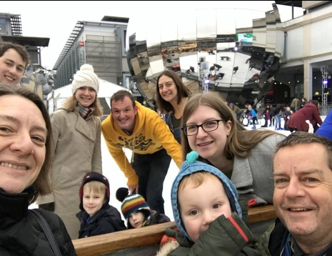

Contact Info

[www.gregsophiesangwine.org.uk](http://www.gregsophiesangwine.org.uk)

[gregandsophiesangwine@gmail.com](mailto:gregandsophiesangwine@gmail.com)

[www.onewayschool.co.zw](http://www.onewayschool.co.zw)

**Prayer Points:**

* For health for all three (four) of us
* For One Way School as we transition through various stages over the next few months
* For the country of Zimbabwe, the people and the leadership, that there would be hope and light.