January Newsletter 2014 gregandsophiesangwine@gmail.com www.gregsophiesangwine.org.uk
Dear Friends,
This is our 20th Zimbabwean newsletter so if you’ve read them all you’ve certainly done a lot of reading! Thank-you and please do share this with your friends or family and help us spread the word about our Zimbabwean projects.
One Way Pre- School
We are full! This means both classes have 30 children. It’s been a crazy month with many new faces. Greg’s class consists of 24 continuing children from last year with 6 new children. These are the pre-school leavers class (reception) and they’re well settled showing excellent learning. In Sophie’s class she only has 6 children from last year and 24 new children, most of which have just turned 3 and are not speaking English yet. They are a handful to say the least. Our education system gives them a freedom they haven’t had before so I’m sure you can imagine the difficulties. But Sophie is a hero and their progress is already highly evident. This is punctuated by a rather cute “unboo Beg – ease I go a tollet?” comment (Translated into English – “Uncle Greg – Please can I go to the toilet?”.) !
One Way Primary School
On opening the pre-school we got a permit to run the school as a church project and the primary school will be the same. Pastor Musora, on behalf of One Way Ministries is in the process of getting together all relevant licences and documentation. They are optimistic and excited for the prospect of primary school education. As often happens in the UK, the government have recently changed their policies with regard to pre-school education. As of next year all primary schools have to have a grade zero (reception) class – as opposed to just starting with Grade One. Additionally, pre-schools like ours will no longer have nursery classes but have grade zero and grade zero-zero. All this jargon means that next year we will have Grade 0 (Children turning 4) Grade 00 (Children turning 5) Grade 1 (Children turning 6) Grade 2 (Children turning 7). This will also mean One Way Pre-School will not separately exist anymore and will collectively be One Way Primary School.
Fundraising
4 classes is our goal for next year but for that to happen we need to raise $10,000 towards the renovations. Fundraising ideas have already been coming in as we hear Beckie Bowler will be running a 10k in May to raise funds and Beth Sangwine, Ali Sangwine, Sue & Mike Burn and Andy Field have all agreed to sell African products to raise money. Here in Zimbabwe we are also on the fundraising trail as Monday 27th January was our first fancy dress fundraising day. It was hilarious because the Zimbabweans interpreted this as your ‘fanciest’ clothes which meant we had girls in dresses and boys in suits at school whilst Sophie was dressed as a carrot and me dressed as superman! Despite these different interpretations we managed to raise $48 towards the project. It is vitally important to us that the children and their parents feel an ownership over the school and that they are part of raising the money themselves.
Fundraising breakdown: $5000 raised internationally, $3000 raised by One Way Ministries, $2000 by the children and parents of One Way Pre-School.
One Way Pre-School Epworth (& Others)
One of the visions initially outlined to Sophie from this church was the idea that our pre-school would be a pilot for other pre-schools. Across Harare, One Way Ministries currently has 5 church centres, In Mabelreign, Dzvarisakwe, Highfield, Greendale & Epworth. The combined congregation from these churches is around 600 people and Pastor Gatsi would love to have pre-schools in all these places. Sophie and I have not committed to running any of them but we have said that we’ll help train adults in those schools and aid them however we can. In Epworth, Pastor Chidewu has opened his pre-school and they are expecting 25 children at the beginning of February. It’s great to see the local people being positive about their future with these schools being built. Also, we fully expect the centre in Highfield to open before the end of this year. That would make 1 primary school with 120 kids and 2 pre-schools with 60 kids in each. That makes the current goal that 240 children will be educated in One-Way-Ministries schools in 2015!
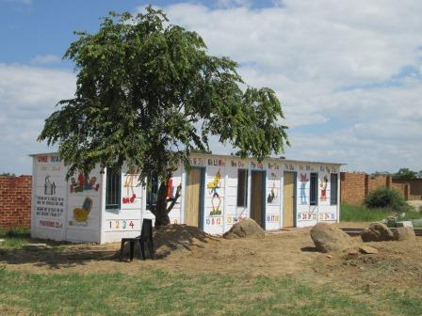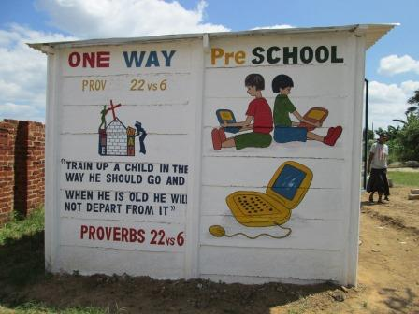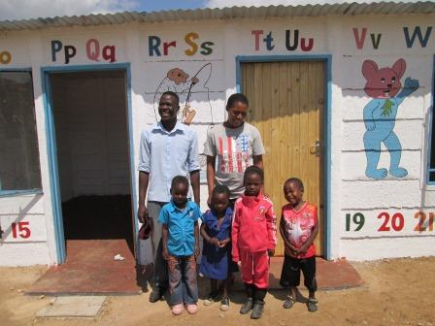
Teacher Training
As you know, Lorraine, Sophie’s assistant and Patience who is Greg’s assistant have been working with us with a view to taking on the running of our classes permantly in September. At the time of writing this they are both writing exams in early childhood development to become qualified pre-school teachers.
In April they graduate with:
Lorraine: A diploma in early childhood development
Patience: A certificate in early childhood development
We want to celebrate this news because they have worked so hard and they’re such great people. We know we are leaving our 2 youngest classes in great hands as we leave to teach the older children. Please do read our latest blog ‘Educating Adults’ to find out more about our current staff.
Hatcliffe Outreach
Sophie has visited Hatcliffe twice this month and was so encouraged. We educated 14 teachers from Hatcliffe in December and she visited schools there which are now using focus tables, doing phonics lessons and have implemented areas of learning into their education. They really have applied what they have learnt from their training. Next term (probably May or June) we’ll be doing another course to build on the learning from the last one and this time we’re less scared and more excited about the prospect! The intention between now and then is for the schools to ask for specific help – which we can then provide on a needs basis.
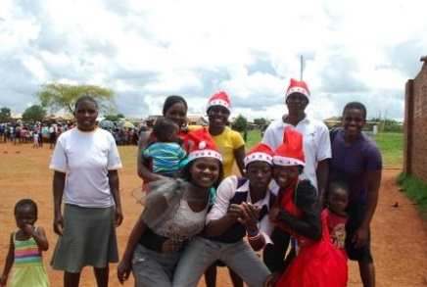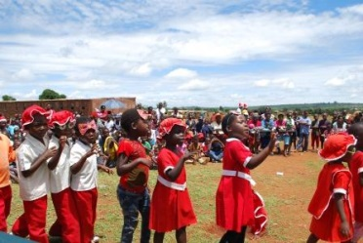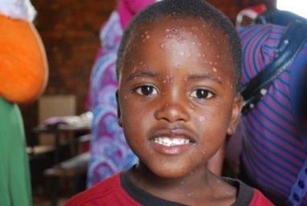
Some Hatcliffe teachers combined their schools for a Christmas performance and outreach!
Gap Year?
Have you or one of your friends ever fancied a year abroad? If you’re a qualified teacher or have experience in a school and are tired of your current job and want to do something completely different then please contact us. We’d love to offer anyone a job who wanted to serve us for a year or maybe longer. We’d be able to offer you accommodation, a car and a monthly allowance so you can do some travelling around Zimbabwe or to other southern African countries. You would receive 3 months off in the year – April, August and December – perfect for some extra travelling! Maybe a year is too long and a few months would be better – we could do that too. Please send us an e.mail if you are interested- or spread the word!
Blogs
We’ve been a little better in the blog department this month –Ella requested more third person blogs as she loved the ‘Save Matty’ blogs so expect a few in February!
Prayer Points
- Please begin praying for us by thanking God for the provision of this school, the pupils and teachers. Our growth has been greater than we expected and only serves to increase our faith that these projects are God’s will. Giving Him thanks will be this month’s largest request.
- Primary School paper work
- One Way Pre- School pupils
- Lorraine, Patience, Prudence and Rumbi as they continue their professional studies
- Fundraising for future developments
- Water – electricity is a pain when you’ve planned an interactive lesson but we’ve learnt to cope well with it. However we continue to have weeks without water in the school. 60 kids, 4 toilets, 1 urinal, no water = ahhhh!
Thank you again! God Bless, Greg and Sophie x

