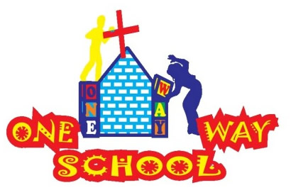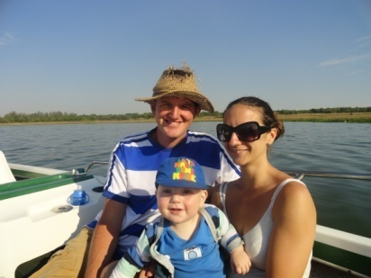

January 2016

SANGWINE NEWS  
Harare, Zimbabwe

**Dear Friends and Family,**

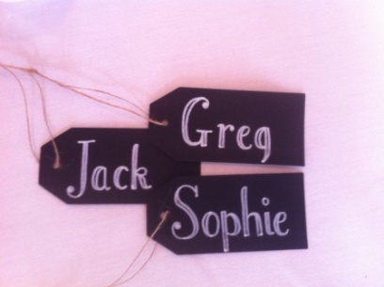

2016 is here and with it our fourth full year of operation at One Way School. Scary!!

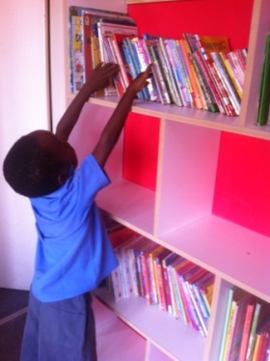

**News from last month’s prayer requests**

**Prayer Points**

* Health: We’ve all been doing much better recently. Greg has some new inhalers prescribed for his asthma, JT has been fighting off his nasty cough and Sophie’s headaches are reducing in number. Thanks for praying.
* Fundraising – we managed to secure all the necessary funds for the building of the roof due to your awesome generosity.
* The building work is not complete – we’re still waiting for a roof (more info below)

New library

**New Classroom**

Just before Christmas; the 18th of December to be precise, we received all the necessary funds to stick a roof on our new classroom. It meant that donations from the UK since September tipped over the $4700 mark which was just an amazing provision for the next generation of Zimbabwean leaders and we are so grateful.

Unfortunately, due to a lot of reasons we fail to understand, the money that was passed to the contractor to buy all these materials for roofing has only yielded 37 planks of wood thus far. I am very sorry that at the moment your kind monetary donations have not be used for the desired cause and I can’t apologise enough. The deal with the contractor was that we’d pay for the materials in full and then have money to pay at the end upon completion of the roof. We are, of course holding that money because in the last 6 weeks they’ve not managed to complete anything at all. Sophie and the new administrator; Mike, in collaboration with the One Way School PTA, are communicating with him and we trust that this problem will be rectified as soon as possible.

Once again, I apologise because we have always tried to be so careful that if you donate $$$ to the school you know where they’re heading. It is still the case that all the monies have been given towards the building project and this will come to fruition, we are just not sure of the timescale.

**Fundraising**

We are of the opinion that in order for this project to be sustainable long term under the responsibility of the Zimbabweans and the Church itself, we must try to ensure the school does not become financially dependent upon donations from abroad. We have been incredibly fortunate to have wonderful support from a huge number of people abroad and this has enabled us to continue the works we are doing.

This year, as you know, we are completing one classroom and building another. This will be the case for the next 3-4 years. We have discussed with the school leadership and PTA and made it clear that there must be a step up in terms of accountability for where the finances are being raised for these continued works.

This year, the school itself will be running various events such as an Easter Concert, a Fun Run, a Fun Day, a sponsored swim, dress up days and multiple cake sales/tuck shops. Combined with the church, whose youth group are hoping to raise funds along with members of the church and church leadership.

This is a huge step up for the people involved in the project and the mentality surrounding fundraising and support for the school. We are looking forward to seeing the change in people and watching them grow as they take responsibility for their school. Please do pray for this change as it is hugely important and one of the things we have been working towards since we began the project!

**One Way School 2016**

We’re so blessed to announce that we now have 105 children and employ 12 local people, full time. We managed to erect a temporary classroom which I am currently teaching the grade two children in. It’s at the back of the church auditorium cut across by a curtain. But, we’re making the most of the situation and the children are learning well. Sophie has taken her new role as ‘Head of School’ by storm and has everything, and everyone, organised brilliantly. Our name continues to spread as an excellent place to bring your child for school and we think that our numbers, come May, are more likely to be around 120-125.

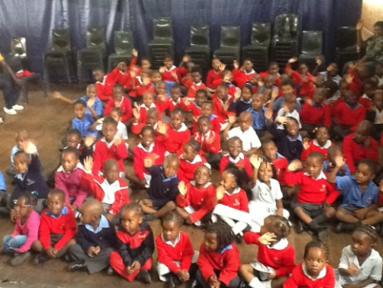 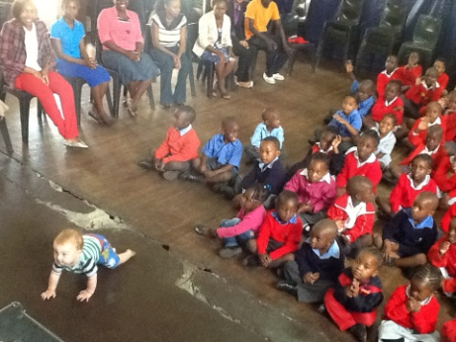 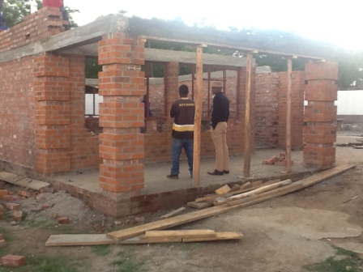

Assembly JT ‘*sitting’* in assembly New classroom

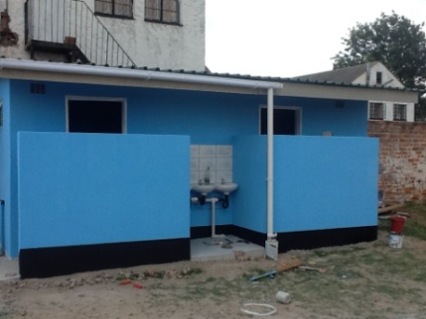 ***An invite – Please feel free to come to Harare to see us – all are welcome!***

New toilets

Contact Info

[www.gregsophiesangwine.org.uk](http://www.gregsophiesangwine.org.uk)

[gregandsophiesangwine@gmail.com](mailto:gregandsophiesangwine@gmail.com)

[www.onewayschool.co.zw](http://www.onewayschool.co.zw)

**Prayer Points**

* Thank God for the answered prayers above
* Pray for completed building work soon
* If someone could pray for QPR I’d appreciate it – 1 win in 12 ☹