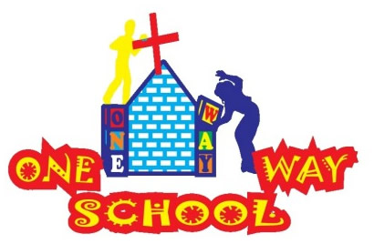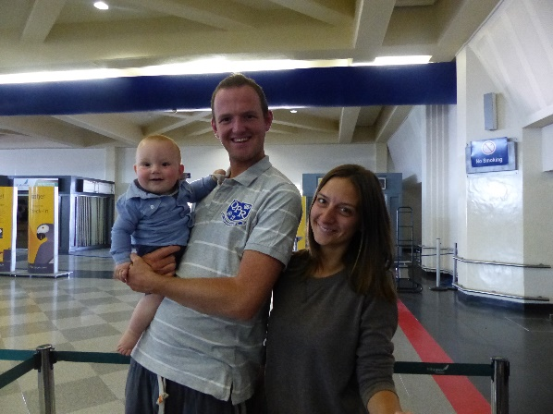

**Dear Friends and Family,**

July 2015

SANGWINE NEWS

++

ONE WAY SCHOOL DEVELOPMENTS

We finished building a set of toilets for the new school and had our planning permission approved to begin laying the foundations for the two new classrooms. Amazingly, the classrooms will be built from One Way School PTA fundraising which currently stands at a little under $3000.

Below are the architectural images of what the new classrooms will look like; (no green surroundings however, it’s a concrete slab area!)

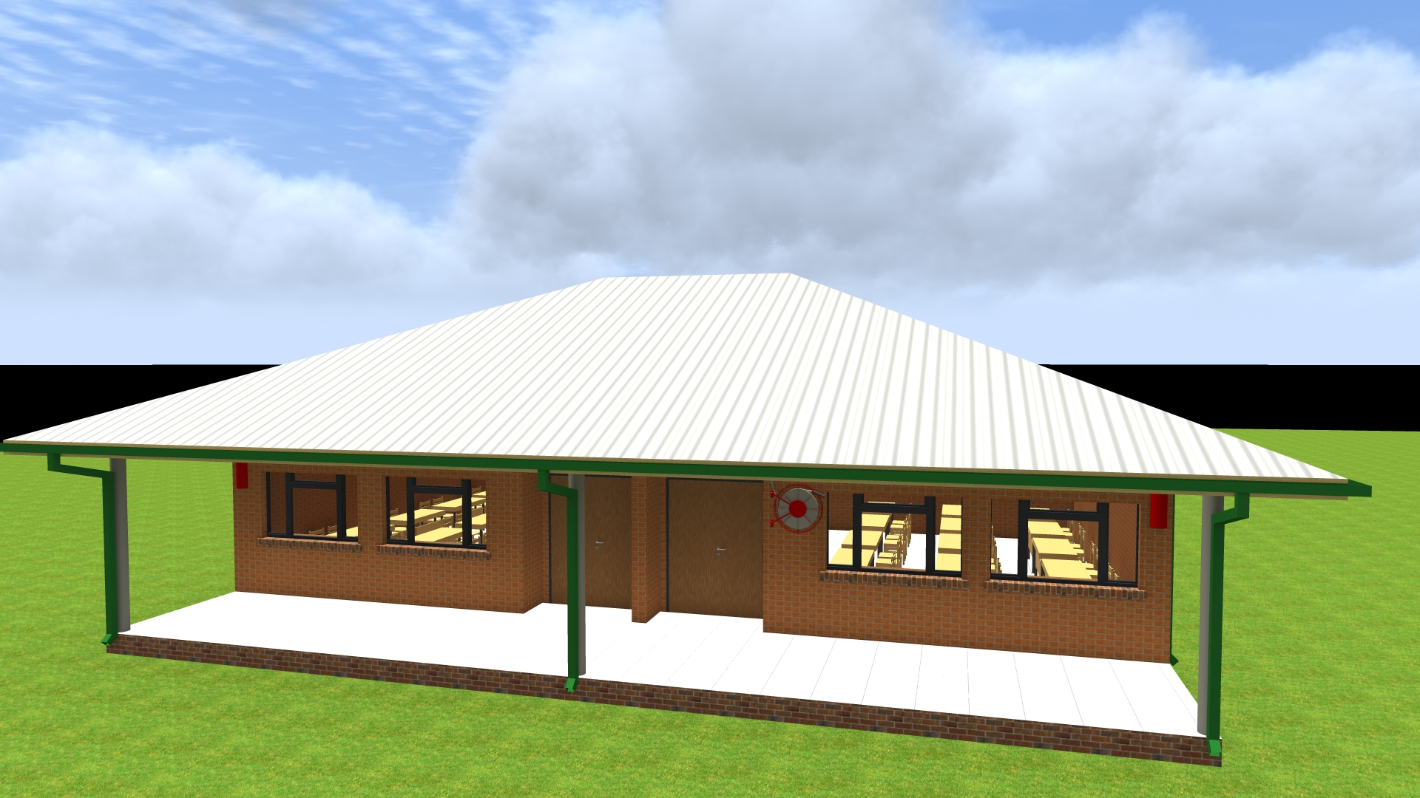 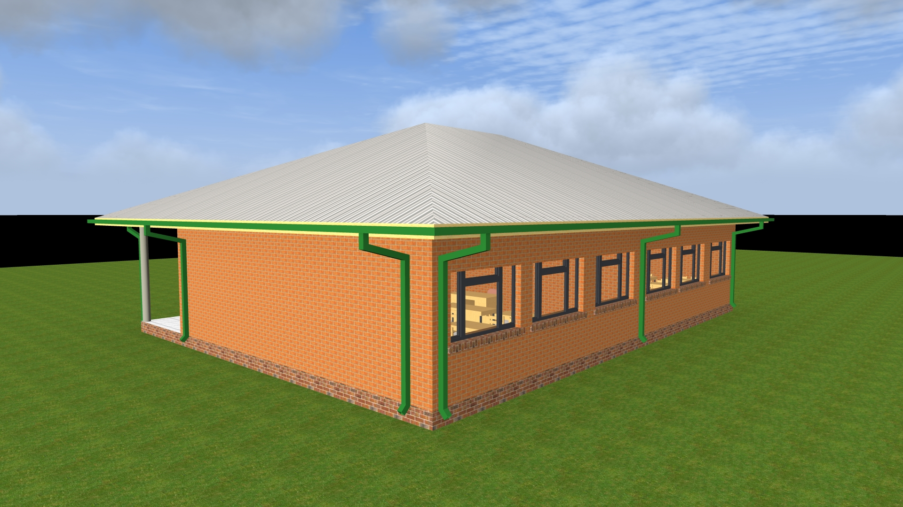 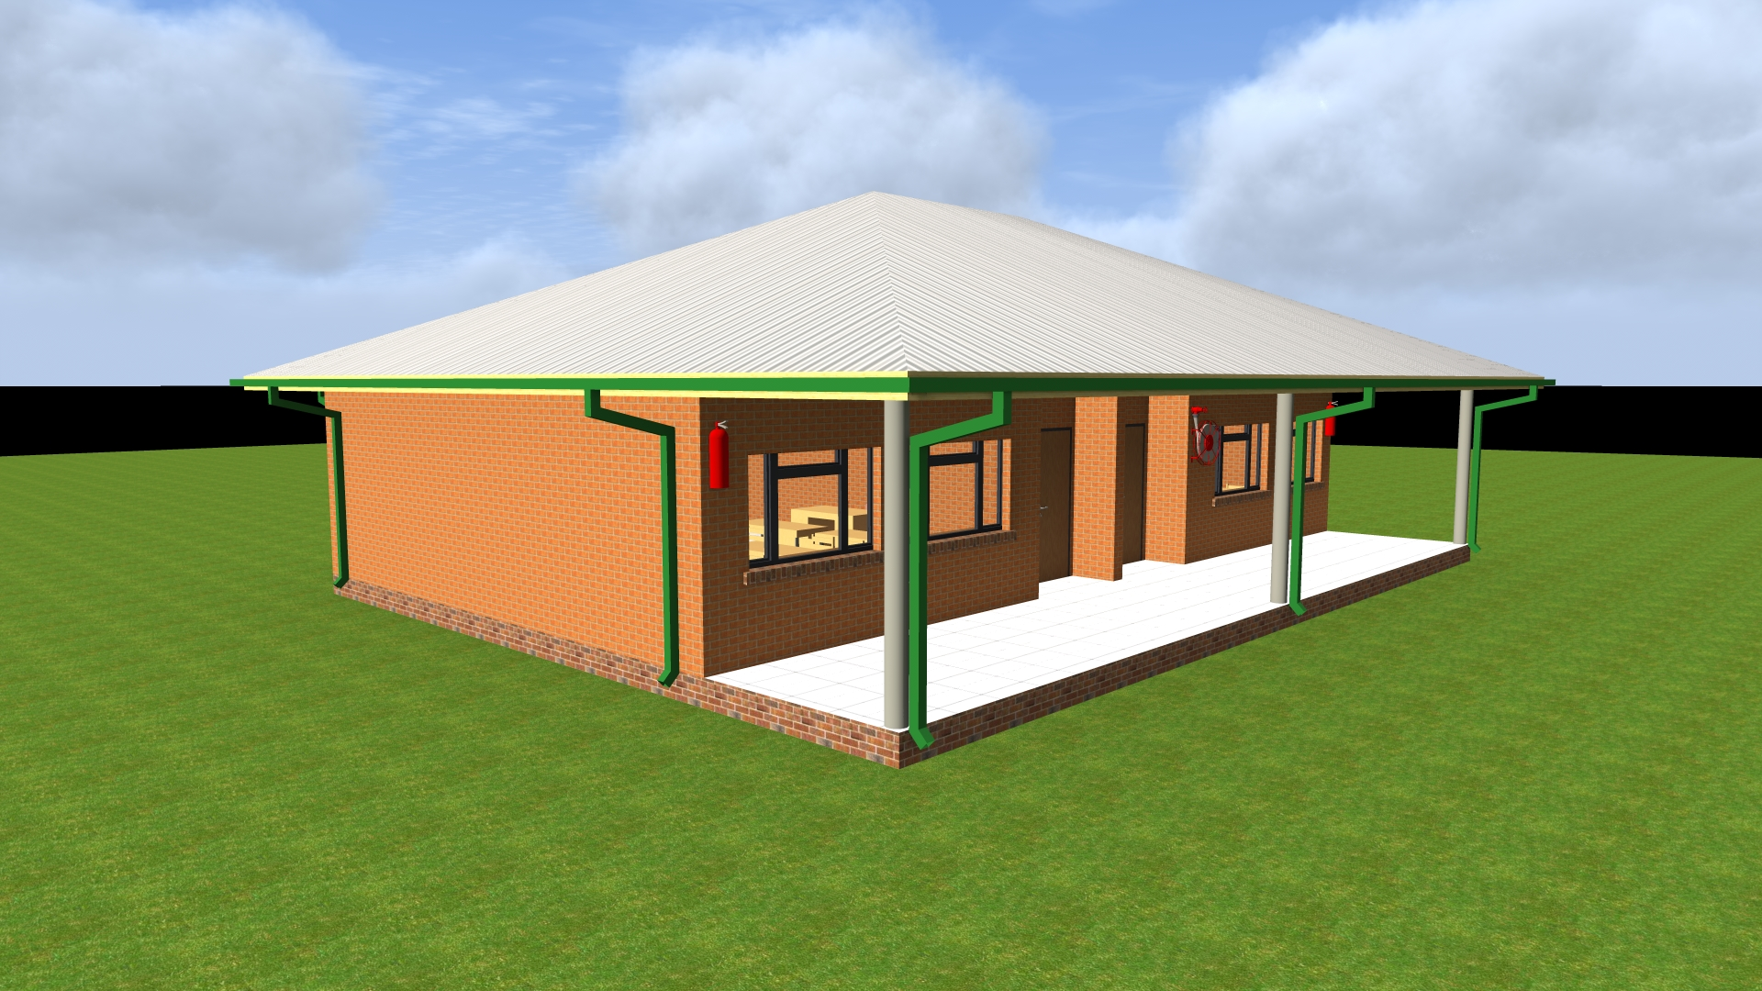

ONE WAY SCHOOL NEWS

Since the beginning of term we have employed a fully qualified primary school teacher to teach at the school. He’s come in, listened to our way of doing things and now he plans his own lessons and delivers the whole curriculum. Onias and Rumbi work so well together in the primary school so we’re delighted with the growth of that team.

On a sourer note; Prudence (our administrator) resigned from her post which has left Sophie and I with the bulk of the admin work. We wish Prudence every success in her future jobs and thank her for all her hard work in growing One Way School over the past couple of years.

We are sorry for the few days delay in sending this letter, but we now send from the comfort of our home in England (we have many!) as we settle down for 5 weeks of family, friends and fun before returning to Zim for the new term in September.

**Personal News**

We are thankful that we arrived safe and well in England for our holiday and that the plane journey over went pretty well! JT managed some sleep and made many new friends (mainly of the female kind) on the plane – he’s such a charmer.

We are mega busy whilst we are back but are looking forward to catching up with friends and family. We are hosting an open house in a couple of weeks and would be delighted to see as many of you as possible for a catch up! Details below

August 16th 2015  
60 Kendale Road   
3-5pm

We are thankful that after a long standing chest infection, JT is now well and in full voice! He is still resolutely refusing to move anywhere by himself, but is eating anything that comes his way – including 3 slices of pizza at his cousins birthday party! Thank you for your prayers for his health

**Visa**   
Greg returned twice to check on the status of our application for extensions on our current visas which expire in October. There is no news and we are not sure our application has begun to be processed yet. Please pray that we receive these upon our return to Zim in September.

**Hellenic Academy Interact Club**

We are so excited that as of this week, the Hellenic Club are beginning work   
on renovating, building and decorating the room which has been designated   
for our new school library!

In total they have independently raised over $1000 and collected an   
astonishing amount of books. Combining these with the books   
donated by St Nicholas Church in Bookham and many more individual   
donations from across our friends and family, the library look set to   
be a popular place from the new term.

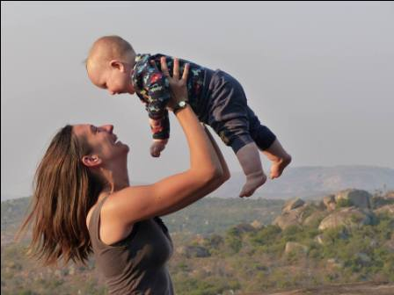

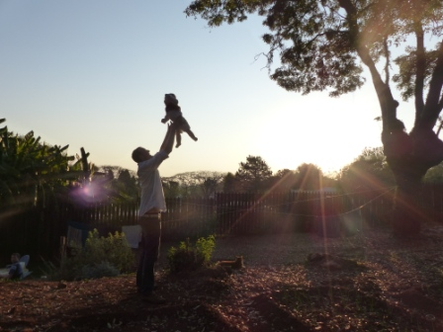

**Prayer Points**

* Please pray we have a restful time in the UK and that JT would settle well in his new surroundings (5 houses to stay in, in 5 weeks! Eek!)
* Thanks for the building works which are starting whilst we are away for the foundations for the two new classrooms
* For guidance and wisdom for us as we continue to seek God’s continued plan for us as a family longer term

Contact Info

[www.gregsophiesangwine.org.uk](http://www.gregsophiesangwine.org.uk)

[gregandsophiesangwine@gmail.com](mailto:gregandsophiesangwine@gmail.com)

[www.onewayschool.co.zw](http://www.onewayschool.co.zw)