July Newsletter 2014 gregandsophiesangwine@gmail.com www.gregsophiesangwine.org.uk
Dear Friends,
Thanks for sticking with us as we enter a third year of our work in Zimbabwe. July is Harare’s coldest months which means sunbathing is limited to four hours a day ;) and temperatures peak at 25 degrees. Tough life!
Despite the challenges Zimbabweans have to contend with it still shocks me that they like to complain about the weather!
JT
Sophie is growing well and enjoying pregnancy (now!). However, she is not loving that she now is referred to as Preggers and/or Bumpy! Pistachio is a boy and will be known as JT when he is born. Full name: Jack Tapiwa Sangwine. (Tapiwa is Shona name and it means God has given us)
Visa
We’re coming home next week for a few months to have JT but we now know we’ll be returning for at least another year because our visas are out and last until the 22nd of October 2015. Thank-you God!
Homecoming
Firstly, we are back in London on Sunday the 27th July and will be heading to Catford Community Church from the airport so if you are from church and not on your own journeying adventures we will see you there! We’ve then got many necessary things to arrange before we visit Ali and Dave in their new home in Bookham, Surrey for a week or so.
We are not sure yet what we’ll be doing about phones but we’re certain that we will be easily contactable by e.mail so please do contact us to arrange something. We want to catch up with everyone as quickly as we can before Greg gets all busy, busy with his new job in September. We’ll be based permanently in Waterloo at Mike and Sue’s flat.
One Way Pre-School
We will admit to feeling more than a little lazy, Greg’s only taught 3 lessons all month due to the completion of the pre-school handover and Sophie can’t recall teaching at all! Both our classes are being well taught by 4 qualified teachers who work together to serve our amazing pupils. The children are making fast progress and we couldn’t be more proud of the impact we know Lorraine, Patience, Leeshy and Rumbi will have on generations of children to come.
Come January and our return to Zimbabwe they’ll run our ECD (Early Childhood Development) Centre, or foundation stage to the rest of us whilst Sophie and Greg begin working in our new primary school with two new teachers. Greg has enjoyed reception but has said that the time he’s had is enough to see him through ;) He’s excited to teach grade two next year! And Sophie gets to be Head of School…be warned!
Waltham Holy Cross Junior School
Greg has been given a great opportunity to work full time as a year 5 teacher for the first academic term (Sept-Dec) He’s delighted to have the opportunity to further his professional development and challenge himself once more. This opportunity is an answer to prayer because we really need to spend some time focussing on our own finances. The full time wage will really help us as we prepare for JT’s arrival.
Primary update
Next month Charles begins work on our building project. So far we have enough fundraising to begin our renovations and we’re so pleased that he’s giving up his time to help us. Please thank God for him because he’s doing this work at a vastly reduced rate for us to serve the school. We’ve had trouble with workman before giving us inflated rates so we’re so pleased that he’s a reliable person to complete the work.
In addition to this we submitted our permit application for the school and all plans seem to be moving along quite fast. We haven’t managed to find suitable staff yet though but we’re more than hopeful that the right people will come into place.
Fundraising
Thanks to everyone who has done something to help to raise funds for One Way School so far. It is an incredible achievement to already have enough money to begin our school renovations but there is still lots of money to raise if we are to achieve our goals. The Fundraising stories are also such an encouragement to the people of Zimbabwe because it’s a struggle for many people here. One of our church pastors recently estimated that only one in three men in our church have employment. The money you are donating really encourages the church as well as the school. Please make every effort to attempt to raise 50 pounds for our schools work and share your story with us. Alternatively, you could donate money through www.hopeforharare.org to Ali Delacourt, Lucy Buckthorpe, Hayley Brown and Marie Goodes who are walking 15.2 miles from Kew Gardens to Tower Bridge on Friday the 15th of August 2014. Please donate whatever you can afford. A tenner might not buy much in the UK but with $17 we can feed one of the pupils for over 5 weeks in Zimbabwe. Your tenner also encourages Zimbabweans to do something. They don’t understand fundraising, you are giving them all ideas.
One of our parents and a member of our PTA encouraged Sophie to put together a CD of 10 Family Worship songs to sell to parents (to raise money) to encourage our families to worship together at home. We think this will raise us around $500. They want to do more because of the generosity of our newsletter readers. We will be bringing a few back to UK with us so if you are interested, we will gladly sell you one or 5! (PS it is the original FW songs, not the children from this school singing on it!)
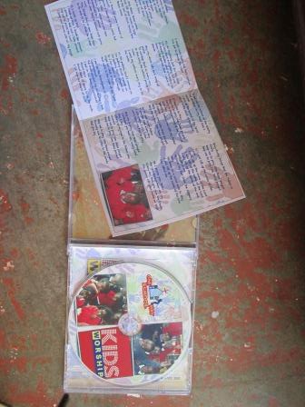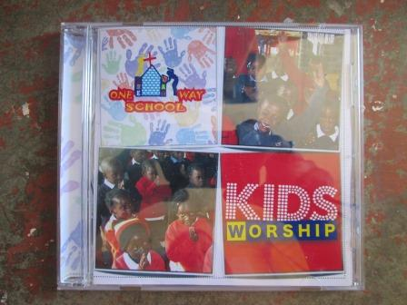
Prayer points
Thank-you God for: Visa, permit, pregnancy, JT, jobs, fundraising, One Way school staff and Charles.
Fundraising for www.hopeforharare.org.uk Thames Walk.
Safe travels
That the school continues to grow from strength to strength in our absence.
Thank you again and God Bless!
Sophie, Greg and a very wriggly JT xx

External Charity Plug
Greg completed a GAP year with this charity and both Sophie and Greg have volunteered for them in the past, if you know someone who is stuck for ideas on how best to spend a GAP year in a God fulfilling way, then please do pass this info onto them, contact details are at the bottom.
"DisTIL Gap Year with Adventure Plus
Do you want to have a year filled with adventure, discipleship, training, and experience in outdoor activities? Do you have a Heart for God, a Heart for Young People and a Heart for Getting 'Out There in Him'?... or do you know someone who would? Then why not tell them about DisTIL - Adventure Plus' very own Discipleship Training and Instructor Leadership Adventure Training Year!
Here's what a former DisTIL member had to say about it: 'DisTIL formed and transformed me as an individual, teaching activity and instructing skills but, more importantly, how to live and work in community with a huge variety of different people...I love the activities and I love the kids, but most of all I love this wonderful, crazy and unpredictable family that I have become a part of!' Rachel Hodson DisTIL 2010-2012
So if you're unsure of what to do next year why not give us a call and come on DisTIL! For more information contact JP Spencer on 01993 703308 ordistil@adventureplus.org.uk

