June Newsletter 2015 www.gregsophiesangwine.org.uk
Dear Friends and Family,
We are amazed that it is now 3 YEARS this month since we started writing newsletters to you wonderful people! Time has flown and we are so thankful to God for everything we have achieved in that time.
One Way School Current News
One Way School is now halfway through the second term and we have more enquiries every week regarding places for this year and next year. The teaching staffs were observed by Sophie last week and the standard of teaching in every class is extremely high with all the children achieving highly, many above their age expectations! We are so incredibly proud of the staff and the hard work they put in to making One Way School a vibrant, fun, engaging learning environment.
One Way School Developments
We are still in the process of building the next stage of the school development, to include a toilet block, two new classrooms and a library. The toilet block was started last week and is being covered by the school finances. See pictures below of the current state, we will be adding the plumbing and decoration in the third term.
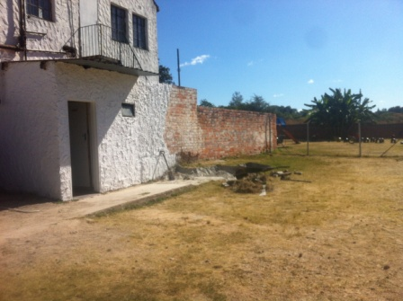 Before 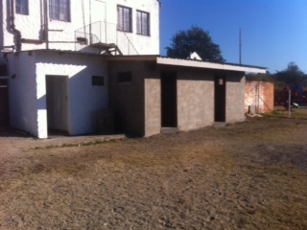 Now
We are also being quoted as we speak for the new classroom builds and we hope to start work on the foundations by the end of this term. This build will be funded by the school PTA which includes the fundraising done by the children which currently stands at $2509. We are still in need of having the plans approved by the council and we are still in need of the licence for the Primary School. We have been in constant communication with the local education officer and he is hoping to arrange a meeting for us with the Minister for Education in Zimbabwe – what an incredible opportunity – in which we hope to raise some of the issues we have and also to help form solutions to the problems.
Hellenic Academy Interact Club
We are so delighted that One Way School has been chosen as the Hellenic Academy Interact Club’s charity of the year. They have been attending school here in the afternoons twice a week fortnightly and spending time reading with the children, playing with them and teaching them sports. This week we will be arranging a timetable with them to include sports clubs, art clubs and drama club! They are also putting the majority of their efforts into fundraising to renovate a room at the centre to create a school library. They will be painting, decorating, furnishing and resourcing the entire thing so we are excited for this to happen and put it to good use!
For the school library, we are always on the look out for good books and unfortunately the supply here is limited or very expensive! We have been delighted with the donations of books provided by Ali and Penny and Paul and we would be delighted to receive any books you may be willing to donate to the library. We can collect these in the August on our return to the UK if you wish to support us in this way! We would also be so excited if anyone was able to find or has any story sacks that they would also be willing to donate for use as a learning tool in the library.
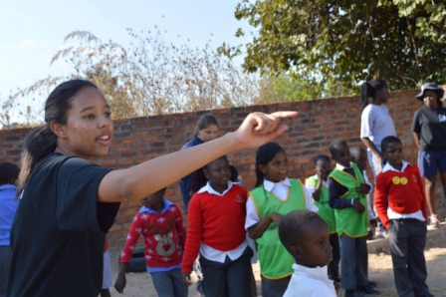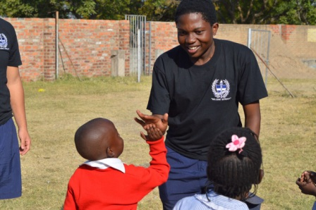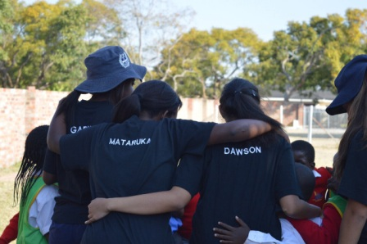 The children thoroughly enjoy the extra sports activities! A HUGE thanks to the wonderful team from CCC who brought a huge range of new sports equipment for the kids to use!
Visa
Today Greg reapplied for our visa extensions, our paperwork was finally accepted and they foresee no problems thus far! Tomorrow, he will return to make the payment once our file has been located. We would very much appreciate prayers that we receive our visas within the next 5 weeks so we have confirmation before we return to the UK for our holiday.
Personal News
We are all settled well and thoroughly enjoying being a family of 3. JT is struggling with a cold which has caused a poorly cough and this is proving hard to budge so prayers definitely needed there! His sleeping is improved greatly and he now settles himself for naps and sleeps for 4-6 hour chunks at night so we are feeling blessed with this! He is eating more and trying very hard to stand up using furniture – he appears to have decided that rolling and crawling is an unnecessary phase which he intends to skip altogether…! He is also so happy with Cheswin – his aunty who looks after him each morning – and we are so relieved that he enjoys his time with her!
For both Greg and I, we are in the midst of some changes within the school which are affecting us personally also so we would appreciate prayers for guidance and wisdom on how to move forward with adapting roles and responsibilities to cover these issues.
Prayer Points
- That we would receive a swift response on our visa application and receive them before we return in 5 weeks
- That JT’s health would improve and that he would master the art of crawling or walking soon so he is less frustrated!
- That Greg and I would find guidance and wisdom with regards to our changing roles
God Bless, Greg, Sophie and JT x

