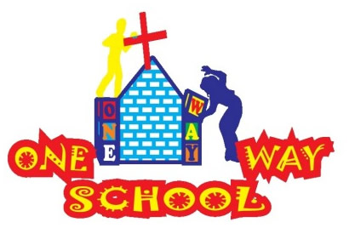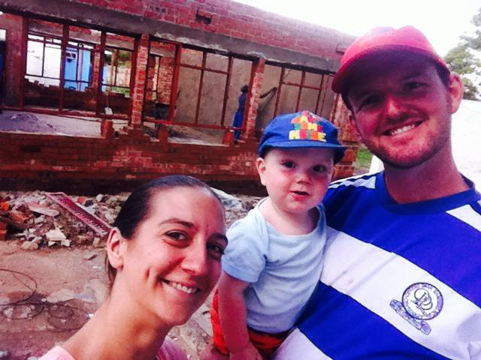

Half way through the year….INSANE! Thank you SO MUCH for continuing to follow our work and supporting us – we love and appreciate you all!

June 2016

SANGWINE NEWS  
Harare, Zimbabwe

**Dear Friends and Family,**

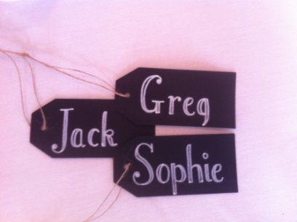

**News from last month’s prayer requests**

**Prayer Points**

* Please pray that the registration with Education and Health continues to move forwards – continuing, we have only two items left to collect then we can register the pre school
* Please pray for the nation of Zimbabwe as it goes through challenges with finance, economy and governmental issues – continuing, steadily declining
* Please pray for us as a family – the man and boy are struggling a bit with health lately! –much better! Health has improved and sleep is being had!

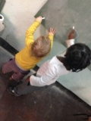

Child Genius

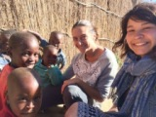

Visiting Mandhebvu Community

Us three

We are having a great time here as a family at the moment! We thoroughly enjoy the amount of time we get to spend together and JT is at a great age! He is talking…a lot! And walking, and running, and ‘jumping’ (a very sweet sort of lopsided skipping hopping thing…) he has also started sleeping so much better and his health is remaining pretty stable, so we are so happy!

Greg and I are much more settled in our roles within the school project and continue to be in awe of everything we have achieved with God’s help over the last 4 years! We wander around the school every day and feel so blessed to be here doing what we do!

We are SO excited to be celebrating our 6th wedding anniversary next month – so prepare for a slushy, loved up newsletter in July! (I joke…a little…)

Personally we are still working towards building up our social lives outside of work and also looking towards our longer term vision and goals as we seek to hear God’s plan for the future of our projects and our personal lives. We very much miss our friends and family and are eternally grateful to all those who have made such a huge effort to come and visit us, we thoroughly enjoy visitors!

We are returning for our annual UK trip from end of July to beginning of September – PLEASE do try and pin us down for a coffee or something!!

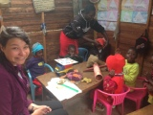

Visiting Hatcliffe Community

ONE WAY SCHOOL

Praise God!

* We now have nearly 120 children registered throughout the Pre and Primary school with more expected
* We have 14 serving and paid members of local staff in all areas of the school community
* We succeeded in opening the 5th classroom allowing us to open Grade 3
* We are in the process of building the 6th classroom allowing us to open Grade 4 in January 2017
* The teaching staff have stepped up in responsibility and continue to excel in their roles
* We had a volunteer for 6 weeks who worked on school and community projects

We have been connected with Hellenic School who have generously donated their time to help our children and who have also raised $1500 to help us complete our building project this August, so when Greg and I have returned from our annual trip back to the UK, we should return to see the brick work completed on the next phase of the project – and potentially a roof! AMAZING

We can only thank God that we continue to thrive in our project despite continual opposition and red tape. Especially, in the current economic difficulties the country is facing. With the introduction of bond notes scheduled for around October, the nation is declining rapidly with inflated prices, incredibly low supply of physical cash (which as the majority of all business are cash based, is causing us and everyone else issues.) Stocks are depleting, salaries are not being paid, the black market is starting to thrive again and many people have already started leaving the country. We need His intervention in this situation because nobody wants to return to the demise of 2007/8.

We are currently building our Grade 4 classroom, and as such, we then run out of space to build 5, 6 & 7. Problem! We have a couple of potential options in place but they are extremely expensive and not favorable. We need much intervention with land issues – including a change in government legislation stating we should have much more land than we currently do, as their bench marks are unmanageably high!

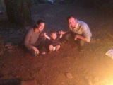

**GAP YEAR**

Are you a teacher? Do you know a teacher? Are you in need of a new challenge? Something a bit different for a while?

Come and spend a gap year here!

We’d arrange your accommodation, a vehicle to use, your visa and an allowance to live on. Inspired? Send us an email.

Our first volunteer since our last request, was a lovely girl called Emily, who was here for 6 weeks. She helped initiate the school’s first ever Science week and helped run a successful school Olympic sports day. She also worked on the school website and social media sites to widen our reach! We were blessed to have such a volunteer with us (JT misses his auntie Eno!)

Family ‘rara!’(Fire!)

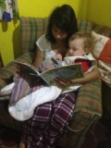

JT and his Auntie Eno (Emily)

***An invite – Please feel free to come to Harare to see us – all are welcome!***

Contact Info

[www.gregsophiesangwine.org.uk](http://www.gregsophiesangwine.org.uk)

[gregandsophiesangwine@gmail.com](mailto:gregandsophiesangwine@gmail.com)

[www.onewayschool.co.zw](http://www.onewayschool.co.zw)

**Prayer Points**

* *The nation of Zimbabwe and its unstable economy, government and daily life struggles*
* *The president and his successor*
* *Our school and the children and staff*
* *Current building works and finances for this*
* *Future classroom buildings and issues of land space*
* *Our personal short and long term goals*