March Newsletter 2014 gregandsophiesangwine@gmail.com www.gregsophiesangwine.org.uk
Dear Friends,
An end to another month has come – they seem to be happening quickly! This also brings to an end our first term of the second year of the pre-school, so it has been a busy time but fulfilling all the same. We are so excited to continue sharing our journey here with you and thank you for taking the time to keep up to date with our news.
One Way Pre-School – End of Term One and Term Two Update!
One Way Pre School is into its final week of the first term of its second year! This term has gone crazy fast and it has felt like our feet have not touched the floor for 3 months. We are both feeling the effects of tiredness with lost voices and general lack of energy, but working with the staff and children as we do, gives us all the motivation we need to press on! The term has been full of excellent learning and progress by all the children, especially in writing and we are so pleased with how each of the staff members have built fantastic relationships with the children to support them in their learning.
The second term, beginning in May, brings some changes to the Pre School. Firstly, we are pleased to announce the addition of another staff member! Taking our total staff count to nine. Auntie Leeshy will be joining us as the teaching assistant in Nursery Class. All of the staff are having a slight change of roles, taking on extra responsibilities, leaving both Greg and I to work in a more overseeing role and giving us the afternoons to spend working on the development of the Primary School.
Lorraine will be taking on the Nursery Class as the full time teacher, with Leeshy as her assistant. Patience will be taking on the Grade Zero Class, with Rumbi as her assistant. We have every faith that they will be fantastic in their new roles and look forward to working with them to help continue their professional development.
One Way School – Update
The development of the Primary School is exciting and daunting but we already have so many positives to take from the experience. Greg and I spent a morning last week at Ariel School, a private school around an hour from us. We met with the Head teacher who was extremely helpful in answering some of the questions we had about curriculum, registration, time tabling and so on. We are pleased to have a relationship with the school and look forward to sharing our journey with them as they support us with advice. The best thing to come from the meeting is that we had got the answers that we had assumed, so we’re on the right track!
We had a visit from our contact at the City Council offices that helped us with registering for our permit for the Pre-School. She informed us of the requirements for our application for the Primary School and answered many questions we had. She has since delivered the permit registration form to us and we now need to begin the process of completing the masses of paperwork that go with it. The process will take around 5 months from date of submission, so it is important that we complete the paperwork and submit the application within the next month or so.
The Pre-School has continued in its fundraising efforts, raising $817 with a further $290 expected by next Friday, taking the total to $1107! We challenged the pre-school to raise $2000 so they are well on their way to their target! Our next event is a fun morning (taking place of our unfortunately cancelled school trip) on Friday with water slide, face painting, clown and yummy food!
Below are pictures of the latest fundraising dress up day – Cultural Clothes! More pictures at www.onewaypreschool.co.zw
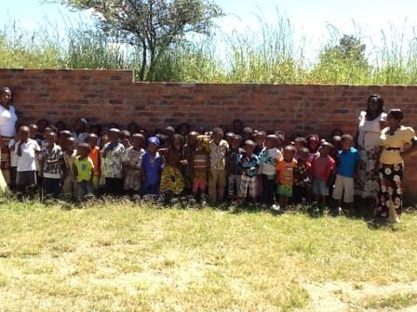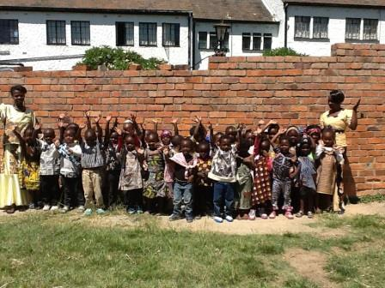

Fundraising – A CHALLENGE FOR ALL
We are lucky in England that we grow up learning all about fundraising, supporting local charities or raising money for developments. In my (Greg) life, I remember my Mum and Dad both getting involved to raise money for Charlbury Primary School and the whole community loving the events. It is a similar community culture that we aim to build our school from as well. It’s amazing that the pre-school parents have raised so much so far, BUT WE NEED MUCH MORE.
We’ve challenged our churches members to each raise $50 so our church can reach its $3000 target. They’re very enthusiastic and one man told me that he is going to clear out his old clothes, sell them and give the school the money. This isn’t an isolated story. The church really believes in the schools ministry of the church and we thank God that we are a part of it.
We aim to raise $5000 internationally to reach our total goal of $10,000. That’s around 3500 pounds- ish. Our challenge to you is to raise 50 pounds each. Our newsletter is sent to 78 people so if everyone who receives this newsletter raises 50 pounds – or as close as they can - we’ll smash our target. Just as important as the cash donation is the story that goes with the fundraising. Please share it with us so we can share your fundraising stories with our friends and colleagues to create the same community culture of fundraising here in Harare that we grew up in.
Ideas so far: Andy Field, Beth Sangwine, Ali and Dave Sangwine, Mike and Sue Burn and Josie Burn have all agreed to sell African products like bags, ornaments and place mats to raise money. Beckie Bowler is going to run a 10k in May and Ali Delacourt is going to do a sponsored walk. Personally, I’m going to paying my security guard $3 every time he cleans my car (which is far too often – he must be bored) to raise my money. The rate he’s going I’ll raise $100!
The aim in the future is that this schools ministry will run successfully without international aid. No international money and no international teachers. Zimbabwean organised schools which can be replicated by Zimbabweans. I can promise you, your 50 pounds will do much more than just buying us some resources or renovations for a school. It’ll create a long lasting legacy that will span generations.
Holidays and Visitors
As it is end of first term, we now have a holiday until the 6th May – long terms, but long holidays! We are super excited that Greg’s parents Dave and Ali are visiting us for 3 weeks and are super excited that it is both Greg and Dave’s birthdays whilst they are here so we are being treated to two holidays within the holiday! It is going to be such a welcome relief to have some family visiting and have some down time together.
We are hoping that my family will also get the opportunity to come and visit within the next couple of months, again, a big relief to see them when they do make it! It is always a pleasure to have visitors and it gives us an excuse to enjoy the country we are now living in, rather than working the whole time!
We have some exciting potential visitors coming later in the year, including one who may be here for 3 months helping with project managing the Primary School. If you are interested in a short or long term trip to support our work here, please do continue to get in touch, we would love to have you and any support is a huge support!
Prayer Points
- Thank-you God for a great term
- Thank-you God that we have a great staff team in place
- Paper work and permits for our primary school
- Primary school fundraising
- Restful holidays
Thank you again and God Bless!
Sophie and Greg xx

