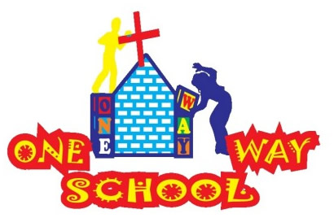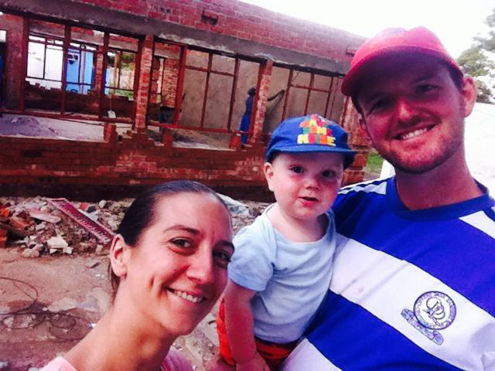

We are on holiday! So please do forgive us for this newsletter coming to you a few days late! This term has been CRAZY!

March 2016

SANGWINE NEWS  
Harare, Zimbabwe

**Dear Friends and Family,**

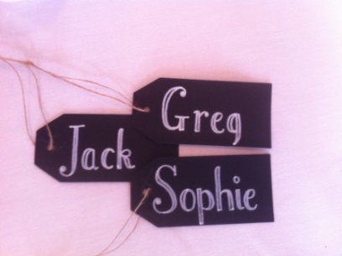

**News from last month’s prayer requests**

**Prayer Points**

* Please pray thanks to God for his faithful hand over the work here, trials have become triumph! We continue to feel blessed
* Please pray for energy for the next 4 weeks until the end of term, they are mega busy! We certainly felt re-energised to get us through!
* Our Primary School is full, amen! Please pray for further ECD registrations. We have had a couple and more promised for next term

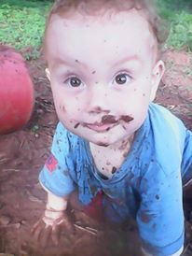

MUD glorious MUD!

School

The children took part in two fundraising events – a Fun Run and an Easter Concert – which combined raised over $1500 PRAISE GOD. They worked incredibly hard and we are so proud of them! Taking the total raised by the PTA this term to over $2300.

We continue to have around 108 children in the school and are hoping for a few more ECD registrations in the new term.

The staff are continuing to develop their skills within the classroom and particularly their knowledge of the curriculum.

We continue to have a battle with the contractor from the previous job and have been consulting legal advice with regards to recouping some of the damages.

We are looking to the new term knowing we continue to have so much more to do and time FLIES so we continue to need prayer for energy, wisdom and guidance as we move forwards.

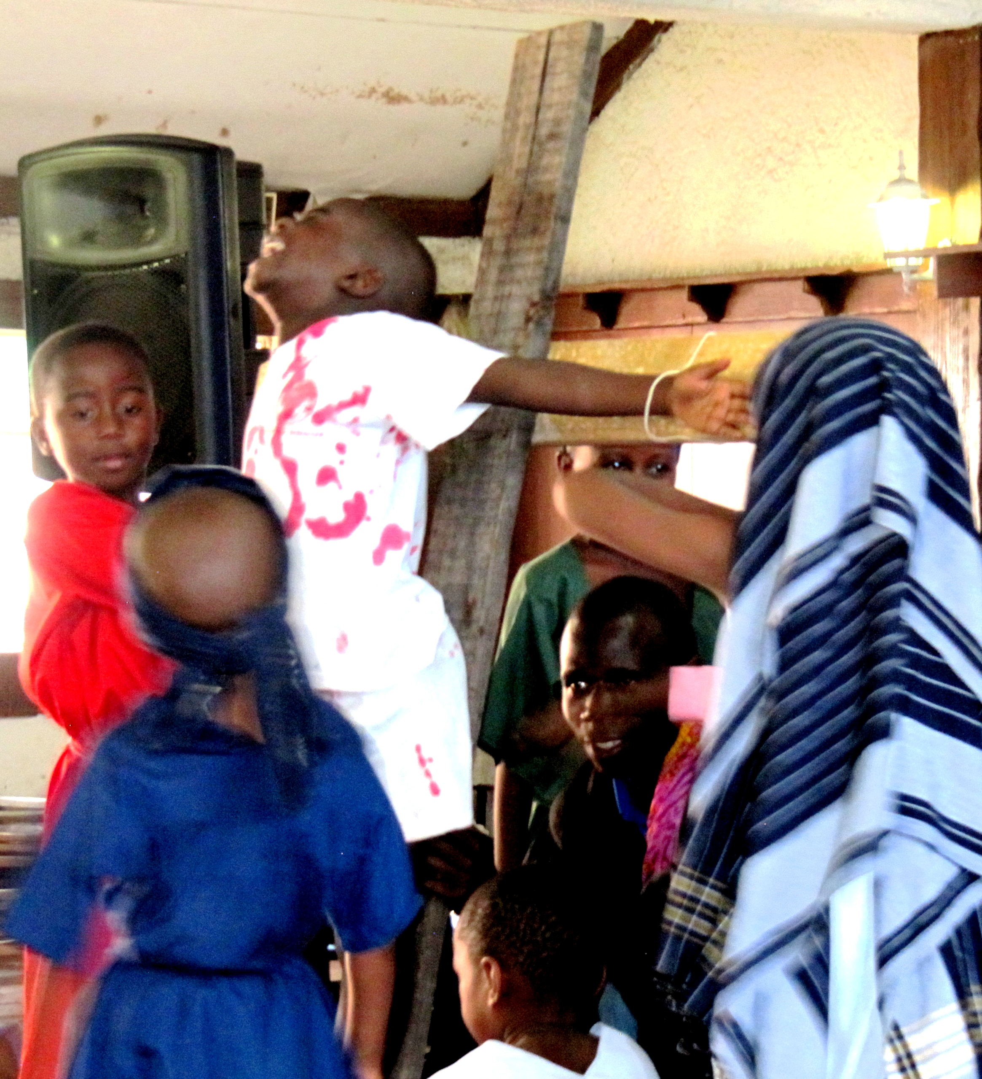Easter Concert

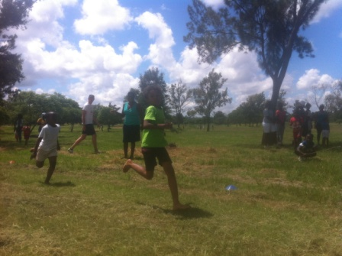

Fun Run

General

We are relishing the chance this to spend some quality time together as a family with lovely long days together (some longer than others, 430am starts are not my favourite! We’ll get there with his sleeping….) and the weather has been beautiful allowing us much time to play outdoors, JT is obsessed with mud and water!

We have one more week until 4 of our friends arrive including Joe and Beth and JT’s godparents Andrew and Sophie – who are going to be getting married here whilst they are visiting! HOW EXCITING! We thank God for the incredible opportunity we have to share in this incredibly special time with them and Pastor Gatsi will be performing their blessing ceremony.

We then have Sophie’s mum visiting before she jets off to London to celebrate her birthday – so we are super excited for JT to also get to see his Grandma!

We then have one week back at school before Emily Cox, a student on a gap year, will be arriving to volunteer with us for around 6 weeks! What an incredible blessing!

So life is never dull and we are throwing ourselves at it with fun, friends and franticness! (is that a word?)

We look forward to hearing from you all and thank you for encouraging us, we couldn’t keep doing what we’re doing without you!

**GAP YEAR**

Are you a teacher? Do you know a teacher? Is that teacher in need of a new challenge? Something a bit different for a while?

We’d love to have fully qualified teachers over here for a year or more to share with us your knowledge and expertise. Teach a class, work with the teachers here and assist Sophie and I with the training of more local teachers.

We’d arrange your accommodation, a vehicle to use, your visa and an allowance to live on. Inspired? Send us an e.mail.

 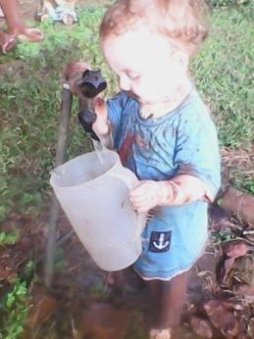

***An invite – Please feel free to come to Harare to see us – all are welcome!***

Contact Info

[www.gregsophiesangwine.org.uk](http://www.gregsophiesangwine.org.uk)

[gregandsophiesangwine@gmail.com](mailto:gregandsophiesangwine@gmail.com)

[www.onewayschool.co.zw](http://www.onewayschool.co.zw)

**Prayer Points**

* For a restful, fun and blessed holiday period for all of us
* For continued improvements in sleeping for JT
* For a fantastic wedding for Andy and Sophie!
* For continued interest in registrations for the school
* For continued development works over the coming months