May Newsletter 2014 [gregandsophiesangwine@gmail.com](mailto:gregandsophiesangwine@gmail.com) [www.gregsophiesangwine.org.uk](http://www.gregsophiesangwine.org.uk)

**Dear Friends,**

As of tomorrow (Saturday 24th May) Sophie will be 16 weeks pregnant and she’s a blooming Goddess! Pistachio is growing nicely and she’s recently better from bouts of vomiting and a throat infection. All is still going strongly with our work so we hope you enjoy reading our latest news.

**Beckie’s Run**This Sunday (25th May) Beckie Bowler plans to imitate double Olympic gold medallist Mo Farah in running a 10k. 100% of the money she makes will be coming directly to the One Way Primary School project and every penny will be spent increasing our educational capacity from 60 children to 120.   
Thanks for doing it Beckie and we hope it is a whole heap of fun! If you’d like to sponsor Beckie a few quid (and we’re sure you do ;) ) then head to [www.hopeforharare.org](http://www.hopeforharare.org) to give through pay pal or send us an e-mail for an alternative payment plan.

**One Way School**  
Our 5th term of the school has started with a bang – we ‘accidentally’ registered two extra children so we have 31 in each class now. Long story but I guess if the bosses can’t break the rules then who can? Exciting things happening this term include next week’s sports day. I spent one afternoon this week painting lines on the ground for a track. I’m doing so many things I never thought I’d ever do here. Check out [www.onewaypreschool.co.zw](http://www.onewaypreschool.co.zw) next weekend for pictures from our sports day.

**One Way School Directors**  
So far we’ve had free range of the running our school. We pop upstairs to Pastor Gatsi and tell him what’s going on and he just says “*I love you guys*” and we move on with our decisions! This is not a sustainable model though so we’ve put together a board (similar to a board of governors) to make decisions on the school. The board consists of Sophie, Prudence our administrator, Pastor Chidewu, Mr Jakaza who is a church elder, 4 parents of children and Rumbi who works for us. Our first meeting was this week and we’re really excited that the church, the school and our children’s parents are working so closely together – meeting again in 3 weeks time.

**Book Corner Project**  
Sophie (in her new head of school role) challenged both classes to decorate their reading areas using the topic of a book. Lorraine in the Nursery chose ‘The Gruffalo’ and Patience in the Grade 0 class chose ‘The Rainbow Fish’ The displays included paintings, collages, writing, colouring and drawing. The children loved reading the stories but from my point of view it is a little annoying when you keep getting advice from 20 wise octopus’ and 15 mice. If you are confused by this then get the stories from amazon – they are great! Below are pictures from our book corners. We’re proud of the children of course but even more proud of the creativity of our awesome colleagues! Sophie opted out of the voting process to remain impartial (chicken!) but Pastor Musora voted for the Rainbow Fish as the winner to the great disappointment of the Nursery class. Tough, because I particularly like the use of the Gruffalo dressing up clothes where the reading area doubles up as role play.

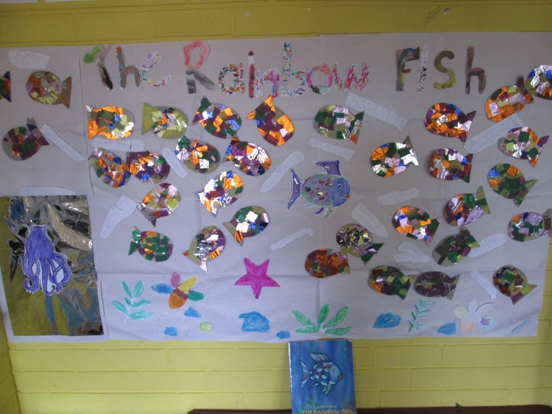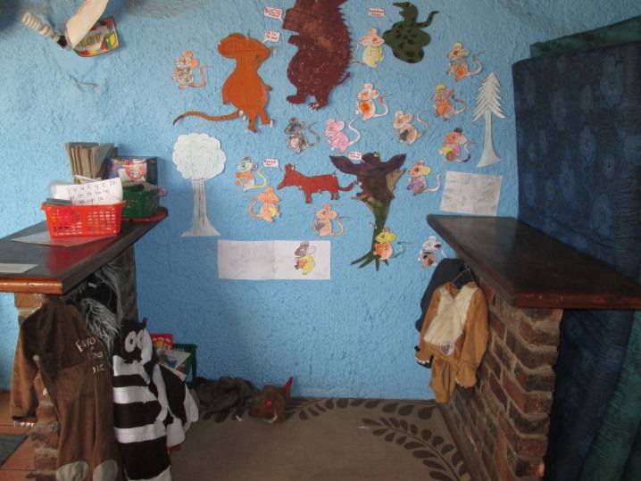

**Church**  
We have been spending time at both One Church and One Way Ministries over the last few weeks and we’re really enjoying meeting many new people through One Church and having a great time. Next weekend we’re going on a One Church weekend away which we’re really excited about it. We would love to get more involved in the church but we’re also keen to retain links with One Way Ministries as we continue to grow our school.

**Pistachio**  
We have decided we will be delivering our pistachio in London so we’ll be back in the UK for August, September, October, November and some of December. I’d love to (and need to) get some work when I return so if anybody has any good ideas, or good contacts, for teaching jobs then please let me know. Sophie will also be available for part time work if an opportunity arises, maybe someone needs a PA to bring them coffee?

**Prayer Points**

* Thank-you God for the growth and development of One Way School.
* Sophie’s health and the growth of our pistachio.
* Beckie’s 10k run and One Way School fundraising.
* Job prospects in London during our extended stay.

Thank you again and God Bless!

Sophie and Greg xx