Dear Friends,
We have been in Zimbabwe for a year now and we’ve run One Way Pre School for two full terms and offered exactly 25 weeks of education. It’s been pretty crazy but very rewarding. I’ll list our bare facts of what God has done here so far:
- Achieved twin visas for Zimbabwean employment and a permit to run a pre-school on the church premises
- Received enough funding to open a working pre-school in an ‘old’ run down building of a hotel which used to be a pub and night club in the 70s and 80s.
- Set up a school business, wrote policies, plans and registration documents and researched the local market with regard to our school fees.
- Advertised for registrations for our school. (We currently have 51 children and have had 6 left due to moving house or financial issues.)
- Offered education to 2 children for free who wouldn’t have access to education otherwise. (Paid for by regular donors)
- Employed 4 local people full time, offering free training (paid for by regular donators) and competitive salaries.
- Continued to improve our education by buying a greater number of resources and extending the school facilities.
We thank God for such an incredible early growth but I do not think that everything is meant to stop just yet. We mentioned previously that we were intending to extend the school to a capacity of 90 in January but it has been decided that this development is a little quick and will happen after then.
For the time being we will be extending our playground, improving our security, decorating our ‘run-down’ facilities and adding some more toilets. Also it is great news that we will not be in sole charge of these developments as our new administrator will be in charge of these works so they can happen without us. We cannot wait to come back and see change happen without us.
Visas
We received back to back 30 day extensions on our current visas but this does mean we will return to Zimbabwe in September without our visas secured. A little worrying but we have spoken to some big wigs at the department for immigration who didn’t see any problems in receiving our applications in September.
School trip
This term we've had our first ever school trip to Mukuvisi Woodlands, a safari place here in Harare. The children were able to see crocodiles, ostriches, giraffes, antelopes, zebras, birds and got to ride some ponies. It was a great day and the children loved every moment. They even got to get take away chicken and chips for lunch which was very exciting indeed. Here are a couple of photos but you can view more on www.onewaypreschool.co.zw

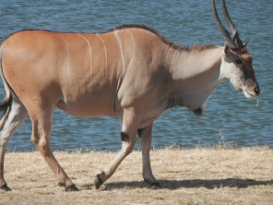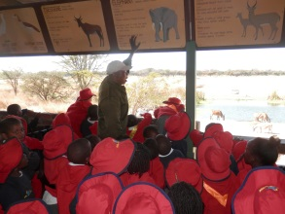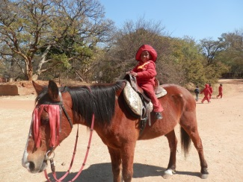

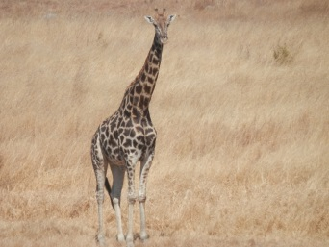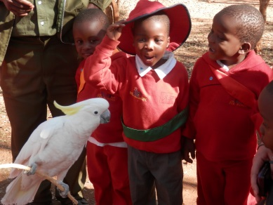

Hope For Harare projects
Hatcliffe
Last week we had the pleasure of going with Sean (a local pastor whose house we rent) to a settlement called Hatcliffe. (Please read a recent blog for more details) Whist we were there we were linked up with some local pre-schools. I feel my writing cannot do justice to this place and we did not take photos for many reasons but there is so much need yet so much love in that place. It’s a poor settlement with a severe lack of running water, sewage facilities and electricity and it is home to an estimated 40 thousand people who have next to nothing but a shed with a corrugated iron roof but you meet the kids and all they want is to go to school. They’re completely beautiful and Sophie was in her element there! I’m not yet sure what we’ll do to help but we have to do something to help the wonderful people already working there. At the moment I’d love to support the schools with donated resources and teacher training. Please do guide us in this venture because we’d love to do the best we can for these people.

Lorraine
Before I write more I must pass on a message from Lorraine to say thank-you to anyone who gives financially to us because without you we could not afford to send her and others to school.
I know that many of you have read and enjoyed the story of Lorraine and her four girls and we have another. Lorraine’s new confidence with her job and her education has led her to dream even bigger. She hopes to buy a plot of land in poorer, rural area where she can build and set up an orphanage so children who have been through what she has been through can be helped from a younger age. She has a huge heart for orphaned children and she wants to dedicate her life to this mission. I have written and will post a detailed blog about this project soon but if you would like to support Lorraine’s projects then you can do so through PayPal and SolidrockUK. We will ensure this money is saved to buy the land for Lorraine’s orphanage. It’s exciting for us as I certainly believe there is scope that this could become another HopeForHarare project. I really believe God brought us here and that He brought her to us. We’re blessed to work with such inspiring, hard-working people.
Update on last months prayers
- Our School Administrator, Pru’s Mum, who had a mini stroke is feeling a lot better and is well on the way to a full recovery. Thank-you for praying for her.
- We have a very healthy dialogue with the church with regard to the future of our charity Hope For Harare so we thank-you for your prayers into this relationship.
- So far the elections seem to be peaceful and well organised, please pray this continues with the election on Wednesday 31st July.
English holidays
We return to England this weekend. We’d love to catch up with as many people as we can so please e-mail to arrange something. We will be based in London between 28th July and 2nd September, except between 31st July and 4th August we’ll be in Charlbury and between 16th-23rd August we’ll be on an amazing family holiday in Devon. For all our wonderful church people we’ll be at CCC on the 11th, 25th and 1st September. On Sunday 25th we’ll be doing a short speech and there’ll be a chance for everyone to pray for us so if anyone reading this would like to attend our church, Sunday 25th August would be a perfect date.
Due to our holiday we have decided we will not be sending an August newsletter so your next Sangwine update will be sent towards the end of September – we hope to send an update on the works happening to the project over August however! By then I hope QPR will be towards the top of the Championship so you can guess my tone to see how well we are doing.
July/August Sangwine Prayers
- Travelling
- Restful holidays
- Wisdom in the future of One Way Pre School and Hope For Harare
- One Way Pre School development projects
- Our children and their families in Zimbabwe
God Bless, and see you soon!
Greg and Sophie xx

