Dear Friends,
June sparks one whole year of writing newsletters and a lot has changed since we were sitting around the living room in Downham unsure of what this adventure would bring. In this year we’ve managed to set up a self-sufficient pre-school in Zimbabwe, successfully settling to life in a new country and we couldn’t have done it without all of your support and prayers. We appreciate more than you could ever appreciate all your messages and prayers. It’s been quite a year but you’re probably not too surprised to hear that we’re expectant of much more in the next year.
Visas
Firstly we share good news that we have been given 30 day extensions on our current visa’s until 17th July 2013 whilst we wait for our applications to be processed by a very busy immigration service. We pray that they will be sorted in this time and before we return to England on August 1st but if they are not we have been informed we are entitled to continue to apply for similar extensions. We are loving our time here and we really don’t want to leave permanently any time soon.
One Way Pre-School
One way pre-school now has 50 pupils and has had 5 more leave due to family relocations so we can boast 55 official registrations for a school of a capacity of 60. We’ve been turning kids of the nursery age away for months so it’s firstly very important that we extend this schools capacity. The plan is that we are going to renovate another building of the old hotel where our school is so we can increase our capacity to initially 90 children and then maybe 120 children if the need is there. Our plan is that Sophie will run the nursery side of the school with Lorraine with the pre-school aged capacity up to 60 children over 2 classes. Then Greg, Patience and a new employee would work with the Grade Zero (Reception to us Brits) children in the new building with a capacity of 30. The project is big but smaller than our original project to set up the school in the first place! The building is already a good size with decent size facilities including toilets but the main part of the work would need to be done on the outdoor area. We have estimated that we need to find $5000 over the next 6 months to make this dream a reality. We really feel that Mabelreign where we work has the need and deserves this extension and we’d love to achieve this next goal.
Below are a few pictures of the new building so you can see the work we need to do…
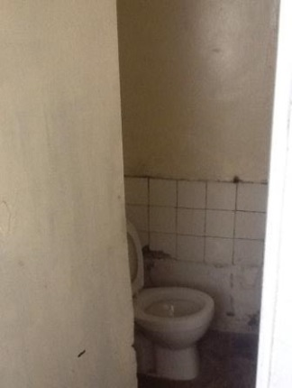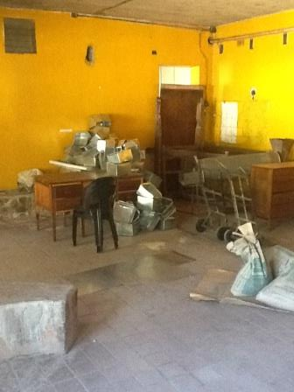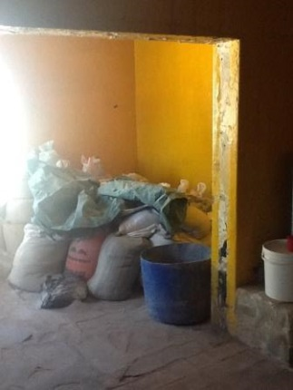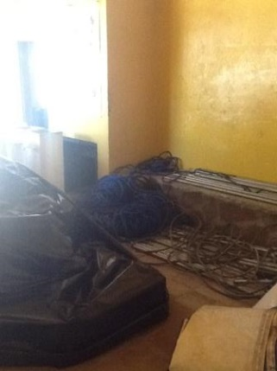
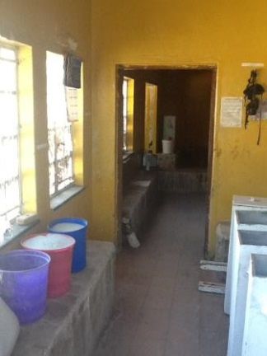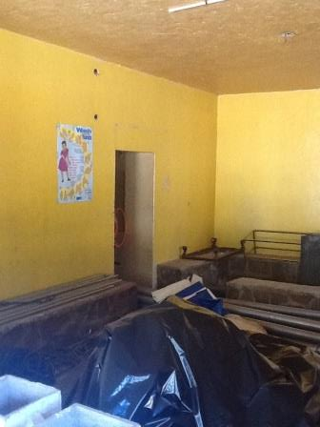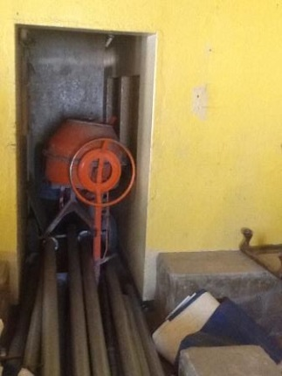
From L-R – boys toilet, main classroom, side room, second classroom, space between 2 rooms, 2nd classroom, office space
Fundraising
We were so delighted that Santi decided to run the marathon to raise money for what will hopefully be our new charity hope for Harare. He raised nearly 1000 pounds and we we’re really chuffed with that as it’s the beginning to our dream of our extension project to offer education to a greater number of children. Money is of course amazing to receive but I know having had friends who have worked on similar projects in the past that you really wish to help but you cannot help financially. If you are like I was then maybe you’d prefer to directly buy or provide our children something by donating resources for the school. On the support section of www.gregsophiesangwine.org.uk we have given (a very long, cheeky and detailed) list of items we’d love to improve the education we offer. If you would like to buy one of these resources for our children then you can do this and send them directly to us in Zimbabwe or send them to Ali Sangwine who will save them for us to ship to Zimbabwe when we return for holiday in August. Alternatively if you can donate a pound or even more for us to pay for the shipping then you can do that through Mike’s charity Solidrock UK. Please do share our website with friends or family who you think may be interested in supporting the children of Zimbabwe through us.
Other News
This term we've had our first ever sports day where all the children competed in races and we had a great morning where around 40 adults were able to attend to cheer on the children. It was a great day and further underlined the community spirit that we have generated through the school. We will make this an annual event and this time of year seems to be perfect for the event despite the Zimbabweans assertions that it is 'very cold at the moment' (21 degrees!). Check out the photos at www.onewaypreschool.co.zw

Personally we've been settling really well and still love our little place where we live. It is actually pretty chilly at night dropping to around 4 degrees which, without any heating, is pretty cold but we're enjoying the chilly mornings followed by the warm days again. We have power out almost every day now but we're coping really well and it bothers us less and less each time. I guess we really are Zimbabwean!

Finally we're all set to return to England in August and we're now counting down those days. We return on August 2nd after having our 3rd Wedding Anniversary in Zimbabwe on the 31st July.

Prayer Points
- Our School Administrator, Pru’s Mum, had a mini stroke on Thursday, please pray for healing and comfort at this difficult time with Pru’s sisters’ new baby also being cared for in the one house.
- One Way Pre School extension – that the Pastors would meet and discuss the options and give a swift answer to us so work can begin.
- Time! We have a couple of possible ventures we may become involved with, but meeting up with others to discuss these are difficult as everyone is so busy! Please pray we find time and wisdom to meet and discuss the future.
- Home! We are coming back to England in 40 days and have lots to do before then, we need some renewed enthusiasm!
- Elections – the Zimbabwe elections are to be held on the 31st July – the day before we fly home. Please pray for safety and peace at this time!

God Bless, and see you soon!
Greg and Sophie xx
