Dear Friends,
Thank-you for reading this September newsletter, the support we receive from you all is completely amazing and we appreciate the time you take to read what God is doing with us and to pray for our plans
One Way Pre School
Our pre-school continues to go from strength to strength. Over the holiday in England we were lucky enough to receive donations to improve much of the learning across our classrooms. Our book corners are incredibly stocked and we now have resources to improve what we can offer in terms of outdoor learning. Thank-you to everyone who bought us resources! If you would like to support the school in this way then please see the support page of our website to see what we’d like.
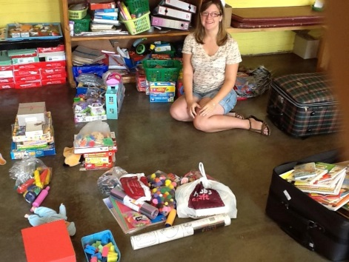
Here is Josie surrounded by a selection of the resources that were kindly donated!!
Whilst we were in England plenty of things happened too. We had 4 children join the school taking our total to 55 children and over the last week we’ve increased our registrations for January (the beginning of the new school year) to 44 even at this early stage. We had our playground extended and a new climbing frame put in. We increased our security with a new wall around the playground and we fixed the drainage so therefore our outdoor area will not flood during the rainy season.
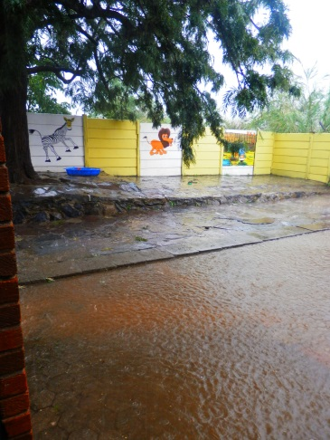
Here is a picture of our flooded courtyard which won’t happen again and our new playground.
We’ve also been able to employ two new members of staff taking our full time staff 8. We welcome Wilson as a full time security guard and Rumbi who had been volunteering with us who’d love to take on some teaching in the future. Rumbi incidentally was the first person to register her child Keith in our school so she’s always been amazingly supportive of our project and of us. Of all the things we have done so far I am most proud of the way we’ve been able to offer adults stable jobs with regular salaries. It’s your generous donations that pay for them to go back to school to train as teachers. Rumbi will be our 4th trained member of staff in one year. I think we certainly hit out CPD quota!.
Our first topic is the World and this week we’ve been visiting The Arctic which has given me an excuse to do paper mache igloos and have ice play in the classroom. We’ve been to Europe and next week we’re heading to Africa. I will admit that I am still really enjoying reception even if at time my class are absolute nutters. (A child’s behaviour will more often than not mirror their teachers though so I am told)
English Holiday report
We spent 5 weeks in England and we’d like to thank Beckie, Matt, Ben and George, Mum and Dad, Boo and Nick, Andy, Mike and Sue and the Ashprington cottage for housing our lovely holiday. We got to see our friends and families and do things we’d never do like ride trains, go to football matches, swim in the sea and drink English beer. We got to spend 3 Sunday’s at Catford Community Church and we just cannot put into words who supported we feel from everyone there. You’re all amazing and we miss you all. Because of all these things we came back to Zimbabwe refreshed and rested.
Life in Zimbabwe
When we returned we managed to get a few bits of our house that had broken, fixed and we couldn’t be happier with where we live. Our house is just a haven for us and we love living there. We’re lucky at our house too that we always have a good supply of drinking water through a bore hole. Harare water is really struggling and we’re finding solutions with dealing with this issue at the school too. The real pain at the moment is with electricity. We’re having a daily 5-6 hour power cut and it does start to get you down. Last week there was a power cut Sunday night, Morning morning, Monday night, Tuesday morning, Wednesday night, Thursday morning, Friday night, Saturday morning and so far this week is continuing the same. It’s tough so please pray that it gets better rather than worse.
Visa situation
As I’m sure I have rambled on about for months now we completed our visa application back on the 3rd of May. They are supposed to take 4-6 weeks and since ours expired on the 22nd June we have been living here on month by month extensions to our old visas. We’d really love to have the two one year visas we paid $1000US for soon so please pray we have a breakthrough there in the near future. **We have just been given a 30 day extension on our TEP’s, not what we were hoping for but gives us a little time to reassess our situation and seek advice**
Visitors
Since we arrived in Zimbabwe we’ve had Mike and Sue, Andy, My Mum and Josie coming to stay with us and it’s been an amazing time. We’re so excited to welcome our friend Ella in late November and please feel invited if you’d like to stay too. I really believe God has given us a house with a spare room so we can show off the beauty of Zimbabwe to people to. Come and see us and see what Zimbabwe has to offer. (I’m not sure I’d make a great travel agent would I?)
Possible missions project(s)
There has been a lot of talk about what our future holds. Questions such as when are you coming home? Are you going to open free schools? What about a primary school? Orphanage? All sorts to be honest. We came to Zimbabwe on request from our church One Way Ministries and Pastor Gatsi and his late wife. Because of this we’re really keen that we’re involved in a project of their choosing through their relationships with God. It is our thought that if they want it to happen then it is sustainable without us but if we offer things then it is possible that it is us on our own. Please do pray that we make the right decision for our future and that choice is God’s will. We’re keen to be here as long as God wants us to be. We’re expecting some sort of longer term plan in the next couple of months.
In the meantime there are two things we know for certain. Firstly there are loads of things that need doing around here that we could do if we had more people. If a group of you liked the idea of a missions trip to Zimbabwe then we could certainly make that happen next year. Let us know if you’re interested.
Secondly are you a teacher? Do you like the sound of a year out to teach in Zimbabwe? If that sounds like a good thing or you know someone who might be interested then contact us as we’d like to explore the idea of a missionary teacher. NB: you don’t have to be a primary school teacher you just have to like the idea of teaching nursery or reception – and it would be paid!

Prayer Requests
- Children and families of One Way Pre School
- New staff at school – Wilson and Rumbi
- Electricity and water situation – that it would improve and we are able to cope with the worsening situations!
- Visas – that we would receive a permanent years visa
- Future projects
Thank you again for reading our newsletter and if you have any questions about anything please do e.mail us as we love receiving e.mails!
God Bless,
Greg and Sophie xx

