November Newsletter 2013 gregandsophiesangwine@gmail.com www.gregsophiesangwine.org.uk
Dear Friends,
We are SUPER excited to be sending this newsletter to you the day after we have graduated 20 children from One Way Pre School! It has been an incredible year for us personally and an even greater year for the success of One Way Pre School Mabelreign. Below is a picture of this year’s graduating class, we hope in the years to come you will receive more and more photos just like this one showing the success of hundreds of children graduating from One Way Pre School education!
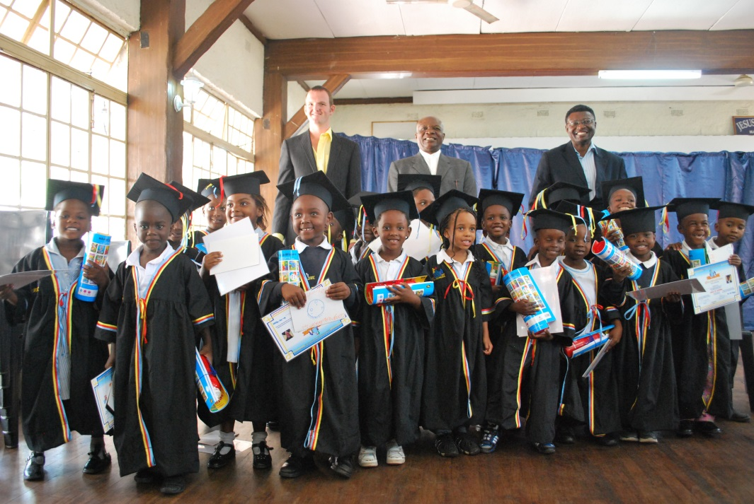
The ceremony today included praise and worship led by the children, memory verses, dramas including The Gruffalo, The Three Little Pigs and The Gingerbread Man, Pastoral Addresses from Pastor Sean and Pastor Gatsi and a guest of honour from Econet who kindly donated money to fund 4 laptop computers for the school. The children then received their Graduation Certificate, a Testimonial (End of Year Report!) and a gift of one workbook and a drinks bottle. We had a fun packed afternoon with a Braai (BBQ!), Jumping Castle (Bouncy Castle!) and Face Painting for the children and their families. What a delight it is to celebrate the achievements of the young children we have educated. Pictures will be at www.onewaypreschool.co.zw on Monday.
Visas
It is with great pleasure that I can announce we have been successful in securing our Temporary Employment Permit Visas for one year until October 2014. As you will be aware, we have had 30 day extensions since June 2013 and there were many months where the possibility of us having to leave became very real! But, with God’s favour and the unrelenting prayers and support from our Friends and Family in England and the rest of the world, we are delighted that the application has been successful. Now to use the year we have been given to full effect!
Teacher Training
The end of year is naturally a very busy time, with Graduation, End of Year and Christmas all merging in the final 2 weeks but we are also hosting our very first Teacher Training Course next Wednesday and Thursday (5/6th) December. We are fortunate to be able to offer 30 spaces and these filled within a week of the course being announced! Each attendee will receive a certificate of attendance and we are eager to meet each teacher, develop their teaching skills, fill them with knowledge in the basic foundations of Early Years Education and hopefully offer advice, resources and support. The course will cover one full and one half day, and include two sections of Classroom Experience where the trainees can observe us both teaching in the classroom (15 teachers observing one lesson…scary!) we hope this practical experience will encourage and motivate each teacher to develop their own classrooms and schools.
Other Centres
We are delighted to hear that some of the adults who are attending our teacher training course are from other One Way Ministries churches around Harare. Two of the centres in Highfields and Epworth, are hoping to open One Way Pre Schools at their centres with one hoping to open in January 2014 and the other later in the year. This is a HUGE development and we are delighted that the church is taking initiative and that One Way Pre School Mabelreign is now a catalyst for further pre-schools in the One Way community. Watch this space!
The future of One Way Pre School Mabelreign
As the first year of One Way Pre School comes to a close, we have taken time to consider the amazing achievements and how best to ensure the future progress and sustainability of the school. The current plan is that as of January, both of us will reduce our hours at the school to 7am-1pm. The intention being that after the first term, we will step down as the full class teachers and Lorraine and Patience will take over as full class teachers for Nursery and Grade Zero respectively. We will continue to work at the school in a slightly different capacity, observing and monitoring the classes and teachers . The final intention being that by the third term of 2014, the school is completely sustainable without us needing to work in it. We will be hoping to use the afternoons to provide tutor support to older children as well as community projects that we hope to establish in the church centre.
General Info
We were fortunate to have a flying visit in the form of Mike (Sophie’s dad) and Simon, who passed through Zimbabwe on the way (or a little out of the way) to their trip to Burundi. We had a lovely few days spending time with the children at the school and visiting the Cathedral in which Mike was christened as a child. Such fond memories for us to learn of, it is exciting to think of the many memories we will be able to pass on to generations of our own family!
We also have the pleasure of hosting our good friend Ella for 3 weeks after her epic travels across Asia and Africa. She has been supporting us with Graduation, teacher training and hopefully spending some time in the Hatcliffe community visiting the nurses and midwives there. We are super excited to have her with us and please do take this as another invitation to visit us if you feel a desire to!
A quick note to say thank you for prayers and support after I (Sophie) was attacked by some dogs! I am fine and have some rather cool scars to remind me of the incident in the years to come, I feel rather hard core really!
Primary School
We announced yesterday at our graduation that it is the intention of One Way Ministries to open a primary school at the beginning of 2015. Please check our blog as it details our proposals in more detail. It is early to be discussing such a project but it is very exciting and is so needed by our community due to local schools bursting with children.
Feedback on October Prayer Requests
Visas – that we would receive a permanent one year visa Success!! Thank you!
Graduation Success!! Thank you again!
Funding and Plans for teacher training course Donations for 20 teachers received from friends and family and plans in place for a packed two day timetable
Prayer Requests
- Teacher Training Course – that the teachers would receive valuable knowledge, that we will build lasting relationships and that we would not be nervous! For more funding to come in to cover the cost of the ten remaining teachers.
- 2014 school changes and future projects – that we would receive clarity and wisdom on how best to move forward and new projects would be created
God Bless and thank you again for your continued support, we couldn’t have done it without you!
Love Greg and Sophie xx

