November Newsletter 2014 gregandsophiesangwine@gmail.com www.gregsophiesangwine.org.uk
Dear Friends,
We’re sorry for the lack of updates over the past few months. London life is certainly busy!
JT
JT was born on Sunday 5th October at 03:47 in the morning. He was a bit of a surprise as we went down to Epsom for Greg’s sister’s birthday and decided to stay with Greg’s parents in Bookham for the evening but at 11pm my waters went and we ended up having JT down in Surrey, He weighed 5 pounds and 4 ounces and is the most amazing little miracle that we’ve ever seen. Unfortunately he had a setback last week and ended up spending 5 nights in hospital with bronchiolitis. He was struggling with his breathing and had lots of oxygen support. I’ll write a blog in the future about the hospital because the nurses and doctors and everyone else at the hospital were completely amazing – thank-you to everyone for their amazing support.
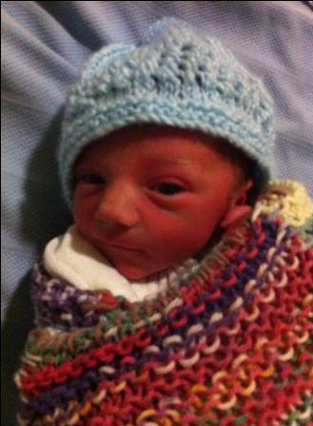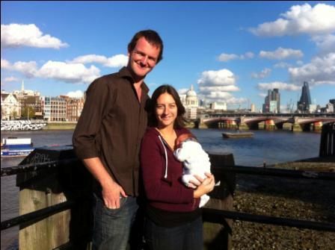
JT’s Dedication
We’re having a dedication service for JT at Catford Community Church at Holbeach School on Sunday 14th December at 10:30. Please come and celebrate with us and stay for some mulled wine, mince pies and cakes afterwards.
Greg’s work
Greg’s been teaching year 5 at a school in Waltham Abbey in a school in special measures. He’s had a busy time with lots of moderations, data analysis and observations but has had a great time where he’s learnt heaps. It’s been a great opportunity for him to focus on his professional development and also earn some dosh for our future,
Family and home life
We’ve been so grateful to be living with Mum and Dad in Waterloo since we returned. Their support and care of us is amazing and it’s been great for JT to spend his first few weeks with his Grandparents, We’ve had a lovely time in London as it’s also been really nice to see all our family and friends so much.
One Way School
The school got its city health certificate this week so we are opening 2 new classes in January. The health certificate is for 45 children per building which means we’ll have 22 children in each class and 4 classes. (88 children). The renovations should be completed by the time we return to Harare but we have recently heard that ‘the new building floods when it rains but don’t worry we’re fixing it’ which is a little worrying…
We were donated 1000 pounds from the Charlbury Beer Festival committee which we’ve used to buy 755 reading scheme books for the school. We now have 6 copies of the entire jelly and bean series so we can do group reading which will be completely amazing. The children love reading so we’re so excited to see their development with these amazing resources. Now all we need to do is work out how we’re going to get 48kg’s of books to Zimbabwe…
Return to Zimbabwe
We fly to Zimbabwe on Sunday 28th December and open the two new classes of the newly formed One Way School on Tuesday 13th January.
Fundraising
Within the next few years we hope to extend the building to an extra classroom every year. The local church and the parents of the pupils will fundraise locally for the future costs for these renovations.
Any financial donations from the UK will now be used for any of these reasons and you can specify, if you so wish, where you’d like your money to go:
- Assisted place education: Sponsor a child to attend our school whose family cannot afford it or the child hasn’t got a family. Cost: 20 pounds every month.
- Adult education: One Way Pre-School is proud that so far Prudence Yohana, Lorraine Machingura, Patience Mpofu and Rumbi Chapwanya have all become qualified teachers whilst working with us. Their course was 9 months long and cost 40 pounds per month each. We’ve heard if you educate a teacher in Africa, he or she will teach a minimum of 30 children a year for an average of 20 years. That’s 600+ children educated for just 360 pounds.
- Food: We currently feed all our youngest children who are at the school all day (44 of them). We’d love to feed more children. 5 pounds a month feeds another child.
- Donation of resources: You could buy or collect any resources that would be useful in a school. Particularly Science and Maths resources. Pens, pencils and other stationary are easy to find but guided reading books and stories are difficult to source. Other games and puzzles and particularly resources to use outdoors would be greatly received. If you have any of these you can post these to Alison Sangwine who will arrange shipping of resources to the school every year. Her address is in the support section of our website.
- Shipping donation: Shipping of resources is expensive. Last time this cost over 1000 pounds.
- Greg and Sophie: Living in Zimbabwe is expensive. Every year we apply for a visa which costs 350 pounds and insurance which costs 1000 pounds per year.
I’d like to help! What can I do?
- Click support on our website to download a stewardship services form and donate through our ministry called Hope for Harare where you can also gift aid your donation.
- Donate a one off donation through pay pal on our website which will go directly towards the day to day running of the school.

Final Thought: We have read forms like this before hearing about others’ work abroad and felt overwhelmed. I remember thinking that I could probably afford something small each month but asking myself what a difference can I make? The answer is a huge difference.
For example if 8 people donated 5 pounds/ month for a year we can educate a new teacher to benefit a generation of Zimbabwean pupils. There really isn’t too little to donate, it really does go a long way.
Prayer points
Thank-you God for: JT, family and jobs
The future of One Way School including all necessary documentation and registration of new children
Fundraising for future developments and assisted places
Thank you again and God Bless!
Sophie, Greg and JT xx

