Dear Friends,
We read somewhere once, that the second year of a mission’s project is often the hardest, and we’ve been facing quite a few challenges since we returned from England. But after the last newsletter, we got the most replies from any newsletter we’ve ever written and it really spurred us on. Thank-you for your e-mails and prayers, it is so encouraging hearing that people are reading these updates and praying for us. Please drop us a quick e-mail when you’ve read this even if it just says “Hey Guys- praying for you now!”
One Way Pre School Graduation
Friday the 29th November will see the first One Way Pre-School Graduation. I like the fuss the schools make out here of their transition from pre-school to primary school. We see it as moving from reception to year one and I’m not aware of a celebration being made of it. It is, however, a whole lot of over kill but it means we get a couple of hours where we can celebrate the achievements of these young children and show them off to their parents and church family before they go to primary school.
The tradition includes graduation gowns and hats, official certificates and food. Our graduation will begin at 11am and finish at 1pm when the children and parents will be able to eat together. We have been told (and we know from going to one last year) that these things can take over 4 hours. The kids and parents are expected to sit through hours of monotonous memory verses and every song they have learnt to show off the school to prospective parents. This is not really our style and if we’re honest we also think 2 hours is actually also too long! Our graduation ceremony will consist of the children leading everyone in worship, memory verses, a brief talk from me and Pastor Gatsi and 3 dramas from the Grade 0 (reception) class. The Gruffalo, The 3 little pigs and The Gingerbread Man which are their favourite stories. To finish, a couple of parents will stand up to share their testimonies of the children’s progress, before we all eat and the children get to play on the bouncy (jumping) castle. It is a lot to do and prepare for but we are glad we’re doing it because for those 2 hours, 20 children get around 100 other people celebrating their achievements. I’m sure it’ll be something they remember for a long time. We will send our November newsletter the day after graduation so we can send you all pictures.
Below is a picture of our graduation gowns as modelled by Sophie, Tawananyasha and Jadon:
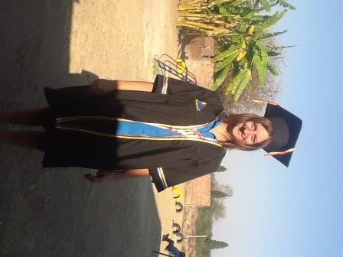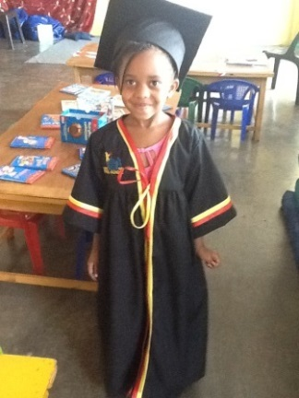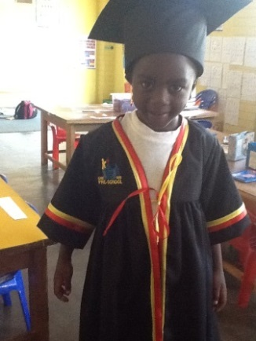
Teacher Training Course
We’ve taken the bold and incredibly frightening step of running a teacher training course the last week of this term. Back in February we had a couple of locally trained teachers come to see what we do at our school and they were so keen to learn they said they’d loved to have an affordable course they could come to, to aid their professional development. More recently we’ve been visited and they don’t understand how our Pre-School kids are reading, writing, calculating and speaking confident English. They want their kids doing the same so they want the training.
Although teaching teachers is certainly not something either of us feels hugely confident in, we’re aware that we were incredibly lucky to have a great education ourselves and to not share it with others would be a waste. We’ve been lucky enough to educate 55 children this year and 6 others who have left for various reasons. But if we train 30 teachers and then they teach 30 each then we’ve reached hundreds more. We feel this is now a very important step in the future of our ministry work.
Local training courses are very expensive. Rumbi (our new teaching assistant) just went on a half day phonics course at a local school. We thought this was a great opportunity for her to learn how other schools do phonics too and she got a lot out of it. But it cost us $25 to send her on it.
Our plan is to offer a one and a half day course (Wednesday 4th December – Thursday 5th December) for free and invite local and rural school teachers. Our course will include planning, assessment, curriculum, indoor and outdoor provision, phonics, resources in the local environment, budgeting and staffing. We’ll be putting ourselves out there as trainers to be observed by the other teachers where they’ll hopefully see the theories in practice.
The catch is that to offer all trainees packs of information, resources for each school that attends, accommodation and food for everyone it is going to cost us money we do not have. We have estimated that 200 pounds will cover the whole one and a half day course for 30 teachers. We are again asking for one off support from anyone who can afford. Currently we send this newsletter to nearly 100 people. That means if everyone reading this donated 2 pounds we could offer this course for free! If you would like to help you can donate through paypal by clicking donate on the front page of our personal website. I know in the past I’ve read similar newsletters and wondered what donating only 1 pound can do but I assure you, if that’s what you can afford it will make a difference! It’d be such a great encouragement to us personally and you’d be sponsoring adult education in the process.
Feedback on last month’s prayer requests
Thank-you for your continued prayers. Here’s last month’s ones and what God has been doing:
- Children and families of One Way Pre School – Recently one of the parents commented how the school is more like a family than a school. They commented we really care about all the children.
- New staff at school – Wilson and Rumbi – Both have said recently how great it is to have regular employment and their work ethic and support is fantastic.
- Electricity and water situation – that it would improve and we are able to cope with the worsening situations! Both have really improved. We got a generator through a generous donation and the electricity and water shortages have both improved, or at least we are better equipped to deal with them! – Thank-you God!
- Visas – that we would receive a permanent years visa – We have the 30 day extension in place but we’re still waiting for comfirmation of our visa which we paid for May 3rd 2013.
- Future projects – The plans for the teacher training course are in place. Once funding is in place we are a go!
Visa situation
We, again, got a 30 day temporary employment extension and we’re still waiting on the visa we bought on May the 3rd. Our extension runs out on 28th November so we are praying this will arrive soon.
Website
This week we have tried adding more gallery pages to our website and we are continuing to write some blogs so please do head to www.gregsophiesangwine.org.uk to check out all that is going on.
Prayer Requests
- Visas – that we would receive a permanent one year visa
- Graduation
- Funding and plans for teaching training course
God Bless and thanks for all your support,
Love Greg and Sophie xx

