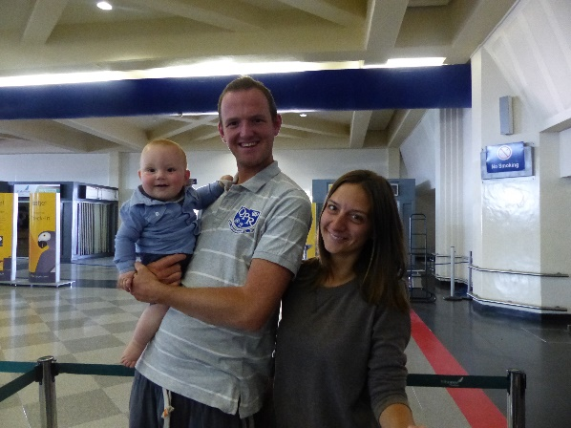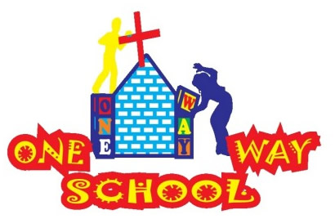

SANGWINE NEWS  
Harare, Zimbabwe

October 2015

Sometime in life you ask; *“where has the time gone?”* and it couldn’t be truer for the month of October. I’m not sure where it’s gone but we’ve had so many exciting things happen that we got to Monday the 2nd of November and thought; darn it – we must share news TODAY.

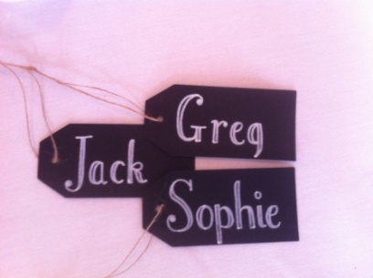

**Dear Friends and Family,**

**News from last month’s prayer requests**

**Prayer Points**

* For continued healing for Greg, Sophie and JT with various injuries, ailments and illnesses – We are glad to report we are all now well and feeling great
* For breakthrough with building works and projects including planning permission and finances – We are glad to report that the building works began, our going and all relevant permission has come through
* For a reconnection with the Church leadership as they return from Israel including serious discussion about the schools future including staffing – We have employed new staff members for 2016 and conducted interviews with Pastor Gatsi and Pastor Chidewu. We feel relationships with One Way Ministries are the strongest they have been.

**Personal testimony**

The other day JT and I were walking around Avondale and we walked past a group of men who were drunk and rather smelly. My first thought was to avoid these guys and walk the other way. However, JT doesn’t think like that, he loves everyone. He kicked his legs, waved his arms and smiled at the men. So, following the lead of my baby we went over and greeted the men. JT had a cuddle with a man, I chatted to the group and they all seemed delighted to meet with us.

As we walked away I was challenged by the thought that I’d just been taught a valuable lesson by my one year old. Those men are also children of God and Jesus taught us to love our neighbour as we love ourselves. I asked myself what had happened to me over the 28 year difference I have with my son that I forgot to love everyone. My challenge was that JT loves everyone but I do not. I naturally judged those men.

So, I went home and shared this with Sophie and we thought together what life would be like if we looked past colour, race, circumstance and just saw each person as; a child of God. What a better place the world would be. From now one I’ll strive to love everyone, just as JT does.

**One Way School**

In January 2013, when we opened the pre-school we prayed for 30 children and God gave us 35. In September 2013 we had wanted to grow the staff team so we asked God for 50 children, he gave us 55. At the beginning of this year we ask God for 90 children and he’s given us 95. Quite a testimony I think you’ll agree.

This time we have put a staffing structure in place to mean the school can operate for 150 children. So, we’re trusting God that he gives us that many children. 150 children will mean we can afford that staffing structure and have enough money to grow the school without the need for additional international aid. I feel God wants One Way School to be sustainable and he’ll bless us with this bold move.

**Fundraising**

The One Way School PTA has raised $4000 this year to build two new classrooms for the school which is an amazing achievement. But, we need $9000. Catford Community Church has committed to raising 2000 pounds towards these developments which is an incredible investment. Leading by example Ian Butcher; the team leader of CCC is riding 82 miles to raise the school money. We would love you to support him and give him some money so we can reach our goal.

These classrooms are essential to the growth of One Way School and we believe they’ll educate these current pupils’ Grandchildren in the future so when you invest in the school I believe your money is helping to grow a generation of Christian leaders in Zimbabwe. What we can do with ten pounds is hardly anything. But, if you donate ten pounds today what God can do with it is unimaginably amazing.

If everyone reading this today donated Ian Butcher a tenner then we’d actually double our goal and therefore be secure in offering the wonderful people of One Way School education for the next generation as well.

[www.onewayschool.co.zw/support-ian](http://www.onewayschool.co.zw/support-ian) to donate.

Thank you

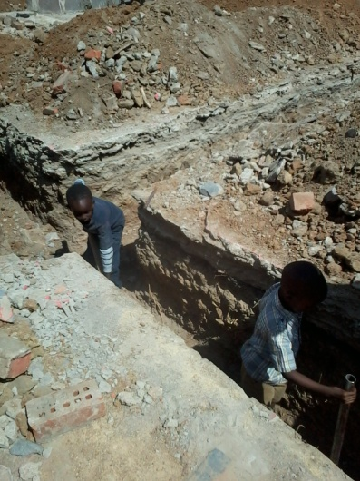 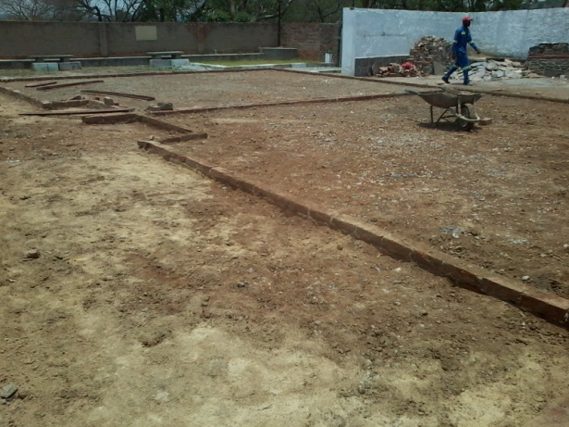

Contact Info

[www.gregsophiesangwine.org.uk](http://www.gregsophiesangwine.org.uk)

[gregandsophiesangwine@gmail.com](mailto:gregandsophiesangwine@gmail.com)

[www.onewayschool.co.zw](http://www.onewayschool.co.zw)

**Prayer Points**

* Thank God for the answered prayers above
* For continued completion of the new school building and toilets and that buildings would be completed before Christmas so over December we would have rest before beginning again in January.