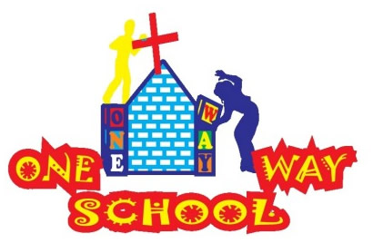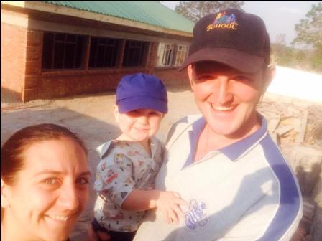

Apologies for the delay in sending….there’s no excuse, we just…forgot! Too busy melting in the heat….!!

October 2016

SANGWINE NEWS  
Harare, Zimbabwe

**Dear Friends and Family,**

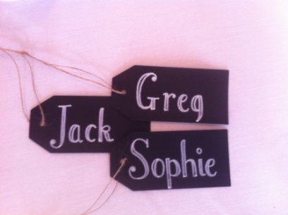

**News from last month’s prayer requests**

**Prayer Points**

* For the UK team as they meet and prepare for their visit at the end of October – for a fantastic time whilst they are here! – SO answered. See below
* For Zimbabwe as a nation as it navigates its way through turbulent times - ongoing
* For energy and enthusiasm for children and staff alike as we power through this mega term! Lots of fun and hard work to be had – ongoing, but great!

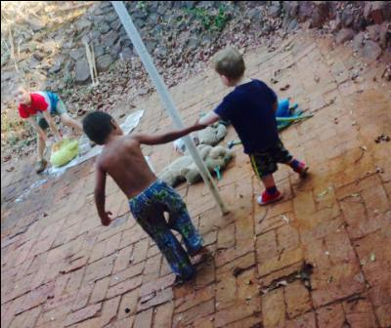

**UK Team**

WOW! We had an absolutely INCREDIBLE week with the team who came from our home church CCC for one – action filled-week! Please see the next page for a few photos of what they got up to – it is only a snapshot.

We were so, so blessed by their hard work and enthusiasm and general support of what we are doing here. The children and staff alike loved them all and we had such productive times mixed in with great opportunities for socialising.

The team undertook some class teaching, teacher training, practical new build work including painting and cleaning, kids church, one on one child support, rural project visits and a whole heap of play! We also took a day out for safari and enjoyed a mega braai at our house.

We are so grateful for the sacrifice everyone who visits us here makes, we know it is not cheap and it’s not a luxurious location – but the appreciation felt by everyone here is so worth the effort everyone makes so thank you!!

We would also like to thank all those who gave so generously either financially or through physical donations – the team brought SO MUCH stuff with them - all hugely beneficial for us!! So thank you for being so generous.

If you are interested in coming and spending some time with us here, either on holiday or on a short (or long) term missions trip then please do contact us, we value every person!

**School**

We now have less than 5 weeks until the end of the school year – CRAZY!! We have a whole heap happening between now and then including assessment week, fundraising events, pre school graduation and prize giving, swimming galas, reports and class change-over week (meet the teacher). So we are BUSY! Please do pray for us as we lead and motivate the school staff especially for this final push.

We continue to develop the Grade 4 classroom for opening in January and are so grateful for the timely donations (thank you Lord!) of paint to cover above and beyond the amount we needed for the classroom.

We now need intervention with regards to the next phase for Grades 5,6,7, most notably where we are going to put them. Also, for continuing intervention in the registration of the pre-school and primary school.

We are also looking into developing the swimming pool and ICT education!

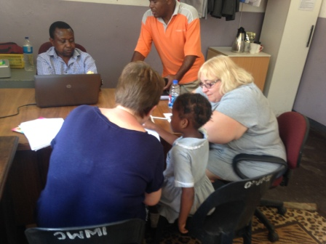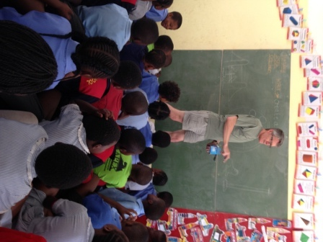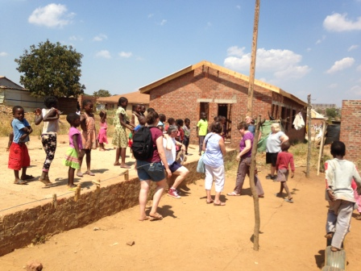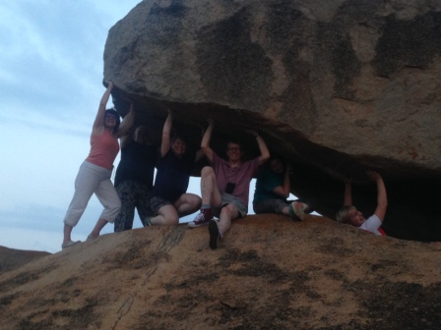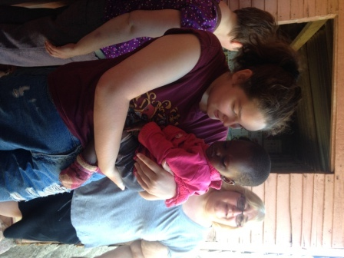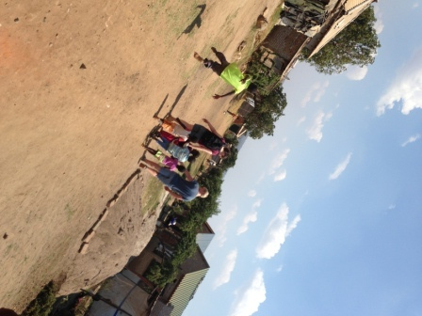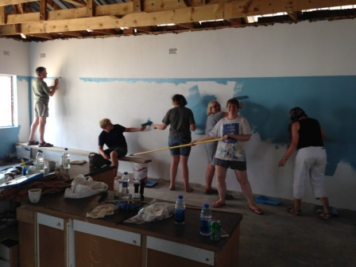

**GAP YEAR**

Are you a teacher? Do you know a teacher? Are you in need of a new challenge? Something a bit different for a while?

Come and spend a gap year here!

We’d arrange your accommodation, a vehicle to use, your visa and an allowance to live on. Inspired? Send us an email.

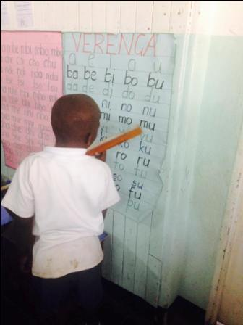

‘E’….doing Shona

**Prayer Points**

* *For the end of the school year as we give a final push of encouragement to complete all that needs doing!*
* *For the Grade 4 building, that we would receive the necessary funds for completion*
* *For us personally as we seek to maintain good health and some rest in the madness!*

Contact Info

[www.gregsophiesangwine.org.uk](http://www.gregsophiesangwine.org.uk)

[gregandsophiesangwine@gmail.com](mailto:gregandsophiesangwine@gmail.com)

[www.onewayschool.co.zw](http://www.onewayschool.co.zw)

***Please come and visit us – we LOVE visitors!!***