September Newsletter 2014 gregandsophiesangwine@gmail.com www.gregsophiesangwine.org.uk
Dear Friends,
This is our third September Newsletter! Time has flown since we started our work in Zimbabwe and so it is with excitement and some shock that we write this newsletter sitting in a flat in central London knowing that the project we have begun in Zimbabwe is flourishing by itself and we are embarking on a new, exciting chapter in our journey!
Time in UK
You will know from previous blogs and newsletters that we are currently back in the UK and have been since August and will be remaining here until the end of December – when we will return to Zimbabwe. We have had such a super time since being back, it’s been a strange transition returning to English culture and has taken a little longer to adjust this time around! The weather has taken some getting used to, but I am looking forward to wearing winter clothes again – scarf, hat and gloves at the ready! I hope there is snow!
Greg is a settled member of his school now as a year 5 teacher and we are grateful for the opportunity he has whilst here to network with people and further his professional development through maintaining his teaching skills in UK. Naturally he is facing the same struggles as all teachers with long days and plenty of paperwork but the children are a delight and are all excited to meet Mr Sangwine’s baby!
JT
We are blessed that JT is growing well, average on all counts currently! We are over 35 weeks in so not long to go until he is here ready to face the world with us! We are super excited to expand our unique little family and are excited to share our Zimbabwean adventure with him.
Pre School
One Way Pre School is continuing to go from strength to strength and the staff are an absolute asset to themselves and the community. The school has gained some new children since we left and they have settled well. Each staff member has had to take on new roles and responsibilities and have done so with gusto! It is so encouraging to see the school sustaining itself and providing such excellent education to the children without us.
The Pre School is currently facing some challenges with regards to changes to the ministry of health guidelines and ministry of education – there are some unforeseen works that need to happen – mainly health and safety and hygiene issues, which mean costs that we had not anticipated – please pray for financial developments in this area.
Primary School
The Primary School is developing day by day and below are some photos of the recent developments including plasterwork, electrics and plumbing. As with when we opened the pre-school, it is reaching a time where the rooms look a mess and we have to try hard to visualise what the school will look like, but we know with God’s provision they will continue to develop and take on their final form! Charles is working exceptionally hard to complete all the renovations and we are stoked that he anticipates finishing all the renovations within the next couple of weeks!
The next stage will be decorating and health and safety within the rooms, followed by collecting together resources such as chairs and tables, storage and classroom resources. We have been so blessed with the donations made thus far into the project and have raised half of the final total needed to complete the works!
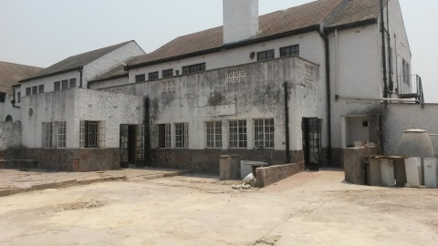 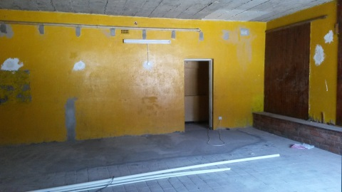 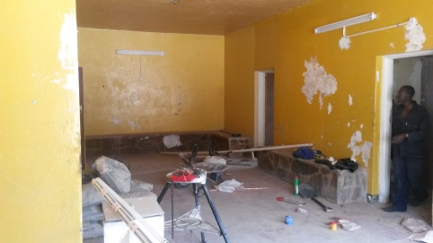
Grade 1 and 2 classroom building Grade 1 classroom Grade 2 classroom
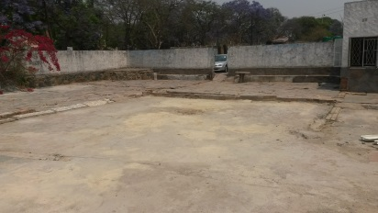 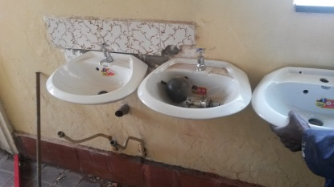 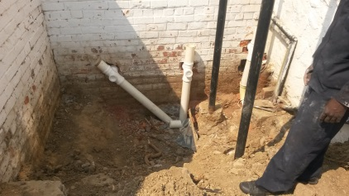
Outdoor courtyard Wash basins Plumbing
The Primary School itself is also facing some challenges again related to the ministry of health and ministry of education guidelines. These are quite serious challenges and Pru is currently working overtime to communicate with various offices and departments to understand the logistics of what paperwork is required to what departments. There are a number of options available but all come with their own challenges and it is currently a search for a ‘best fit’ option. Pru is confident she will work through this but with the Pastors away in Israel and the end of term looming ever closer, we need to pray and support her in the greatest way possible as without the registration documents, the Primary School cannot open in January.
Fundraising
As mentioned, we have been so blessed by all fundraising efforts both here in UK and by the pre-school in Zim and have raised half of the $10,000 we estimated needing to open the Primary School. There are a few events scheduled to happen in Zimbabwe over the next 2 months and we are grateful that Mike and Sue and Andy and Sophie have both got a stash of Zimbabwean goods that they are hoping to sell in the next couple of months including a seriously fun selection of Christmas decorations! (getting excited about Christmas in September, I can’t be the only one!) We will, however, be limited in what we can achieve within the next 2 months in terms of the Primary renovations and registration costs without praying for God’s provision in terms of finances. It is a huge total to ask but we know it can be done! If you are able to spare any financial amount towards the project or have an idea of a fundraising activity that we could highlight, please do get in touch via the website where you can donate directly through paypal or send us an email – we cannot explain how grateful we are for your continued support.
Ali Volunteering
You will know again from previous (and recent!) blogs that we have a super enthusiastic volunteer working in Zim at the moment in the pre-school, primary school and supporting various projects with One Church. Ali has been out for almost a month now and has been stuck in from the get go! We are delighted at how she has been received in Zim and are thankful for the support she has both given and received. Please do keep up to date with her blogs on the website which include some photos. She has been a valuable asset to the team and we hope her volunteering experience will be an encouragement to any friends or family you may know of who may be interested in spending an extended time out in Zimbabwe with us!
Prayer Points
Thank you God for
- Greg’s job and continued healing
- Sophie’s health and healing and JT’s continued development
- One Way Pre Schools sustainability and continued growth and development
- One Way Schools renovations
- Ali’s expert support to the staff and all projects she has become involved with
We ask for
- Support and guidance for Prudence as she works through the logistics of registering the Primary School
- Open communication lines with the Pastors and the school as it continues its developments
- Renewed energy for Charles as he continues to strive to complete the Primary School renovations
- Financial support to come to complete the Primary renovations
Thank you for your unwavering support and God Bless,
Greg and Sophie xx

