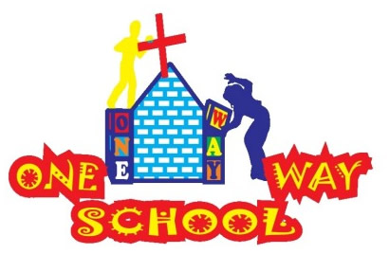
SANGWINE NEWS
Harare, Zimbabwe

September 2015

Phew, September has come to an end, and what a MEGA few weeks it has been! We have returned to Zim, reopened school for the third term, organised fundraising events, begun some social activities, got more involved in church life and managed some sleep in between!
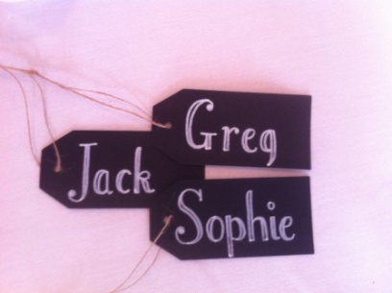
Dear Friends and Family,
Harare
Daily, the city is finding it increasingly hard to function with little to no water and power cuts ranging from 6-48 hours regularly. This causes problems with lighting, food storage, administration, charging, cooking and general living for the majority of people. In particular, the food waste from lack of cold storage options with no power is a big problem. We are fortunate to have installed a small solar panel to run some lights and one plug point in our house and at school, allowing for basic tasks to still be completed- this helps greatly. However, phone networks are struggling with the power loss causing problems with communication – again an issue when trying to run a school! Lack of water causes problems with flushing toilets or hand washing – again not great for a school! So it is these basic day to day functions that cause the biggest challenges. The city is struggling. The country is struggling!

Home Solar Power – Inverter, roof panel and LED lights
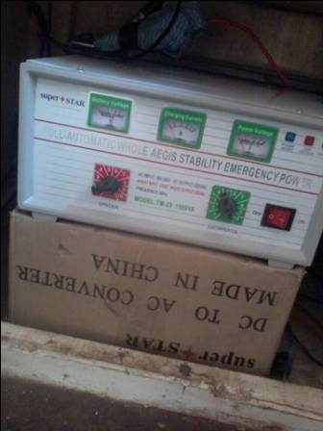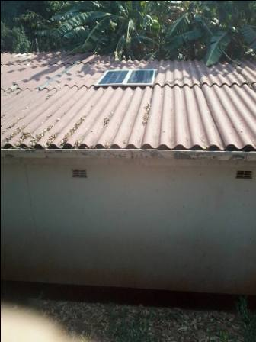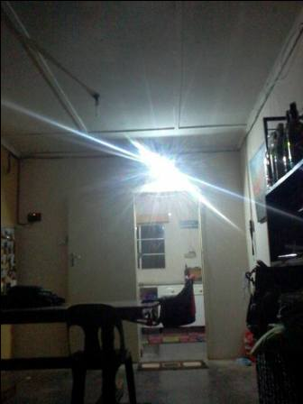

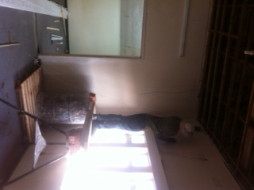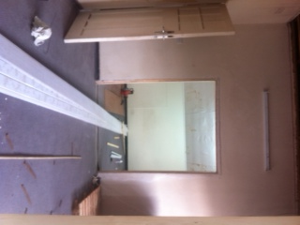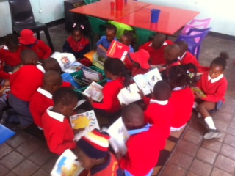
One Way School
The school now has 95 children registered across the 4 classes and already we are receiving some registrations for 2016. We will be opening our 5th classroom – Grade 3 – in 2016.
We are pleased that Uncle K who was going to be leaving us has decided to remain teaching, giving us a stable teaching team for each of the classes. We have, however, had to lose another staff member due to breach of contract. We have employed a stand in member of staff to cover the staffing shortage whilst we seek to collect CV’s for a number of roles to be filled in the new year including a full time cleaner, primary school qualified teacher and an administrator.
Each year, we are continually seeking to build for the expansion of the school including classrooms, toilets, sports facilities, library (see pictures below) and so on. We have attached a further breakdown of this for you to read and hopefully support us with.
Personal Life
We have settled well back into our normal routines and JT in particular has adapted well to the change in climate and new daily routine, particularly he enjoys being able to spend so much time with his Auntie Chassie again every day! He will be turning one in a few days (5th October) and what a first year he has had! Still resolutely refusing to move, but his sleeping is much improved! Some nights he even sleeps through – Hallelujah! He is growing so well, is a delightfully happy child and we are blessed to be able to share in his life adventure as a family.
Greg has started back into school with a bang and been very, very busy, but is enjoying the challenges each day brings. His back/ legs have been causing some more pain, however this seems to be subsiding slowly – in part helped by the opportunities he now has to swim every day and play 5 a side football socially.
Sophie is settling back into routines with juggling JT and school and is finding a balance with these. She has started dance classes (hip hop/ street!) and is hoping to possibly join a ballet class also for social opportunities. Her back is also causing considerable pain quite frequently so prayer is needed for healing for both!
Prayer Points
- For continued healing for Greg, Sophie and JT with various injuries, ailments and illnesses
- For breakthrough with building works and projects including planning permission and finances
- For a reconnection with the Church leadership as they return from Israel including serious discussion about the schools future including staffing

Contact Info
www.gregsophiesangwine.org.uk
gregandsophiesangwine@gmail.com
www.onewayschool.co.zw

Fundraising
So far the growth of One Way School has exceeded our expectations. But, where there is growth, it is important to continue to remain ambitious. We want these children to have the best education possible. But, we need your help to break down the financial barriers we currently face.
Through much advice and prayer we have drafted a plan for the development of One Way School and we want YOU to be a part.
Goal | Fundraising target | Time scale
Resource school library with a large selection of high quality reading material | All through donated books that can be bought to Zimbabwe in visitors suitcases. | On going
Purchase of new chairs for classrooms | 8 pounds per chair – 150 chairs = 1200 pounds | January 2016
Development of school sports field. Levelling an existing field and planting new grass. | 500 pounds for hire of large digger to level land and buying lawn seed for planting the grass. | A.S.A.P
School Computer suite with 15 laptops | 3000 pounds buys all the laptops, a projector and board, all software and a server to network everything together. | September 2016
Purchase of gymnastics apparatus for indoor PE hall | 1000 pounds | Open January 2017
Renovation of old swimming pool for use for lessons | 1750 pounds | A.S.A.P

Can you organise your own fundraising event as a church or a group of friends to contribute to any of these areas?
January (3years after opening) we will be offering affordable education to between 100 and 150 children each day.
The building of a new toilet block and two new classrooms will be built solely from the fundraising of the One Way School PTA. Can you support the hard work of these local people in any way? Your donation really would help us to change the lives of a special group of children.
Please contact us if you are able to support us further with any of the above mentioned projects. We thank you for your support!

