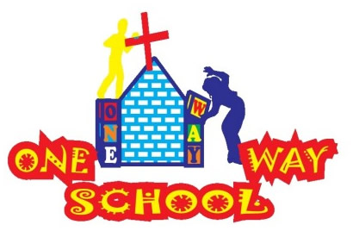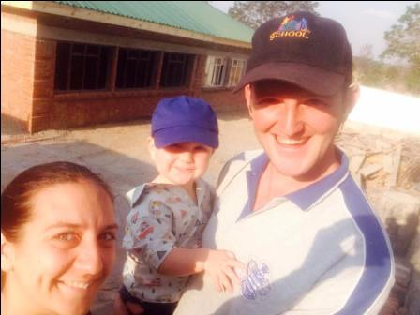

September has come and gone in a flash! We have been crazy busy – but that’s never a bad thing! We are thoroughly enjoying the serious heat also!!

September 2016

SANGWINE NEWS  
Harare, Zimbabwe

**Dear Friends and Family,**

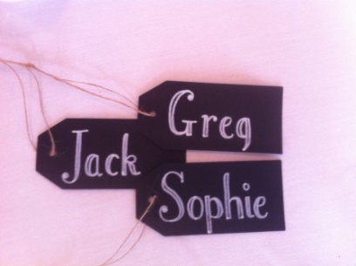

**News from last month’s prayer requests**

**Prayer Points**

* *The stability of the country, its government and economy – please read below*
* *The building works for the Grade 4 classroom – answered - please SEE below!*
* *Our family holiday to the UK – for rest and fun! – ANSWERED!*

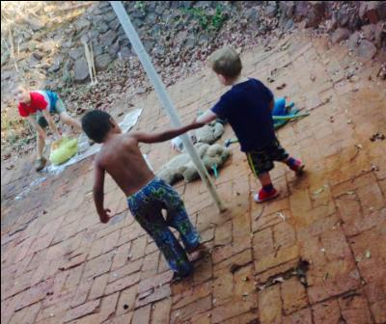

School, Stones and Small miracles!  
We have 120 children registered and almost daily are receiving enquiries about next year so we are SO thankful to God for continuing to provide for us. The children are daily praying, worshipping (loudly!!) reading the bible and genuinely sharing the love of God to anyone and everyone, and it is such a joy to be a part of. They are simply wonderful kids and we feel so blessed to be a part of shaping them.

The school itself continues to grow with regards to the building works. We have 75% completed the Grade 4 building and just need to do ceiling, painting and electrics. We have also covered the outside area in stones in order to reduce the serious dust issue we have going on with the dry season. We are also awaiting work this weekend on the verrandah and courtyard of the new classrooms plus drainage to ensure safety and again to reduce the dry dust issue.

We are continuing to pursue various avenues for the Grade 5/6/7 developments which need to be started in the new year in order to maintain the schedule for completing the primary school. We are still needing huge prayers for this as none of the option are looking ideal at the moment. We are also still facing battles with the school registration and would appreciate prayers here also.

We are SO delighted that we have taken two boys, one of whom has autism and the second who is yet to be diagnosed but has sensory processing disorder and potential behavioural needs. They are such lovely boys and although we are not necessarily ‘equipped’ to take them, we are daily seeing improvements and achievements in them both. One of the boys, in Grade 1, particularly dislikes speaking the local language. However, in the last few days, he has not only remained in the classroom for the Shona lesson, but has also begun speaking and writing the language – which is a small step, but a small miracle in itself!! So please do pray for both these boys as we make decisions on how best to support them whilst they are at our school.

**Our Country**

Zimbabwe continues to struggle with ongoing protests, some violence, corruption, deception and fear. We continue to hold our breath for the introduction of bond notes scheduled for the end of October – which brings with it a whole heap of uncertainty. Already we are seeing the decline of many goods due to the inflated import taxes on a huge number of items, reducing anyone’s ability to trade across borders. Cash flow is incredibly low and people are beginning to stock pile goods in fear of a repeat of the 2007/08 times. Many are beginning to leave the country to look for work elsewhere. Everyday people are pleading for democracy and an end to the suffering they have felt for many, many years.

We are unsure of what the near future holds, but we remain steadfast in faith. ‘I lift my eyes up to the mountains, where does my help come from? My held comes from the Lord, maker of heaven and earth” Psalm 121

Team, time and toilet training

We are SUPER excited that we have a team from our home church CCC coming here at the end of October! We have 6 people, 4 adults and 2 teenagers, and a serious range of skills and abilities which we are delighted to be able to put to good use whilst they are here. PLEASE do get in touch if you would also like to come and visit or volunteer at any time, we can always make use of you!

Time is absolutely flying and this third term is always the craziest as it is end of school year, it’s often over 30degrees and is very dry and dusty….and then the rains hit and its hot and wet! So we love the craziness but please do pray for us as we push through with all the end of term happenings – school trips, assessments, reports, graduation and prize giving, swimming galas etc…

We are also SO excited that JT will be turning 2 on the 5th October!! It has quite literally been the best 2 years ever (if also the MOST TIRING!! Hehe) and with his 2nd birthday, comes toilet training! He has quite literally the most luxurious potty I’ve ever come across with a backrest and handles and is quite literally like a throne. So, I guess we’re gonna need some prayers…I’ve heard it’s never a plain sailing phase!! But he is talking – ALLLLLL the time – and has a huge vocabulary, and is super intelligent (or so many people tell me…!) and continues to be the most entertaining human I’ve ever encountered, so we are thankful to God every day for our not so little Jack Tapiwa – Our gift from God!!

**GAP YEAR**

Are you a teacher? Do you know a teacher? Are you in need of a new challenge? Something a bit different for a while?

Come and spend a gap year here!

We’d arrange your accommodation, a vehicle to use, your visa and an allowance to live on. Inspired? Send us an email.

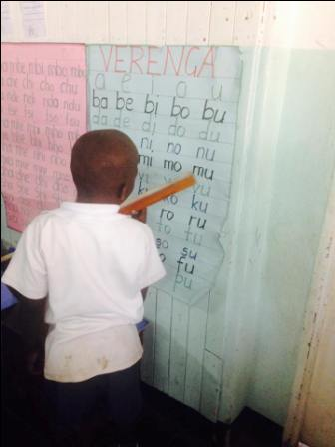

‘E’….doing Shona

**Prayer Points**

* **For the UK team as they meet and prepare for their visit at the end of October – for a fantastic time whilst they are here!**
* **For Zimbabwe as a nation as it navigates its way through turbulent times**
* **For energy and enthusiasm for children and staff alike as we power through this mega term! Lots of fun and hard work to be had**

Contact Info

[www.gregsophiesangwine.org.uk](http://www.gregsophiesangwine.org.uk)

[gregandsophiesangwine@gmail.com](mailto:gregandsophiesangwine@gmail.com)

[www.onewayschool.co.zw](http://www.onewayschool.co.zw)

***Please come and visit us – we LOVE visitors!!***