Dear Friends,

We cannot believe another month is over, we have now lived here for 6 and a half months – doesn’t time fly! The weather at the moment is scorchio! One of us looks a little like a lobster at the moment…I leave it to you to decide who! Many people here are complaining that not enough rain has fallen this season, as Maize (the staple food) is not growing properly, as it should be harvested very soon, so as much as we love the sunshine, we could do with some more rain! (Completely opposite to how we feel in England!)

OWPS
The school has now been open for 2 months and it is busy, busy! We now have 44 children on our registration list and know of a few more that should be starting in a few weeks, so we are SO close to reaching 50! We never, ever thought we would achieve this and are feeling so blessed to see so many wonderful children each day. Each child has such a distinct personality and their behaviours and mannerisms keep us on our toes! The language is a constant barrier and the nursery class are struggling with the confusion of English and Shona – luckily Sophie is picking up some more Shona so can tell them what they are trying to say in English…except even we get confused sometimes! The nursery class is nearly at capacity with 26/30 spaces filled, and Grade Zero is at 18/30, it would be lovely to have 20 children graduate this year! (We still have 2 spaces to fill with orphans that we have funding for, currently there are still no suitable candidates in the near vicinity able to attend).

Here are some of their beautiful faces for you to see just who the project is reaching!

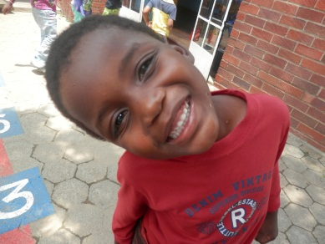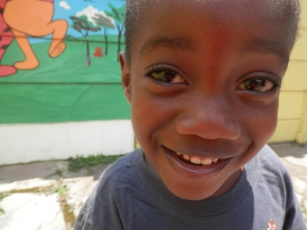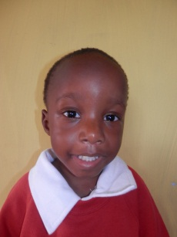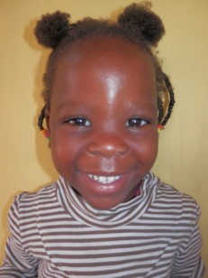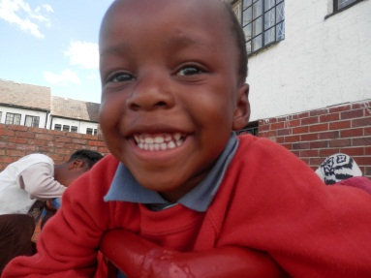

Developments
As the school is continually growing, so is the staff team. We have a core team of volunteers who work with us 2 days a week each – Precious and Mary, enabling us to provide the children with more individual attention. Mary is also studying for her ECD qualification and so we are supporting her with her assignments, planning and course work. It is a delight to work alongside the adults to develop their skills also, as this is the only way the school will maintain itself in the future!

We have our administrator starting work on Friday 1st March, Mai (Mrs) Figueira. We are so very excited to have her on board to help with the day to day running and office work, leaving us more time to concentrate on the education side of things.
The first task for us as a staff team with our new administrator is to have a meeting with the Pastors of One Way, which is scheduled for next Monday. We look forward to discussing the current achievements of the project and how the project may be developed further in the future.

Personal Information
We have both had a lovely February, any illnesses seem to have disappeared (tonsillitis and colds!) and we are relaxing into the routine of being back teaching. We are looking forward to the end of term in 5 weeks, as both Greg’s friend Andy and his Mum are coming to visit – for 5 weeks in total – so we are looking forward to some extra company!

Prayer Points

- Meeting on Monday 4th March with Pastor Gatsi and Pastor Musora regarding the current and future status of the Pre-School project – please pray for wisdom, understanding and clear communication between all parties involved.
- Continuation of registrations – we have spaces for 14 more pupils…let’s fill them!
- The children currently in our care – we have had a huge number of absences, and one hospitalisation of children with bugs and illnesses – please pray for complete healing of all children and staff.
- School resourcing – we have had some large pay outs this month for a number of things including car repairs from a crash (no injuries!) and a lockable deep freezer as food was being stolen – so we need to start putting money back into resourcing the school, the outdoor area is in desperate need! Please pray we receive the funds necessary to further the educational opportunities.
- Personally – we are tired! Pray for strength each day and also for wisdom and understanding of each situation that arises.

Thank you again to those of you who have contacted us this month, we love to hear from you as it is a huge encouragement.

God Bless and Keep Smiling!
Love Sophie and Greg xx

Here is Alex…asleep.
