60 Kendale Road



Bromley

Kent, BR1 4NH

Dear Friend

**August 2012 – leaving on a jet plane…**

As you may be aware, Sophie and I are heading off to Harare, Zimbabwe this August. We will be working with a church group, One Way Ministries, to open a pre-school for the church and local area.

Zimbabwe is known as one of the most troubled nations in the world, with political uncertainty, and a very low life expectancy due to hunger, sickness and poverty. The population also all have recent memories of intimidation, violence and fear.

*But, hope is rising, and we want to go, to play our small part in helping bring hope to some of the youngest children in the nation – the children who are the very future of Zimbabwe.*

**Why Zimbabwe? Why now?**

Back in 2007, Sophie and her family went to Harare with their friends, Dave & Jean Bankhead, who have much experience in other nations of the world in bringing hope through music. Working with the church in Harare, they set up and ran a children’s holiday programme for a week in the summer, which has run every year since, and has grown in numbers and impact. For many of the children, it is the highlight of their year.

Sophie’s love for the country, the people and the church there grew. She’s been back 3 times since, and has always felt Zimbabwe to be a calling upon her life. During her second trip, the pastor of the church, Langton Gatsi, asked Sophie how she’d feel about opening a local pre-school – an exciting offer.

However, Sophie did not want to do this on her own, so she held on to the thought, and wondered. Then, we got married! So, we went to Harare together in 2011 for the kids club, which was a fantastic time for both of us – hard work, but so rewarding. We were again asked about the possibility of working with the church to open a pre-school. After several months of prayer, conversation with our families and friends, and lots of excited giggling, we have made the decision to go ahead. We leave in August.

*Scary, but thrilling as we believe this is God’s chosen path for us. We’ve never felt more excited. So, our reason for writing is simple –* ***we’d like you to join us on the journey.***

The most important thing you can do for us is to please pray for our trip, pray for us, the church, the children we’ll teach and the projects we’ll be involved in. (I can’t wait to find some future African football talent!) Then, of course, we’ll need support for the project. Over the page you can see some of the ways you can help. We are so grateful for your friendship and partnership on this journey – the first step starts now – who knows where it will end??

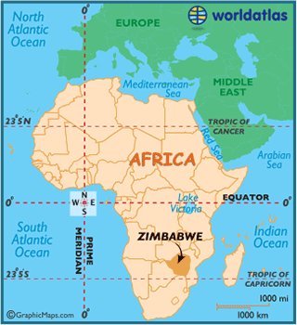

With our love and thanks

`

Greg & Sophie - a very excited pair of Sangwine missionaries!

PS – check out our brand new blog – we’ll keep you posted there! [**www.gregsophiesangwine.org.uk**](http://www.gregsophiesangwine.org.uk)

When Sophie first visited in 2007, she learned how many people in the nation at that time felt they had been abandoned, especially by the UK and the US. Will you help us to show that there are in fact many people in the UK & elsewhere who care deeply about their brothers and sisters in Zimbabwe?

Detailed below are the ways in which you can help. Just tick the boxes for those that you may be interested in (and there is no commitment in ticking the box – we’ll just give you more details!)

* Prayer Support

* Monthly Newsletter
* One off donation
* Regular giving (for the school)
* Regular giving (for us personally)
* Donation of goods/ resources

Your name: ______________________________________

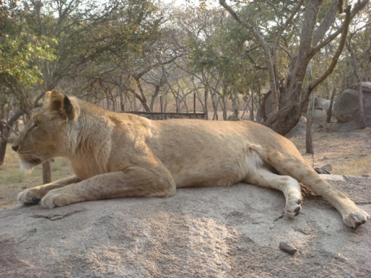

Email: ______________________________________

Phone: ______________________________________

Address: ______________________________________

______________________________________

______________________________________

***We want to stay in touch – will you help us to do that? It really matters to us…***

Check out our blog, and stay tuned for updates - [**www.gregsophiesangwine.org.uk**](http://www.gregsophiesangwine.org.uk)

Email us anytime - [zim@gregsophiesangwine.org.uk](mailto:zim@gregsophiesangwine.org.uk)

Call us before we go… (we’ll let you have our Zim numbers when we arrive)

07875 011206 – Greg

07814 522590 – Sophie

Thank you!