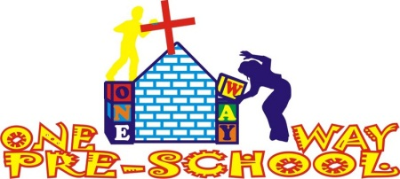
Dear Friends,

Milestone!
We have reached another milestone…our first term of One Way Pre School has come to an end! We have 4 days left then a one month holiday. With registrations, we have stalled at around 46 children, with some of these new children beginning at the start of next term (6th May). We were hoping to reach 50, but the Nursery class is now full and Grade Zero age children will normally have found a place by this time of year so we are not expecting any new children to that class.

We are pleased that we have been able to bring Auntie Pru on board to work with us as our administrator as it has allowed sharing of workload. She has been a blessing already and has helped to maintain the finances, public relations and also the organisation of our first Official Opening!

Official Opening
As One Way Pre School is brand new, we wanted to open it officially within the community and have an event that both Pre School and Church members could attend. The event took place on the 26th March from 4-6pm. The children took part through singing praise and worship songs (with over half Family Worship songs!) and speaking some memory verses. Both Pastor Gatsi and Greg spoke, with Pastor Gatsi then officially opening the school through cutting the cake (we didn’t have a ribbon!). The children then took their parents to the school and other guests were invited also. Children’s work was available to look at and the classrooms set up as an example of the education we offer.

The children were so excited to share their work with their parents and it was a delight to be able to speak to so many parents about how proud they were of their child’s development. Pre-schools here are more and more becoming day care centres, offering less education and more daily child care for children of all ages. So these parents are delighted that there is a school they can not only afford, but receive an education they never knew existed!

Below are a couple of pictures of the opening (Main photographer Sophie was taking part in the event so there’s not many!)

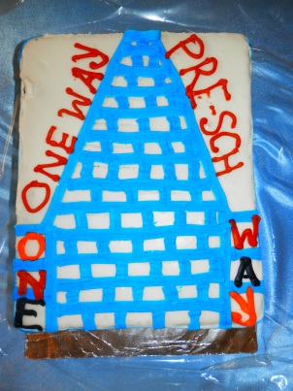 | 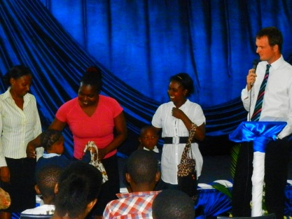 | 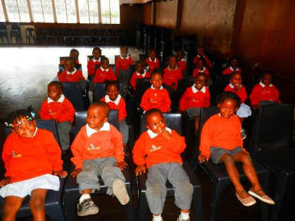 | 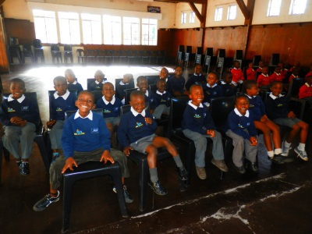

Personal
It is safe to say we are feeling relieved that the first term is nearly over, unlike English school system, we don’t get a half term, so 13 weeks of straight teaching has taken its toll! We have both been fortunate to have good health and the ability to fall asleep at 8pm some nights!

We are still in a state of disbelief that we have achieved as much as we have and that the first term is nearly over! The school is thriving and people are being blessed everywhere we look, including ourselves. We can only pray the second term is as good as the first!

Our visa’s run out in June 2013 and we were hoping to get a renewal. After 2 meetings and a few trips to the visa building (by Greg) it is not looking too positive at this time. From what we can understand, the visa we first received was a temporary visa, this cannot be renewed. We must re-apply which can take a few months, and also means we must leave the country and return in order for the visa to take effect (we may have to take a weekend to South Africa). Each visa is $500 and if we reapply, the visa is granted from the date of application, not from the end of our current visa – meaning we would have to pay $1000 for only 9 months visa rather than the full year. Pastor Gatsi has arranged a meeting with the Chief Immigration Officer to discuss our options.

We have been blessed to be living at our current house for 4 months now, and it has had its fair share of excitement! A few weeks ago whilst having a shower, the shower starting having a disco, the lights were flashing on and off, the TV was on and off, then the TV blew up and the oven was giving an electric shock to anyone who went near it! Lights then started blowing up and we hurriedly searched to turn off all electrical points including the main board – which also electrocuted anyone who went near it! Fortunately no one was injured and after 4 days of fixing, the house is now back to a normal electrical state! We have celebrated this, by re-decorating the kitchen, living room, bedroom and hallway. It is lovely to feel so at home!

This holiday we have Greg’s friend Andy coming to stay for 2 weeks followed by Greg’s mum staying for 3 weeks after. We are so excited to have them coming and have some touristy things to do with them as after 7 and a half months living here, we would like to explore some of the things the country has to offer! It will be so lovely to have fun and friendship for 5 whole weeks.

Next Term
We had a meeting with the Pastors of One Way Ministries and our administrator about the future of the current project. Everyone is very pleased and proud of what we have so there is immediate decision to increase development. In the long term the possibilities are huge and we will blog on the many options for the future over the holidays. But in the short term we will be working to officially register with the Ministry for Education.

Prayer Points

- Holidays – that we would rest!
- Visas – that the meeting with the CIO would be productive.
- Children – that over the holidays they would be safe and cared for, continue to eat well and come back next term with a renewed enthusiasm.

Thank you so much for your continued support; we are blessed every day through your encouragement.

God Bless,

Greg and Sophie xx

