Dear Friends,

Apologies and Visitors
Firstly we’d like to apologise for not sending an April newsletter. We had such a relaxing time being Zimbabwean tourists that to be honest, we forgot what the day was and it was May before we noticed! Andy was here visiting for two weeks and we travelled to Antelope Park in Gweru which is where Animal Planet film a programme called Roaring with the lions. We did a lion walk there and many other amazing activities. We also went to the Zimbabwe V Bangladesh test match at Harare Sports Club which is the only national cricket ground in the world which has a public house looking out onto the pitch. We saw the Zimbabwe captain score a century in his home town so it was quite special. Even for me who is not the biggest fan of cricket!
After that my Mum came to stay with us and we had an amazing time doing all sorts of exciting sightseeing things. My Mum was really excited about everything Zimbabwean. She couldn’t stop commenting on the beauty of the country, the friendliness of the people and about how it was nothing like she expected. Whilst Mum was here Dad sent us off to Pamuzinda Safari Lodge which was an amazing experience too. We saw giraffes on early morning walks and had a glass of wine with a resident warthog in the evening – special!

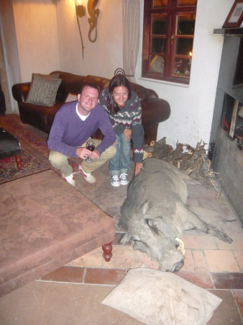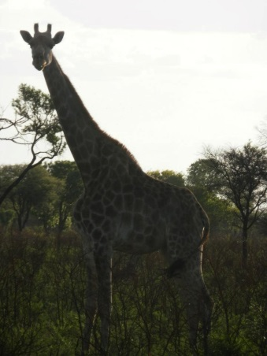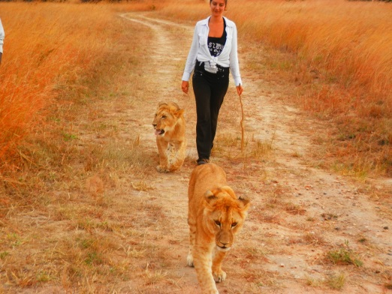

We have a lovely place to live here now so I extend the welcome of our spare room to anyone who would like to visit Harare. You can stay with us!

One Way Pre-School news
We’re delighted to announce that we have 52 children at One Way Pre School and Sophie’s nursery class is not only full but she already has registrations for January 2014. The children are growing up so fast and are all of a sudden speaking full sentences of English. They’re now settled into the English style of teaching and are making good progress because of this. I’d personally like to show off my ‘power of reading’ style The Rainbow Fish reading corner.

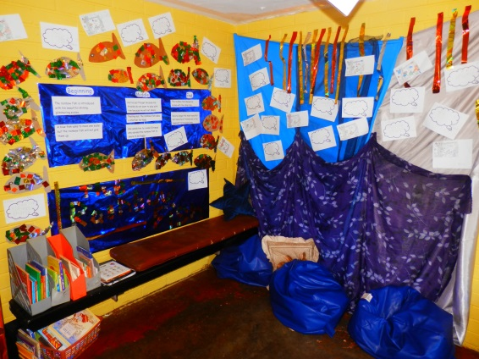

The children made their own Rainbow Fish, retold the story by looking at the beginning, middle and end and did lots of writing with describing words and phrases that appear in the story. If you have young children or a class of them, I really recommend the story because the children here loved it.
The whole school is now doing daily phonics lessons in three groups. Auntie Lorraine is teaching phase 1, I’m teaching phase 2 and Sophie is teaching phase 3. It’s been a lot of fun and our parents cannot believe the progress their children are making.

Staff Team
We’ve employed a 6th member of staff this term to work as a teaching assistant. Auntie Patience is also very ambitious and will be starting an ECD certificate course next month. Lorraine completes her course in the next month and has exams coming up but she’s completely driven so will be immediately enrolling in the following course to up her qualifications to a diploma before the end of the year. Their commitment is inspiring because they work for us all day Monday-Friday and then head to their own schools on the weekends and spend most evenings working on their school work – we are delighted to further adult education to ensure One Way Pre School will continue long into the future with excellent teachers! Thanks again to those of you who give financially to the school, because without you these ladies would not be able to complete these qualifications. If you’d be interested in sponsoring adult or child education then please contact us. We’d be so excited!

Sports Day
This term will have the first One Way Pre School sports day on Prayer Mountain which is quite an experience for me. PE and sports with the little ones has been such a giggle I cannot wait to see them racing. The children will be racing and the winners will get certificates. They’ll also all receive a certificate for taking part. We are also taking the sports day as an opportunity to get to meet lots of new people so we’ll be having a Braai (BBQ) afterwards for all the parents, friends and members of our church to attend.

Trip to Mukuvisi
As well as a sports day we are also going on a whole school trip to learn about looking after animals at a local animal safari woodlands. It links with our topic on Pets and Animals and we will be having an educational presentation, pony rides, game viewing (including giraffe and zebra!), bird walk and some good fun play time!

Hope for Harare & Links with the local community
www.hopeforharare.org is now set up and online and we hope to establish a UK charity in the near future to support Harare in many ways. We want to start by supporting our current school, but many other projects are being discussed and the possibilities are exciting. For example, more schools spreading to rural areas, primary schools, busses to bring children from the rural areas to our city schools or even opening an orphanage.
We rent a cottage on the land of a family who run a church here linked with New Frontiers and he is keen to speak to us about working alongside them to open and run a pre-school for their church and the rural communities they work with – they already have a basic set up, but it is not working effectively at this time.
It’s clear to us that God really wants to reach Zimbabwe’s youngest through us which is incredibly exciting. We are asking everyone for their prayers and guidance in this venture. Sophie and I have a clear vision for One Way Pre School but as yet just have many, elaborate ideas for the future of the work of our charity. Please do pray for us, we appreciate your guidance and wisdom.

Isn’t it exciting that just 12 months ago we were not even sure if we could open a successful school or even live in Zimbabwe and now we’re already discussing expansion projects? We thank God for that and we thank all of you for your support.

THANK YOU
We would like to end with a HUGE Thank-you to Santi who is a colleague of Mike’s who ran the London marathon for Hope for Harare raising nearly 1000 pounds in the process. We’re going to be using the money to hopefully expand the schools capacity to 90 children for the beginning of next year. We estimate we need around $4000 for this to happen so we have a large chunk of this through everyone’s generosity.

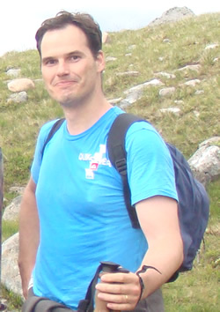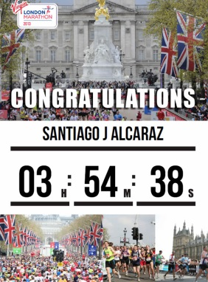

Prayer Points

- Hope For Harare projects and setting up
- Sports Day and school trip
- Lorraine and Patience’s education
- The children and families at One Way Pre School

God Bless,

Greg and Sophie xx

