Dear Friends,
Firstly thank-you for your recent support and messages. We and the project continue to be blessed and we have much to tell you about.

Thank-you God:
- A new place for us to live
- The classrooms are set up
- Secured donations for 2 orphans to attend our school
- We have employed a cook/cleaner for the school from the church
- 12 confirmed registrations and (we think) around 15 unconfirmed

The school building now really looks like a school!

Your kind donations and prayers have bought Mabelreign, Harare a well-resourced, vibrant, inspiring pre-school so we are so grateful. Please do pop on over to our blog www.gregsophiesangwine.org.uk/blog to check out all the latest pictures (now Mike is here, we can learn how to do the gallery properly!!)

New place to live
Last Saturday we moved to a 2 bedroom cottage just a kilometre away from the school building. We now have our own garden, use of a swimming pool, a tennis court and plenty of space for Clive to run around in. We are so lucky to have found such a great place so thank-you for your prayers. I am sure you can all appreciate how nice it is not to live at the place you work.

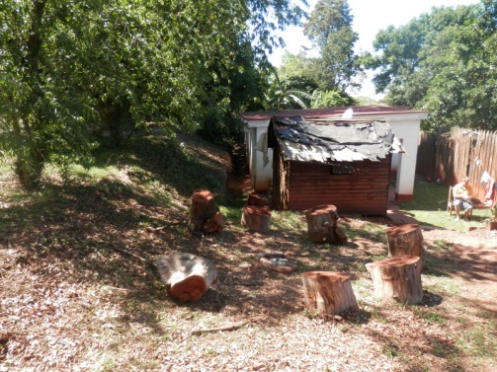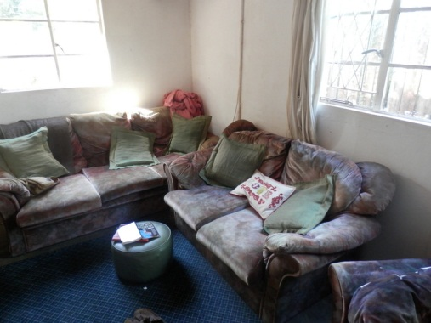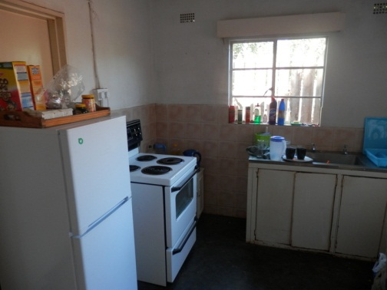

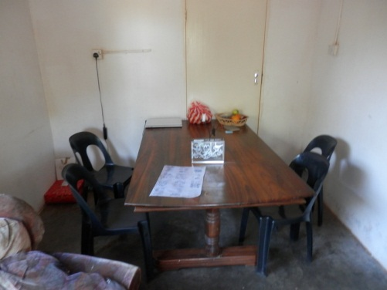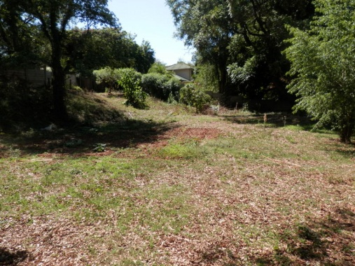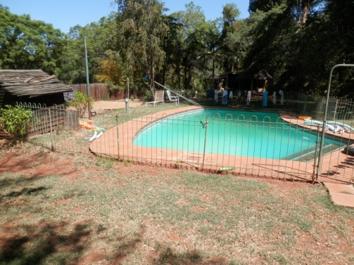

Support Opportunities
Our next big step will be on the purchase of computers for the children to use. We’ve even set up a computer area suitable for four computers in anticipation that God will provide soon.
We would also like to offer a great deal of outdoor education, as most pre-schools provide sit down education only – so we would like to buy outdoor equipment.

Sponsor an orphan?
Education in Zimbabwe all costs money and when people agree to look after an orphan very often they cannot afford to pay for them to go to school too. But here at One Way Pre School and because of your very generous donations we can currently offer education to 2 orphans. I cannot explain to you how exciting it is typing that and there is no way I can thank-you enough. During the next month every person who has donated to this cause will receive information on your child and a picture and we’ll endeavour to keep you updated on their progress.

If anyone is reading this and would love to sponsor an orphan then please give what you can per month. It is £60 a month per child but we’d love to receive small donations from people and we can add you into a consortium. If you are able to give £2 or £5 then this really will benefit these children directly.

Prayer points
- Registration of children to continue to grow.
- The fixing of the school swimming pool.
- Provision of transport arrangements for the school.
- Computers for use in One Way Pre School
- Donations to come in for educating local orphans.
- Please also consider us, the church and the country of Zimbabwe in your prayers.

With our love and thanks
Greg & Sophie x

We had our first experience cooking on an outdoor fire at our new cottage, which we shared with Mike and Sue! After much fanning to keep the flames alive, we had a delicious meal of boiled chicken and five bean casserole – which we ate sat on our makeshift outdoor furniture!

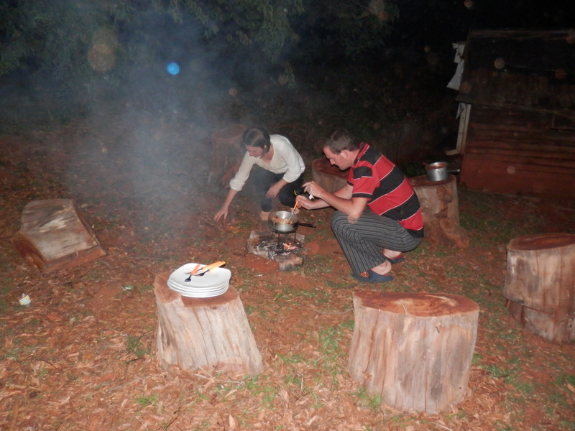

PS: Thank-you to those of you who listened to my QPR warnings and shouted for Hughes to be sacked, at least now we’ll be relegated with dignity under a gentleman like Harry Redknapp!

