Dear Friends,
Firstly thank-you for your recent support and messages. We and the project continue to be blessed and we have much to tell you about.

Thank-you God:
- We are healthy and well.
- Our shipping arrived.
- Our schools permit has been approved.
- All building work and decorating is completed.
- So far 6 children have registered for our school.

11 weeks and we could legally open the school:
I cannot believe it has been 11 weeks we have been here! We have some great news on the project to tell you about: This month we have been able to complete the works on the classrooms, toilets, playground and courtyard renovations. Hopefully these pictures will tell you more than we can…

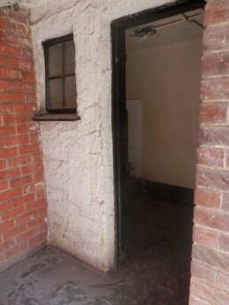 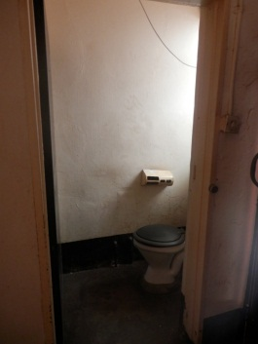 Before 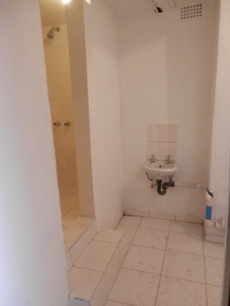 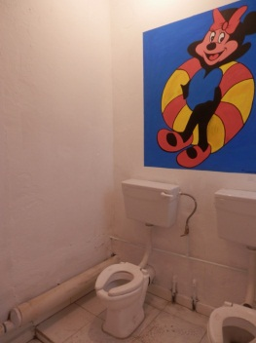 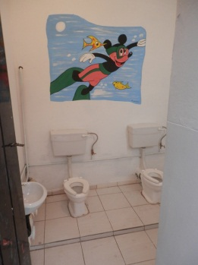 After
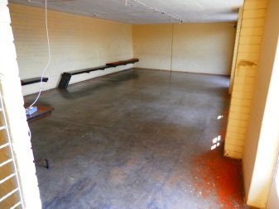 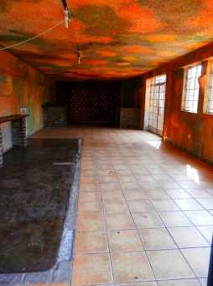 Before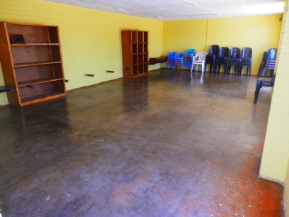 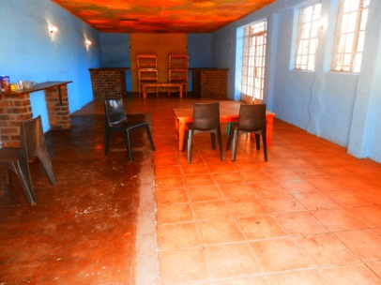 After

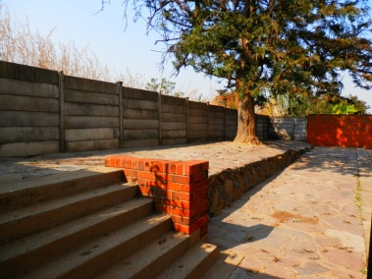 Before 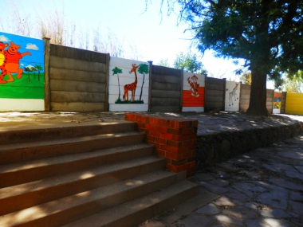 After

Support opportunities:
As always despite the achievements so far there is room for much improvement. We would love to offer education to more people from a wider area so we are in need of organised transport1 for the school. Please pray that the right company, at the right price comes forward so we can offer education to as many as possible. We still have to resource the school and any donations you make will be used to buy things for the classrooms to improve our learning environment.

Marketing:
We also have a road sign, banner, flyers and posters all around town to promote our school which we are hoping to get 60 children to attend. (So far we have 6)

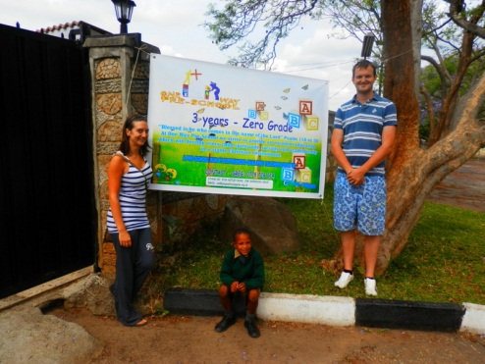Banner 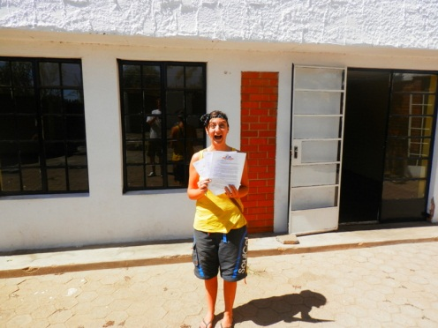 Our first registration!

New place to live
We’ve been living at the churches prayer and worship centre where the pre-school will be running which has been a great way to meet many people and settle into the new country but we have been presented with an opportunity to move to a cottage just 1km away. It is a lovely, little 2 bedroom cottage on the grounds of a couple from another church. They have been really kind and recently said to us how they cannot wait for us to be part of their family. We are hoping to move towards the end of November.

Sponsor an orphan?
We’d love to offer education to local orphans who would otherwise never afford such educational opportunities. Government schools are overcrowded and everyone has to pay – we are the cheapest option! It is the ambition of this church that they could offer a completely free education for orphans. Our school fees are £60 per month. We ask if you would be interested as a group, family or church to donate this money through stewardship services. This money will mean the child can be picked from their residence, taken to school for a school day from 8-4, given a hot lunch, provided with free uniform, school equipment and taken home after school. In return you will be presented with information on your child and be sent a termly report on the progress of the child socially as well as academically. It is a fact that kids who have lost their parents at this very young age struggle with all aspects of their life and £60 a month really will set them on a good path.

If you are able to give £2 or £5 but cannot find more people to reach the £60 then please donate what you can and we will include you as part of a consortium when we receive enough donators. You really cannot give too little!

Prayer points
- Registration of children to grow quickly.
- The fixing of the school swimming pool.
- Provision of transport arrangements for the school.
- A well-resourced, exciting learning environment provided for both classrooms.
- Donations to come in for educating local orphans.
- Please also consider us, the church and the country of Zimbabwe in your prayers.

With our love and thanks
Greg & Sophie x

PS: I am very upset at the performance of QPR recently so if anyone loses their minds, comes into money and fancies a trip to Loftus Road to shout at them all then I’d really appreciate it

