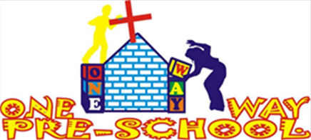
Mobile: +263778729214 Email: zim@gregsophiesangwine.org.uk Website: www.gregsophiesangwine.org.uk
Dear Friends,
Thank-you to you for signing up to this newsletter, sending us messages and donating your money towards the One Way Pre School project. We hope this newsletter confirms that this project is continuing to be blessed by our wonderful, faithful God.

September 2012 – over 6 weeks and so many blessings…
We’ve been in Zimbabwe for a total of 6 weeks now and we’re pleased to announce lots of exciting news. Firstly the new logo for the school is completed (see above) and we have leaflets, posters and business cards for the schools marketing. Secondly the completions of building work: The following pictures show before and after pictures so hopefully you have a picture of the progress in this short period. We still need to paint though so we will of course show pictures of everything when it is fully completed.
These first pictures show where a urinal has been transformed into a shower unit and more space created for 2 toilets and a wash basin in the same room which will be the girls toilet.
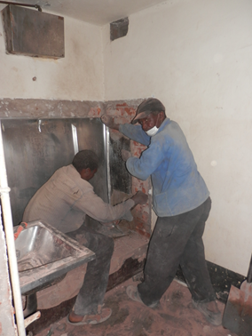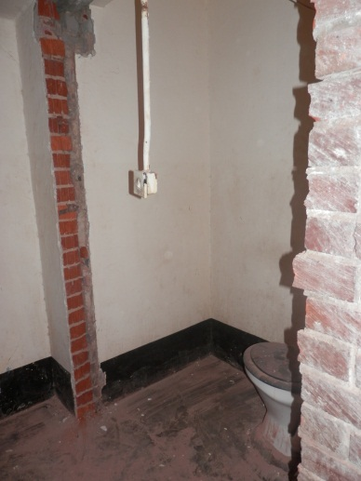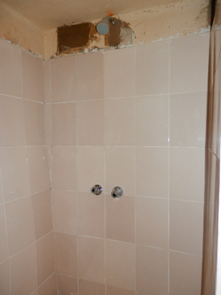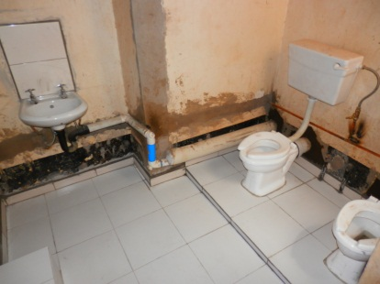
The 3 pictures below show where the builders knocked through the wall to fit two toilets in the other toilet building. This will be the new boys toilet.

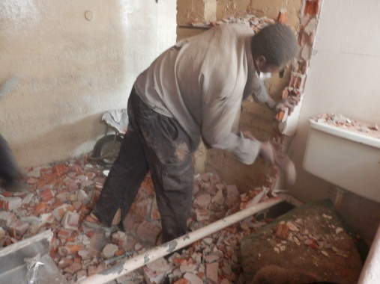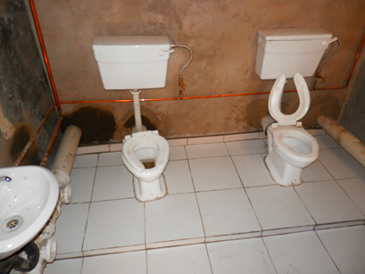
Next we have been completing a lot of gardening so that the new playground is safe. We had to buy and erect a fence for security and complete the digging ourselves. We found this particularly exciting as digging in the hot sun in temperatures hotter than 30 degrees was definitely a Zimbabwean adventure. Greg now knows how to mix cement, quarry stones, quarry dust and water together to make strong concrete for fence poles so if teaching ever goes down the pan then he’ll consider a career as a labourer. The following are a selection of pictures which detail our playground adventures:

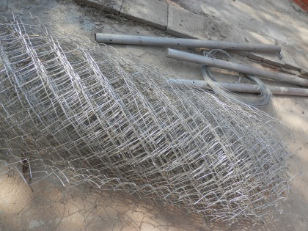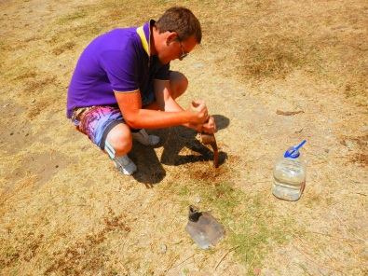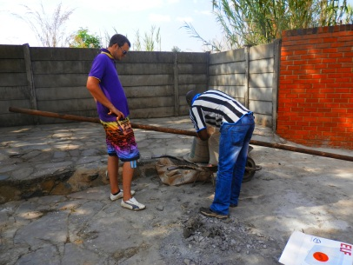

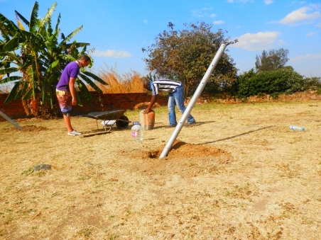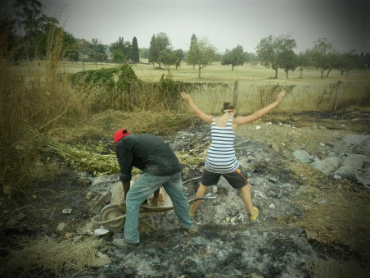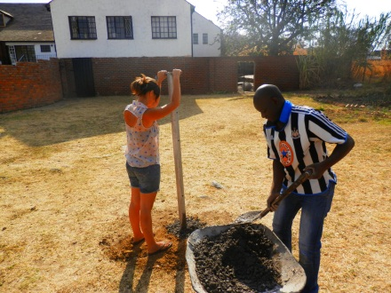

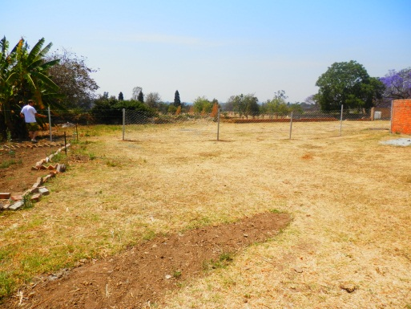
Other things that we are very close to completing include the arrival of the schools tables and storage units made by a local carpenter and the arrival of swings, a slide, a merry-go-round and a jungle gym in the next week or so to go in the area in the picture above. By the next newsletter we’ll also have a road sign, school banner and our shipping will have arrived so classroom set up will have begun.

As always despite the achievements so far there is room for much improvement. We have run out of our own money we are putting in to the school and still have many needs which include buying more resources for the school and the painting and decorating. Please prayerfully consider whether a financial donation to the project is something you would be able to give towards. Your money is used to benefit the children of this incredible country directly. If you are interested please visit the support section of the website for more details or send us an e-mail.

2 Key Prayer Points – arrival of shipping – at no extra inflated cost! Acceptance and arrival of official school permit.
Please continue to pray for us and keep updated via our blog.

With our love and thanks
Greg & Sophie x

