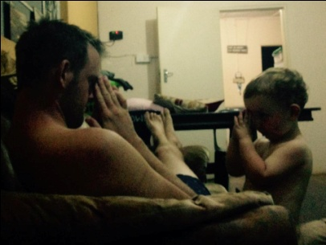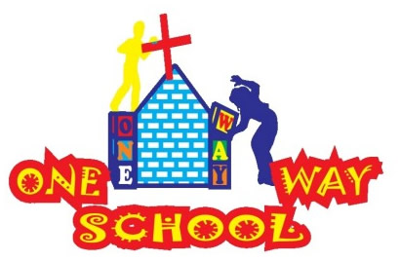

April/ May 2017

***Hey All, we share news from One Way School, the country we serve and our family – we hope you enjoy.***

***Thanks for sticking with us – 5 years now!***

SANGWINE NEWS  
Harare, Zimbabwe

**Dear Friends and Family,**

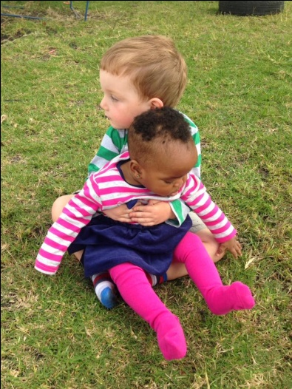

**News from last newsletter’s prayer requests**

* For health for all three (four) of us – baby growing nicely
* For One Way School as we transition through various stages over the next few months – Greg redundant ☺– see below
* For the country of Zimbabwe, the people and the leadership, that there would be hope and light. - ongoing

**Sangwine update**

We are back in the UK full time from the beginning of July after a holiday in New York with Mike and Sue Burn (Mum & Dad) and we’re so excited to take a little rest from what is our normal life out here. Over the past year, we’ve really been missing home ‘comforts’. We continue to love our Zimbabwean life but have really noticed how much we miss ‘home’ in the UK. For example, our first nephew, Ben was 13 months old when we left for Africa and he’s now in year one and writing us letters – we miss so much!

The plan for our sabbatical is now all confirmed. Greg managed to secure a supply teaching job in Surrey so will aim to get as much work as possible to help support us and Sophie will be doing something much more important. Growing, delivering and sustaining our new little one and our cheeky little 2-year-old.

The baby is growing beautifully and Sophie is feeling well. She just needs to stop running a school for a while so that she is not so tired. Although, I’m fairly sure looking after JT full time will be just as, if not more tiring! ☺

JT continues to speak random Shona sentences that bamboozle us. He’ll say what, to us, sounds like gibberish and then we’ll ask his Auntie who tells us that he wants to run around outside or something similar. A quick story: The other day I was taking JT to the supermarket and he started shouting chi-bar-gay at me. You can only imagine what I thought he was saying…Turns out he wanted to stop by the side of the road to buy roasted maize from a vendor. So, I told him that he had to go buy it if he wanted it. The shock on the vendors face when this little English baby walked up to him asking for the local delicacy was a picture. I’m even laughing now whilst I’m typing the story.

We just feel so lucky that he’ll have a baby ‘sister’ to play with very soon. (NB: That is just a prediction)

**One Way School**

We believe our mission is ‘To establish an excellent primary school in Mabelreign which can be run by local people to the same standard’. So, good news, the reason I’m now writing a newsletter rather than Sophie is that I’m pretty much redundant. At the beginning of 2016 Sophie took on the job of ‘Primary School Lead Teacher’ which meant being in charge of all the teaching and learning in our new primary school. I taught grade 2 and did the planning for grade 3 and grade 1 as well as working with and training the teachers we have. I have over the past few months gradually handed over lots of responsibility to other people. Uncle K has now taken over that job and Uncle Prince now teaches grade 2. It’s nice to have plenty of men around. 6 of our 18 staff are men! In 2018 (when we return to school) I will be relinquishing most of my responsibility in the classroom to focus on the implementation of a new curriculum.

Four bits of great news:

1. Funding secured for a school swimming pool
2. Laptop trolley up and running and pupils learning computing lessons
3. Funding secured to develop the schools playground facilities
4. 151 pupils being educated, 16 local people employed.

**The short story of T** (name made up)

T grew up in a loving home, went to school, tried his best and achieved great results. He secured O levels, A levels and was thinking about university as a next step. His father had always worked hard to scratch the money together to support T and his brothers and sisters and pay for them to go to school. Unfortunately, T’s father passed away suddenly. T then became the ‘bread winner’. When I spoke to him he knew there was no way of accessing any more education for himself so he searched out a job. You’d think with his excellent results this would be easy pickings. But, in a climate with an estimated 90% unemployment rate, employment is not easy to come by. Despite his qualifications, T works as a security guard for a local café. He parks cars, washes them out of the goodness of his own heart and smiles at all the guests. Out of his $220 a month salary (which he receives in dribs and drabs) he pays $240 a term for his 3 younger siblings to attend school. His siblings attend a school where they are one of 65-70 in a class so rarely get the attention they need. So, in the evenings T sits with his siblings and helps them with their work. “It’s what my Dad would have done” T remarks. Zimbabweans all feel this way about education – they’d sacrifice everything for it. It’s such a pleasure to serve those who have an attitude like T.

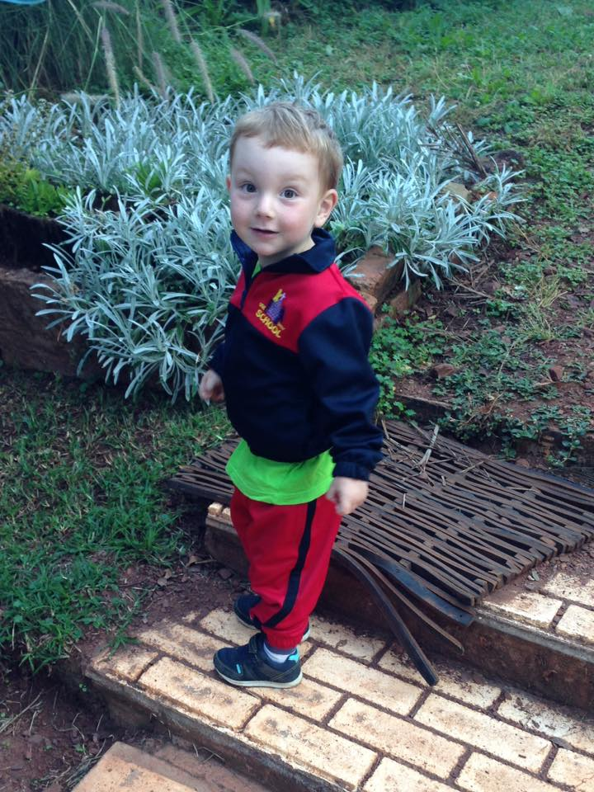

**GAP YEAR (or 2, or 3, or 7)**

Are you a teacher? Do you know a teacher? Are you in need of a new challenge? Something a bit different for a while?

Come and spend a gap year here!

We’d arrange your accommodation,   
a vehicle to use,   
your visa   
& an allowance to live on.

Inspired? Send us an email.

Contact Info

[www.gregsophiesangwine.org.uk](http://www.gregsophiesangwine.org.uk)

[gregandsophiesangwine@gmail.com](mailto:gregandsophiesangwine@gmail.com)

[www.onewayschool.co.zw](http://www.onewayschool.co.zw)

**Prayer Points:**

* Safe travels and enjoyable sabbaticals
* That Greg would get plenty of work
* Safe growth of baby and health for Mummy