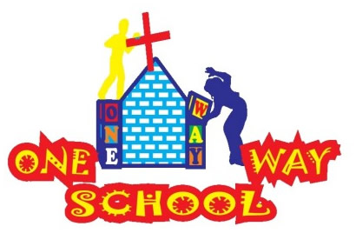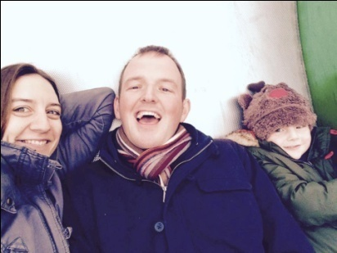

***WE ARE SORRY!! We did not send our last 2 newsletters…our only excuses are that we were really busy and then spontaneously flew to ENGLAND! So…here’s as much info as we can cram into the space….combined!***

January 2017

SANGWINE NEWS  
Harare, Zimbabwe

**Dear Friends and Family,**

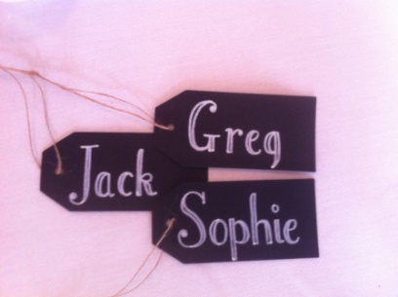

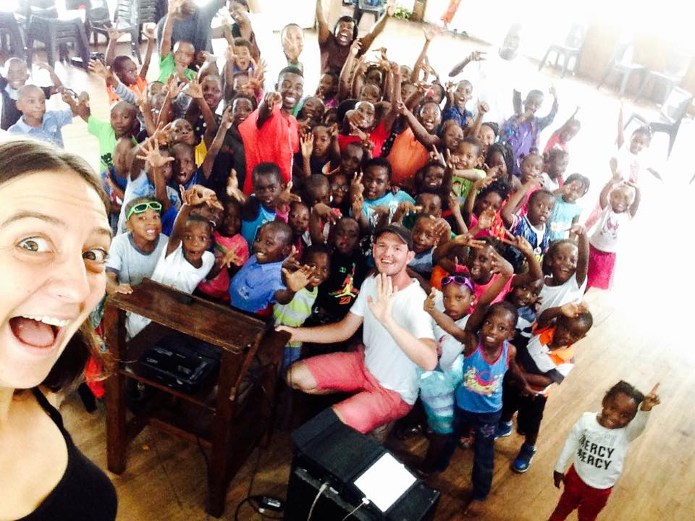

**News from last newsletter’s prayer requests**

* *For the end of the school year as we give a final push of encouragement to complete all that needs doing! We had an incredible school year!*
* *For the Grade 4 building, that we would receive the necessary funds for completion All has been completed and the new class started the school year as normal in January!*
* *For us personally as we seek to maintain good health and some rest in the madness! We are happy to report that we three have been very healthy recently- save for a few bugs and viruses since term has started*

**One Way School 2016 review** *It was a wonderful year, our best yet!*  
**Building**  
When we ended 2015 we had almost completed the building of the grade 3 class but due to issues with workman we couldn’t move that class in to their new classroom until late in February. Since then we’ve completed all renovations and are set to begin with 6 beautiful classrooms and adequate toilet and kitchen facilities for our maximum capacity of 180 pupils.

**The pupils**  
We ended 2016 with 122 children at the school. All but 1 of the children has English as an additional language but they’re a credit to themselves and their families. They work hard, play hard and bring us so much joy. We’re so proud of all their progress.

**Our roles**  
I (Greg) have been teaching Grade 2 (year 2) this year and have been heading up the teaching and learning in the three primary school classes. I’m a duck out of water but I think when we’re challenged we achieve our best don’t we? It’s been wonderful working with my class and my team of teachers. I’m going to be doing the same next year.  
Sophie is the head of the school. She’s my boss! She ‘pretends’ to be really busy in the office and sometimes comes out to work with intervention groups, assist in classes and organise everything else. To be honest we’re not sure what her job is, it’s just; everything! ;)

Staff  
We now boast a full time staff team of 15 local people. (It seems so crazy to write that!) with more to add in 2017.

Where we’ve been!

So, we disappeared off the communication radar for a couple of months and we apologise for that. End of 2016 was a bit tough for us as a family and we realised we had only had one proper day’s restful holiday in the whole term – so we were a bit beat! Incredibly generously, we were gifted with flights to the UK and spontaneously hopped on a plane on the 21st December and were blessed to spend Christmas, New Year and Sophie’s birthday with family and friends in England. We saw all our family – (Including Sophie’s parents who flew over from New York!) and we managed some serious rest and relaxation – and copious amounts of eating of baked goods! We found time to spend together as a couple and as a family with JT and were able to talk and rest and refocus ourselves for coming back in the New Year.

We made the crazy decision to fly back on a Sunday, and then start work on the Monday. So this is my next excuse for a delayed newsletter, that as for 2017 thus far, we have hit the ground running! So thank you for bearing with us and continuing to show us such love and support, we look forward to sharing 2017 with you all!

Where we’re at

We continue to spend time developing the school in as sustainable a way as possible, with the intention that we are hoping to hand over large areas of role and responsibility over the coming year. This means finding, or training, someone to take over the role of Primary School Lead teacher (coordinator) which is currently Greg’s role (alongside being a class teacher). Secondly, a Head of School, which is currently my (Sophie’s) role – this is slightly more complicated as (as previously mentioned above) this role currently is tricky to define, as I currently have my hand in many pots and this is not sustainable and a clear job description needs to be created. Thus many responsibilities need to be dispersed amongst our already capable staff team. So please do pray into this key area for us as we seek God’s wisdom and guidance to place the right people in these positions to develop the school further.

Personally, we have a visa until October of this year and we have been taking some time to decide whether we wish to reapply. We have come to the current decision that we will reapply, however we will also take a sabbatical in the UK this year – to spend some time seeking God’s wisdom and guidance again for us personally, and also to allow those in the new positions at the school, to run the school and *fingers crossed* hopefully have much success – enabling us to see the long term sustainability of the school project more clearly.

**GAP YEAR**

Are you a teacher? Do you know a teacher? Are you in need of a new challenge? Something a bit different for a while?

Come and spend a gap year here!

We’d arrange your accommodation, a vehicle to use, your visa and an allowance to live on. Inspired? Send us an email.

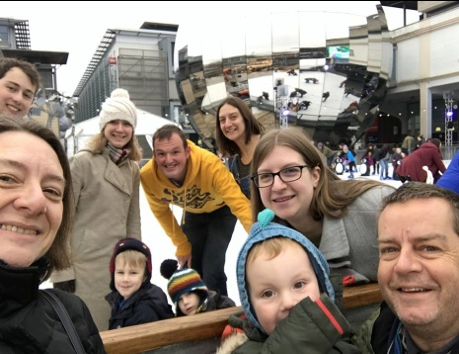

**Prayer Points:**

* Thank-you God for our 6 completed classrooms, 15 new laptops and 3 new staff members.
* Please God can we have 160 pupils on our register
* Please God grant us the vision for the continued growth of your school so we can complete the primary school with grade 5, 6 & 7 classes

Contact Info

[www.gregsophiesangwine.org.uk](http://www.gregsophiesangwine.org.uk)

[gregandsophiesangwine@gmail.com](mailto:gregandsophiesangwine@gmail.com)

[www.onewayschool.co.zw](http://www.onewayschool.co.zw)

***Please come and visit us – we LOVE visitors!!***