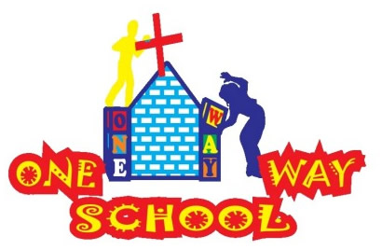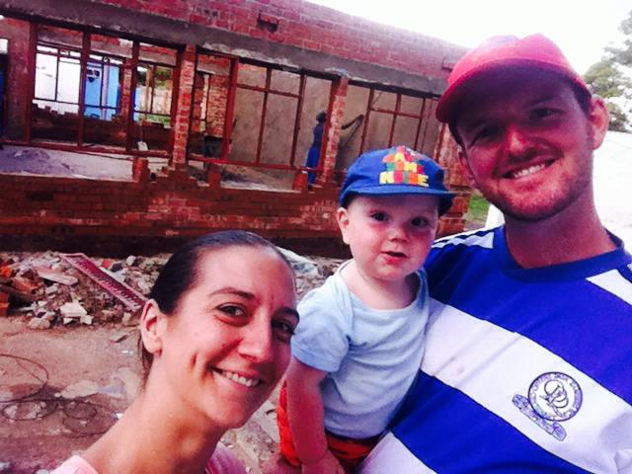

Look out England, the Sangwine’s are back in town!

July 2016

SANGWINE NEWS  
Harare, Zimbabwe

**Dear Friends and Family,**

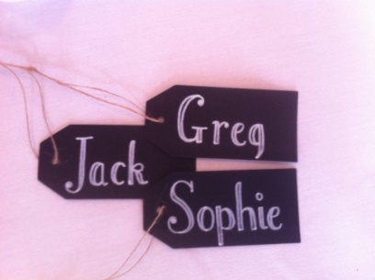

**News from last month’s prayer requests**

**Prayer Points**

* *The nation of Zimbabwe and its unstable economy, government and daily life struggles (see below)*
* *The president and his successor - ongoing*
* *Our school and the children and staff - ongoing*
* *Current building works and finances for this (see below)*
* *Future classroom buildings and issues of land space - ongoing*
* *Our personal short and long term goals - ongoing*

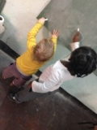

**Zimbabwe**

Since our last newsletter, a lot has happened! The country is currently in a state of uncertainty regarding power, leadership, protest and change.

There were nationwide ‘stay aways’ in which the entire country almost shut down with no one opening schools, businesses, public services – except government run institutions. The citizens of the country are protesting against government repression, poor public services, high unemployment, widespread corruption, financial instability, delays in salaries and economic sanctions.

One leading Pastor of the #thisflag campaign was arrested, charged, trialled and then released after a protest of thousands outside the courtrooms. Numerous other citizens have been arrested in the wake of the incidences.

Violence has been sporadic and the police have been countering this by using violence also.

In general the country is sitting on a knife edge and everyone is very wary of the uncertainty of the near future. Financially the situation is getting worse by the day with everyone limited as to how much cash they can place their hands on, bank withdrawals are being further limited daily. People are beginning to pay for services using offers of groceries, return services or goods/items.

We are continuing to pray for peace across the country and are thankful that no violence has encroached upon the area we live in.

Please do help us to lift up the nation as they navigate this period of unrest, that there would be significant change at all levels and that there would be a return to democracy for all.

**All loved up!**

IT’S OUR ANNIVERSARY! (on the 31st!) 6 years of marriage and what an adventure it has been! We feel so blessed to have our family pod of 3 living out the greatest adventure that God could have sent us on and we are feeling incredibly thankful for 6 years of pure joy!

I (Sophie) am so thankful that I get to spend time with my best friend. In a country I love, running a project I love and surrounded by people I love! There is no one else I could imagine wanting to stick out our unpredictably crazy life with! Plus, he’s kinda easy on the eye ;) I said it 6 years ago and I’ll say it again, I love Greg Sangwine!

**School, building works, the future and stuff!**

So we are absolutely DELIGHTED that whilst we are away this August, the Grade 4 classroom will be built, including roof! What an amazing testimony to the determination and insane ability God has to make plans happen when you least expect it!   
Please, please do pray for our ongoing situation with the previous rogue contractor, it is now under the courts and we have a school lawyer and are hoping for a resolution within the next few days so please pray this is a success!  
Next term we will be continuing to fundraise in order to complete the classroom and furnish it alongside working on the outdoor areas as these are hazardous at the moment and need much attention.   
In particular focus is now shifting towards what will happen for grades 5,6 and 7. However, positively, the carpenters working on our current classroom seem to believe we can potentially make a double storey out of what we have and get the correct permissions for this, so please do pray that we would bear fruit from the seed they are planting! As having a plan in place for the future will be a huge leap for us.   
We continue to liaise with the ministries for health and education regarding licencing and so forth, however we still have the issue of land space. So please also continue to pray for resolutions and solutions for this, it’s a big deal!

**GAP YEAR**

Are you a teacher? Do you know a teacher? Are you in need of a new challenge? Something a bit different for a while?

Come and spend a gap year here!

We’d arrange your accommodation, a vehicle to use, your visa and an allowance to live on. Inspired? Send us an email.

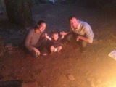

**Prayer Points**

* *The stability of the country, its government and economy*
* *The building works for the Grade 4 classroom*
* *Our family holiday to the UK – for rest and fun!*

Contact Info

[www.gregsophiesangwine.org.uk](http://www.gregsophiesangwine.org.uk)

[gregandsophiesangwine@gmail.com](mailto:gregandsophiesangwine@gmail.com)

[www.onewayschool.co.zw](http://www.onewayschool.co.zw)

***An invite – Please feel free to come to Harare to see us – all are welcome!***