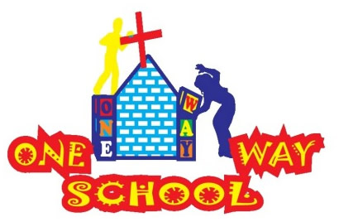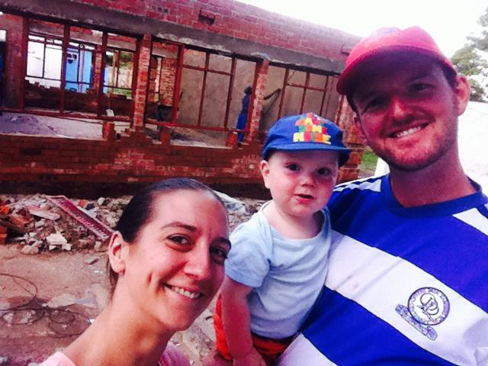

Term has started again with a BANG! And winter has hit! (We brits do like to complain about the weather…!)

May 2016

SANGWINE NEWS  
Harare, Zimbabwe

**Dear Friends and Family,**

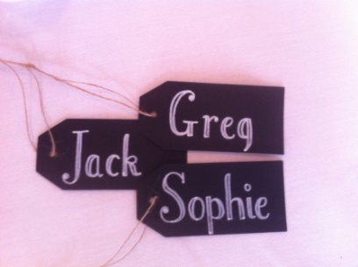

**News from last month’s prayer requests**

**Prayer Points**

* That One Way School would continue to develop and grow especially in teacher development – ongoing and successful! We have more registrations and teachers are gaining confidence
* That we would seek God first and foremost in all decision both short and longer term – ongoing…!
* For the country as it struggles in desperate economic times –things are getting tougher…



Zimbabwe

We find ourselves in the midst of some difficult situations. After the worst drought in decades, many people have struggled with food production, particularly the local staple food Maize plants. Latest statistics also place 90% of the country’s population out of formal employment. Mixed in with the ever looming introduction of a new Zimbabwean currency in the form of ‘bond notes’ and the economy is failing. ATM’s no longer give money, the queues for banks are insane with people being given limitations on daily withdrawals and these are being decreased daily – causing multiple issues with the cash based economy! Shockingly, we withdrew some money for the school and were given all $5 notes…some of which are of such poor quality the bank had actually stapled them back together!

So we ask you to stand with us in prayer for this nation. People are nervous and scared of a return to 2007/8. With elections looming in the near future also, everyone is asking the same question – what next?

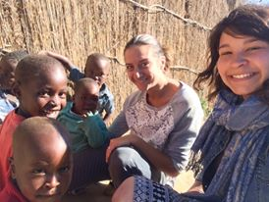

Mandhebvu Community

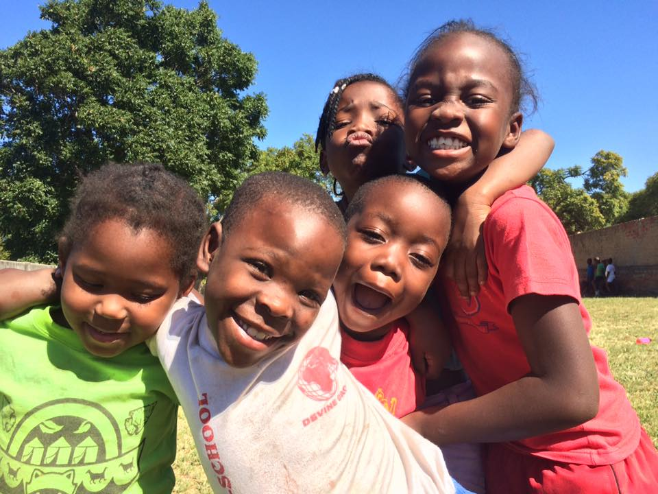Smiles

ONE WAY SCHOOL

We have had a fantastic start to the new term with new registrations coming weekly and a positive buzz around the school. The children seem happy and enthusiastic to come and the teachers seem to enjoy teaching creatively alongside us so we are feeling blessed in this regard!

Unfortunately, everyone is feeling the struggle financially and we are currently in a reasonably stable position, however, please do continue to pray for this as the situation changes daily and we are all holding our breath!

We are currently in the midst of SCIENCE WEEK! Which is bringing so much joy (check out the school website for pictures!) and we are so blessed that we had a financial donation which has helped support this. The teachers are in awe that we are able to do so many practical activities with the children – the curriculum here in other schools is taught without practical elements. It is such a pleasure to see the children enthusiastic about learning and creative in their thinking!

We have a Fun Day, Sports Day and Trips coming up so please do pray that these would be successful!

We also continue to work on our building developments and are continuing to fundraise for these with a successful cake sale and civvies day raising us $300. Praise God.

Our administrator has also been meeting with the Ministry for Education and Health to find out what requirements are needed for us to move forward with becoming officially registered…this is ongoing.

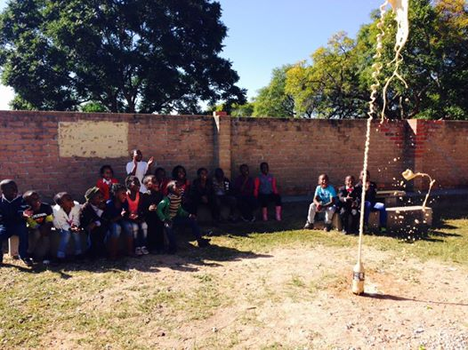

**GAP YEAR**

Are you a teacher? Do you know a teacher? Are you in need of a new challenge? Something a bit different for a while?

Come and spend a gap year here!

We’d arrange your accommodation, a vehicle to use, your visa and an allowance to live on. Inspired? Send us an email.

We are delighted to have Emily visiting us for the next 6 weeks to volunteer alongside the project!

SCIENCE WEEK!

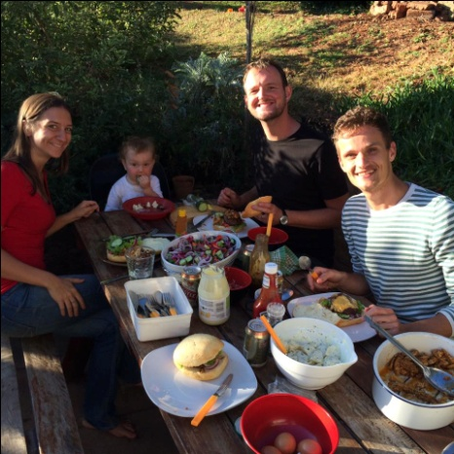

Our ‘Hollandish’ brother Sander!

***An invite – Please feel free to come to Harare to see us – all are welcome!***

Contact Info

[www.gregsophiesangwine.org.uk](http://www.gregsophiesangwine.org.uk)

[gregandsophiesangwine@gmail.com](mailto:gregandsophiesangwine@gmail.com)

[www.onewayschool.co.zw](http://www.onewayschool.co.zw)

**Prayer Points**

* Please pray that the registration with Education and Health continues to move forwards
* Please pray for the nation of Zimbabwe as it goes through challenges with finance, economy and governmental issues
* Please pray for us as a family – the man and boy are struggling a bit with health lately!