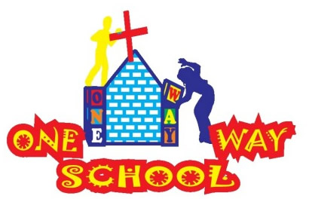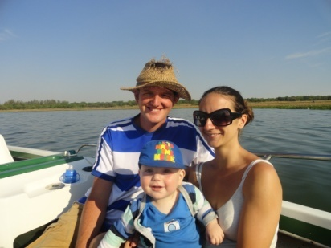

November 2015

SANGWINE NEWS  
Harare, Zimbabwe

**Dear Friends and Family,**

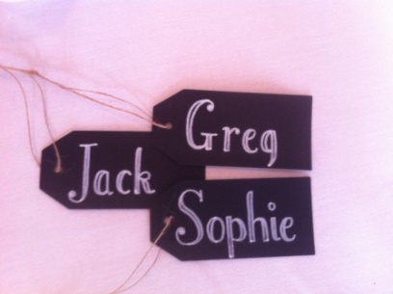

We are often asked if we’re building schools in Africa and until now we have had to reply that we’re renovating pubs and clubs to make schools in Harare. But, now here we are actually laying bricks on the ground to build classrooms to educate the future leaders on Zimbabwe. SOOOO EXCITING!!!

**News from last month’s prayer requests**

**Prayer Points**

* For continued completion of the new school building and toilets and that buildings would be completed before Christmas so over December we would have rest before beginning again in January. The building has begun and plans are in place to complete the classroom whilst work on the toilets is 90% completed – please Thank God for His wonderful provision.

**Personal testimony**

When things are hard and they seem unachievable it is difficult to focus on the achievements you’ve already made.  
For example, this time 3 years ago we wrote a newsletter asking for prayers for registrations to come in for our pre-school and for money to come in for classroom resources. At that time we hadn’t opened yet and had 7 registrations. This is what we have now;

* 96 pupils (26 who attend free or with assisted places)
* We employ 12 local people, full time and have educated 5 teachers through your donations
* We have a fully functioning early years department which is run solely by local teachers
* We renovated 2 disused pub/club/pool hall buildings into 4 classrooms
* We have built a new toilet building
* We have a sports field and large playground facility which used to be car parks
* We have the foundations for two, brand new classrooms and the walls are being built as I type.
* We have a newly renovated library facility

It’s a lot in three years so before you and I ask God for more. Let’s thank Him for all He has blessed One Way School with thus far.

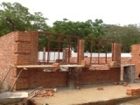

**Building update & Fundraising**

Thank-you to everyone who helped Ian Butcher raise 1010 pounds towards building the new classroom for One Way School. My estimates turned out to be a little optimistic so we decided just to raise one of the classrooms from the foundation level to house our grade 3 class in January. More money has come in, including a large donation from a parent of the school so we’re nearly there with achieving our dreams. The amazing thing is that this will be the last time I ask our newsletter readers to help us – the school and the local people will be able to afford to grow this school after this point.

**Christmas Appeal – Target 2000 pounds**



The completion of the current classroom will increase the schools capacity to 150 children. Times are difficult in Zimbabwe. Current statistics state that 85% of Zimbabweans are without work, there are no benefit systems, little water, little electricity and all educations costs money.   
But, in the face of these challenges, what Zimbabweans value higher than anything is education.

That’s why in spite of these challenges the PTA of the school has raised $5000 this year to build their school. Can **YOU** help these people with that final push and realise their’ and our dreams?

* Donating 20 pounds would help us buy 50 bricks
* Donating 10 pounds pays for a builder for the day
* Donating 25 pounds buys window frames
* Donating 50 pounds buys all the lights for the new classroom

For Christmas this year why not offer education rather than Christmas cards? Offer the gift of education this year and your donation will be used to educate a generation of children. The building you help to build will educate 30 children a year for more than 50 years. That’s ***YOU*** educating 1500+ Zimbabwean children and giving them the hope of a brighter future.

**If you can afford; I ask you to donate as much, or as little as you can this Christmas and buy these kids a gift that we could take for granted when we were their age – education.**

Please head to [www.hopeforharare.org](http://www.hopeforharare.org) or [www.gregsophiesangwine.org.uk](http://www.gregsophiesangwine.org.uk) now and donate whatever you can. We appreciate you!

For pictures and new galleries including recent school trips and our annual prize giving and graduation ceremony please check out our school website [www.onewayschool.co.zw](http://www.onewayschool.co.zw)

Contact Info

[www.gregsophiesangwine.org.uk](http://www.gregsophiesangwine.org.uk)

[gregandsophiesangwine@gmail.com](mailto:gregandsophiesangwine@gmail.com)

[www.onewayschool.co.zw](http://www.onewayschool.co.zw)

**Prayer Points**

* Thank God for the answered prayers above
* For continued health for all 3 of us – we have been struggling!
* For God’s provision of the necessary funds to complete the build.