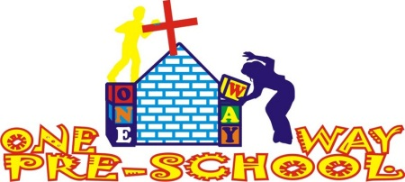
Dear Friends,

Opening
One Way Pre School officially opened on Monday 7th January 2013 and it’s been another really busy month. We’ve had more and more registrations each week but we are now settled at 35 children. Although we are expecting a few more to come in early February so we wouldn’t be surprised if we are educating 40 or more by this time next month. We are really thankful for everyone’s help and support over the last few months that have made this vision a reality. Please read some recent blogs for a little more detailed information on the school and please check out our new school website at www.onewaypreschool.co.zw too.

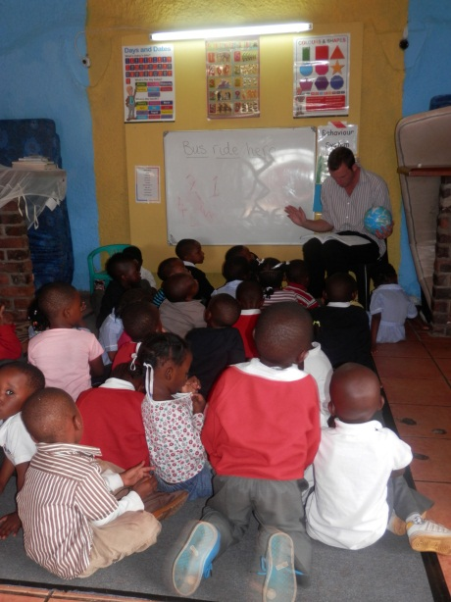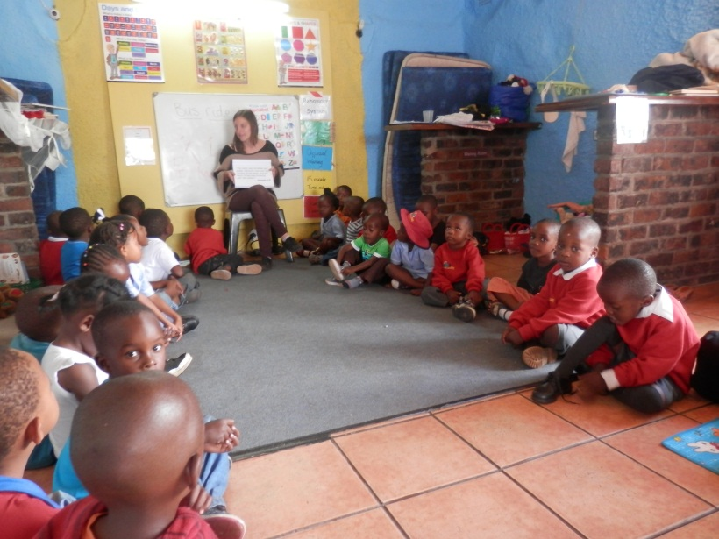
Greg teaching the story of creation Sophie teaching about how God loves us all very much!
(Using play dough!) (Each child gave every child a hug!)

This month’s achievements
This month we’ve already managed to significantly develop our school building with the renovation of one of the kitchens which is now complete with a gas cooker for use during the ever more frequent, pesky power cuts and all our own bowls, kitchen utensils and cooking equipment which have been bought with donations given over the Christmas period. The amount of registrations we have means we can afford to have 5 full time staff at the school which we are so excited about. We have decided to employ someone who has a vision for the school to expand even further. This lady will act as our administrator, be in charge of the finances and future projects which will leave us to do the teaching and look to future developments! Great news for us but even better for the future sustainability of the work of ‘Hope for Harare’

Orphans
We are still trying to find orphans that 1) Are the right age. 2) Can be brought to school and picked up on time and 3) Are suitable. So we will let you know when this happens. In the mean-time your orphan donations have been saved to buy school equipment and school uniforms.
Personal information
We are really well settled in our new place now and it is so relaxing to be able to get home from work, go for a swim and watch a film or football match! We really feel like this is home now and I think as each day passes this feels less and less like a holiday and more like a way of life. We feel really lucky for that. We are continually praying for what God holds in the future for us and would appreciate any wisdom and guidance you may feel the Lord wishes to give us!

We are blessed to have already had Sophie’s parents visit in 2012, and we are due to have Greg’s mum and best man; Andy visiting in April so we are looking forward to those!

2013…the future
So, a new year has begun, we are one month in and so much has happened to us and the project all of which we are truly thankful for. We have been talking, praying and wondering about what the future of 2013 holds for us as a couple and are at a stage where we could be sticking with just one school and developing the project through this, or we could be looking towards more schools and more projects!

Below are some prayer points which we would value your support with:

- In June our Visas run out so we need to re-apply for those in the coming months. When re-applying, the Pastors here have mentioned that the length of stay can be judged on individual basis, which means we could apply to stay for longer than a year. We have already determined that we will be here until the end of 2014, beyond that, we are awaiting God’s plan!
- One Way Pre School Mabelreign currently has 33 pupils and counting – we can take up to 60 – more are always welcome and needed to maintain the school.
- New Administrator – Will be beginning work in March and will oversee finances and general jobs within the Mabelreign School.
- Discussions with Pastors at One Way regarding current status of One Way Pre School and the future of the schooling project. Whether to maintain where we currently are or develop and expand in the coming year.

Thank you again for your support and encouragement. We miss you all and look forward to keeping you up to date.

God Bless and Keep Smiling!
Love Sophie and Greg xx

Here is Alex. The Lion.
